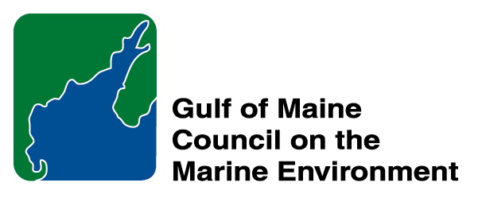 | 2014 Gulf of Maine  Industry Award  Nomination Form

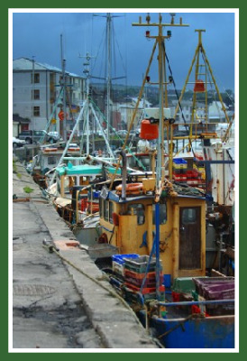 | The Gulf of Maine Industry Award is made annually to an individual, company, or organization within the Gulf of Maine region: Massachusetts, New Hampshire, Maine, New Brunswick, and Nova Scotia. The Award recognizes demonstrated innovation and leadership in efforts to improve the well-being of the Gulf of Maine ecosystem and the communities that call it home. Nominations are sought for nominees from the following sectors: tourism; fisheries (commercial and recreational); aquaculture (finfish and shellfish); renewable energy generation (tidal, wave and wind) and transportation (shipping, ferries, etc.).  Nomination instructions:  - Individuals or organizations may submit nominations. Self-nominations are not accepted.  - The nominee must be resident of Maine, Massachusetts, New Brunswick, New Hampshire, or Nova Scotia. The nominee’s contributions must have been to the Gulf of Maine watershed.  - Industry Award nominees may be paid professionals or volunteers.  - Nominations must be made on this form. Attachments will not be accepted.  - Nominations must be emailed directly to jleblanc@gulfofmaine.org by March 30, 2014. Please rename the nomination form with _LastNameofNominee added to the end of the file name.
Questions? Please contact Council Coordinator Joan LeBlanc at jleblanc@gulfofmaine.org.
To view a list of past award winners, please visit: http://www.gulfofmaine.org/2/opportunities/

Nominee information
Name (as it would appear on the award plaque if selected):
Mailing address:
Phone:
Email:

Brief background on why the individual/organization is being nominated:

Summary that will be read during the awards ceremony if nominee is selected. This text will also be used in media releases (not to exceed 2,000 characters, including spaces and punctuation):

Contact information for person making the nomination:
Name & Affiliation:
Address:
Phone:
Email:

