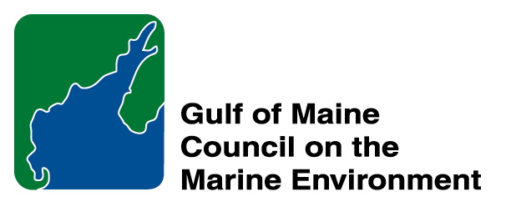 |  | 2014  Sustainable Communities  Nomination Form
The intent of the ‘Sustainable Communities Award’ is to recognize communities, or groups within communities, of their exemplary work in achieving sustainability outcomes related to the environment and economy, in line with the objectives of the GOMC Action Plan. The selection criteria are derived from the Melbourne Principles and the Government of New Brunswick’s Community Recognition Award selection criteria.
- Provides a long-term vision for communities based on pillars of sustainability: social /cultural, environmental and economic, as well as political equity, and the community’s individuality.
- Works towards achieving long-term economic, social, and environmental security.
- Recognizes the intrinsic value of biodiversity and natural ecosystems, and acts to promote the stewardship of biodiversity and natural ecosystems, and protects and/or restores them.
- Strives to enable communities to minimize their ecological footprint.
- Engages the community in the planning and implementation of sustainable solutions.
- Builds on the characteristics of ecosystems in the development and nurturing of healthy and sustainable communities.
- Recognizes and builds on the distinctive characteristics of the community, including their human and cultural values, history, and natural systems.
- Empowers people and fosters participation.
- Expands and enables communication and cooperative networks to work towards sustainability as a common and shared goal.
- Promotes sustainable production and consumption, through appropriate use of environmentally sound technologies and effective demand management.
- Enables continual improvement, based on action planning, accountability, transparency and good governance.

Overarching Program Criteria
Nominations should demonstrate that the community, group, program, or project contributed to the long-term viability of the community, improved the health of its immediate environment, and impacted positively the health of the Gulf of Maine.

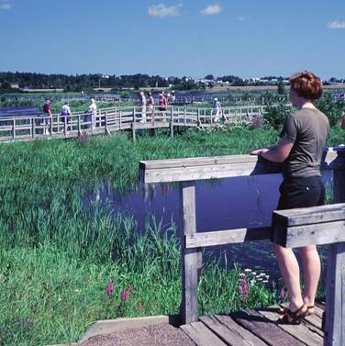 | Nomination instructions  - Individuals or organizations may make nominations. Self-nominations are not accepted.  - The community must be based in part or in whole in Maine, Massachusetts, New Brunswick, New Hampshire, or Nova Scotia. The nominee’s contributions must have occurred in the Gulf of Maine watershed.  - Nominations must be made on this nomination form. This form may be reproduced electronically. Nominations with missing information will not be considered. Please provide all information on this form—attachments will not be accepted.  - Nominations must be emailed to jleblanc@gulfofmaine.org by the close of business on March 30, 2014. Please rename the nomination form with _LastNameofNominee added to the end of the file name.
Questions? Please contact Council Coordinator Joan LeBlanc at jleblanc@gulfofmaine.org.
Nominee Information
Name (as it would appear on the award plaque if selected)
Affiliation:
Mailing address:
Phone:
Email:

Brief background on why the community or group is being nominated:

Summary that will be read during the awards ceremony if nominee is chosen. This text will also be used in media releases (not to exceed 2,000 characters, including spaces and punctuation):

Contact Information for Person Making the Nomination
Name :
Affiliation :
Mailling Address :
Phone :
Email :

