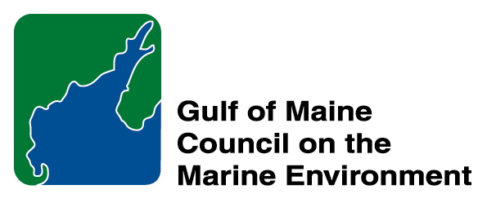 | 2014 Gulf of Maine Council Visionary Award  Nomination Form

The Gulf of Maine Visionary Award is presented annually to an individual or organization within each of the five Gulf of Maine jurisdictions of Massachusetts, New Hampshire, Maine, New Brunswick, and Nova Scotia. The Awards recognize innovation, creativity, and commitment to marine protection by businesses, environmental organizations, or individuals who are making a difference to the health of the Gulf of Maine.
* As the Council celebrates our 25th Anniversary, we seek to recognize the value of young people as well as experienced leaders in working to protect the Gulf of Maine ecosystem. We welcome and encourage nominees of all ages (including students or youth organizations) for our 2014 Gulf of Maine Visionary Awards and Longard Volunteer Award.

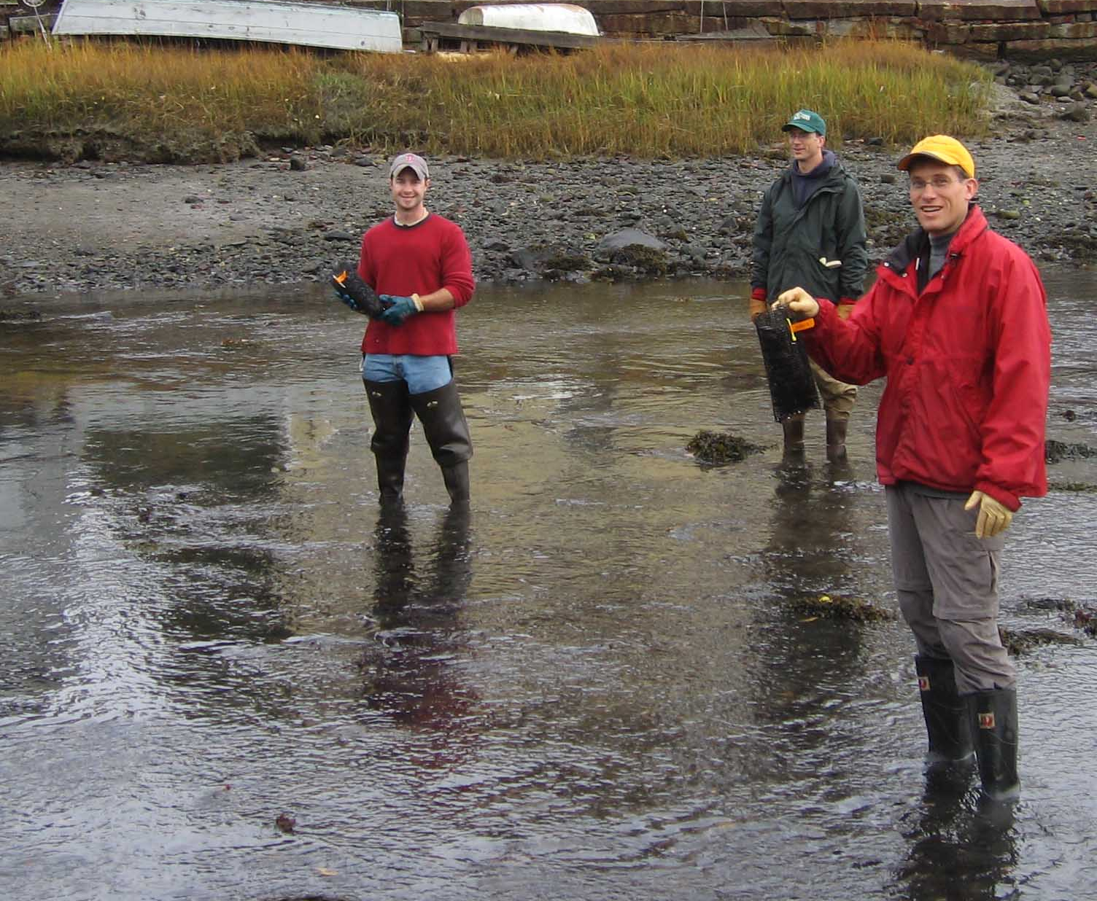 | Nomination instructions:  - Individuals or organizations may make nominations. Self-nominations are not accepted.  - The nominee must reside in Maine, Massachusetts, New Brunswick, New Hampshire, or Nova Scotia. The nominee’s contributions must have occurred in the Gulf of Maine watershed.  - Visionary Award nominees may be paid professionals or volunteers.  - Nominations must be made on this nomination form. Nominations with missing information will not be considered. Attachments will not be accepted.  - Nominations must be emailed to jleblanc@gulfofmaine.org by the close of business on March 30, 2014. Please rename the nomination form with _LastNameofNominee added to the file name.
Questions? Please contact Council Coordinator Joan LeBlanc at jleblanc@gulfofmaine.org
To view a list of past award winners, please visit: http://www.gulfofmaine.org/2/opportunities/

Nominee information
Name (as it will appear on the award plaque if selected):
Affiliation:
Mailing address:
Phone:
Email:

Brief background on why the individual/organization is being nominated:

Summary that will be read during the awards ceremony if nominee is selected. This text will also be used in media releases (not to exceed 2,000 characters, including spaces and punctuation):

Name and contact information of person making the nomination:
Name & Affiliation:
Address:
Phone:
Email:

The mission of the Council is to maintain and enhance environmental quality in the Gulf of Maine and to
allow for sustainable resource use by existing and future generations.

Massachusetts Office of Coastal Zone Management • 2002-2003 Secretariat
GOMC • c/o NHDES • PO Box 95 • Concord, NH, US • 03302-0095 • Phone (603) 225-5544

The mission of the Council is to maintain and enhance environmental quality in the Gulf of Maine and to
allow for sustainable resource use by existing and future generations.

Nova Scotia Environment • 2013-2014 Secretariat

