

**ANNUAL NEWSLETTER**

**Activities & Accomplishments**

**July 2014**

The EcoSystem Indicator Partnership (ESIP), a committee of the Gulf of Maine Council on the Marine Environment (GOMC), was formed to help assess the health of the Gulf of Maine through the use of indicators. ESIP was created out of an identified need to better understand and convey information on status and trends in the Gulf of Maine ecosystem and the impacts of human use.

ESIP is a cross-cutting committee of the GOMC. Its primary role is to lead ‘Environmental Indicators and Reporting’ under the GOMC’s 2012-2017 Action Plan Goal 2: Environmental and Human Health. However, ESIP’s activities support objectives and activities under all three goals of the GOMC’s Action Plan.

For 2013-2014, ESIP’s activities were focused on:

* Completing ESIP 1.0
* Improving the regional use of indicators.
* Embarking on the next phase of ESIP (ESIP 2.0)

**COMPLETING ESIP 1.0**

ESIP 1.0 activities centered on evaluation of indicators for seven theme areas: aquaculture, aquatic habitats, climate change, coastal development, contaminants, eutrophication, and fisheries.

|  |  |  |
| --- | --- | --- |
| **Fact Sheet** | **Original Release** | **Copies distributed**  **(prior to July 2014)** |
| Aquaculture Indicators | January 2011 | 2,315 |
| Climate Change Indicators | February 2011 | 2,054 |
| Aquatic Habitats Indicators | October 2011 | 1,779 |
| Eutrophication Indicators | May 2012 | 1,504 |
| Contaminants Indicators | April 2014 | 233 |
| Coastal Development Indicators | Coming Soon |  |
| Fisheries Indicators | Coming Soon |  |

**ESIP Fact Sheets**

ESIP has been delivering information on ecosystem indicators in the Gulf of Maine for eight exciting years! One of the main vehicles ESIP uses to get the indicator information out to our users is through our fact sheets. Each of the fact sheets delivers information on both the status and trends of important indicators for the given theme, and discusses how users can obtain and use this information for themselves through the **ESIP Indicator Reporting Tool**.

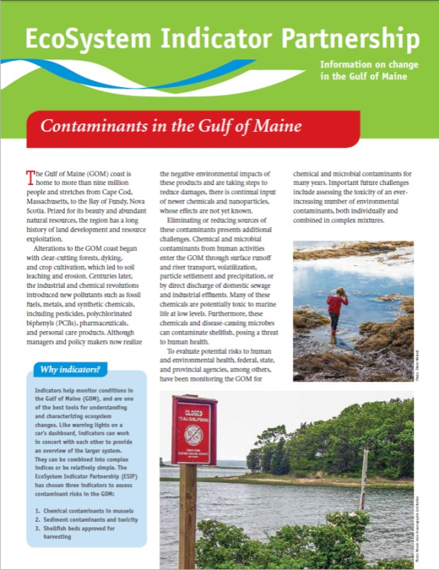

This year ESIP released the **Contaminants Indicators Fact Sheet**. This fact sheet highlights three indicators which ESIP uses to better understand and convey information on contaminants in the Gulf of Maine:

1. Chemical contaminants in mussels

2. Sediment contaminants and toxicity

3. Shellfish beds approved for harvesting.

**IMPROVING THE REGIONAL USE OF INDICATORS**

**GOM Climate Change Monitoring Sites**

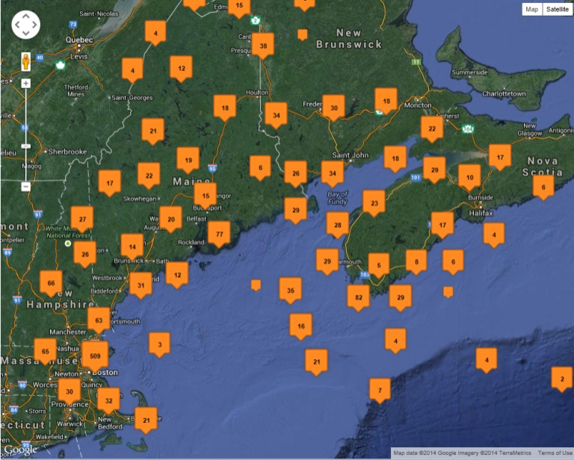

**On-line Monitoring Map Update**

This year ESIP has done a major revision to the **ESIP Monitoring Map**. The new platform includes information on more than **13,000 sites**.

Using the Monitoring Map, individuals can locate information on monitoring sites near them and learn **who** is looking at **what** indicators in the Gulf of Maine. Both the US side of the Gulf of Maine and the Canadian portions of the Bay of Fundy are included on the Monitoring Map. Very important for bi-national projects!

**Sharing Knowledge**

Every year ESIP participates in a variety of scientific **networks, meetings and workshops** held in the US and Canada where ESIP conveys information to managers and scientists on ESIP’s Monitoring Map and Indicator Tool, the newest fact sheets and journal entries, and decision support tools. In 2014 ESIP participated in:

* NE Regional Association of Coastal & Ocean Observing Systems (NERACOOS) Board of Directors
* Gulf of Maine Council on the Marine Environment (GOMC) Climate Network
* Senitinel Monitoring Effort
* Bay of Fundy Ecosystem Partnership (BoFEP) Health Index Workshop

In addition to the events above, ESIP also participated in **Coastal Zone Canada (CZC) 2014** held in Halifax, Nova Scotia. ESIP members presented talks focused on climate change indicators and decision support tools, and presented a poster on ESIP’s joint project with the US Environmental Protection Agency. The ESIP Program Manager also chaired a session on mapping coastal ecology. In addition, ESIP contributed significantly to a GOMC special session on the Gulf of Maine and to the GOMC’s 25th Anniversary activities. If you would like copies of the presentations, please contact the ESIP Program Manager at [ESIPmail@gulfofmaine.org](mailto:ESIPmail@gulfofmaine.org).

One of ESIP’s most utilized and valued products are the **ESIP Journal Entries**. Published regularly on ESIP’s website, these journal entries highlight current activities in the Gulf of Maine. The short articles, submitted by scientists, practitioners, and decision-makers working in the region, cover various topics around research, programs, project results, and events that help to better understand and address ecosystem health in the Gulf of Maine. Journal entries posted this year included a project to determine what species of fish consumers are really purchasing at local grocery stores, information on newly available impervious surface information for Nova Scotia, and critical information on right whales.

**Project Collaborations**

ESIP participates in numerous collaborative efforts.This year ESIP participated in projects with:

* US Environmental Protection Agency
* Bay of Fundy Ecosystem Partnership (BoFEP)
* Sentinel Monitoring Effort
* Eastern Charlotte Waterways (ECW)
* Lobster Settlement Index Project

ESIP plans to continue collaborative efforts with groups like the Eastern Charlotte Waterways to fill in eutrophication and contaminant indicators gaps in New Brunswick and Nova Scotia.

The Gulf of Maine Council on the Marine Environment (GOMC) is celebrating its 25th anniversary in 2014. To celebrate this milestone, the GOMC created a **geotour** of the Gulf of Maine watershed. The intent is to get the community out exploring the region and learning about the value of the Gulf of Maine. The geotour includes twenty-five sites; five in each of the five states and provinces that border the Gulf of Maine. ESIP is featured in two of the geotour sites, as a pilot for the **ICUC App** that is currently under development.

**EMBARKING ON ESIP 2.0**

In ESIP 1.0, ESIP identified priority indicators, compiled indicator data for a multitude of sites in the Gulf of Maine, and released fact sheets. The goal of ESIP 2.0 is to provide a more holistic understanding of the health of the Gulf of Maine/Bay of Fundy. To this end, the ESIP Steering Committee brought together a small group of individuals to determine a framework or best approach for delivering information on integrative 'super' indicators that assess ecosystem health and resiliency of the Gulf of Maine. Look for a preview of this effort at the Regional Association for Research on the Gulf of Maine (RARGOM) meeting in the fall with full details to be released in the beginning of 2015.

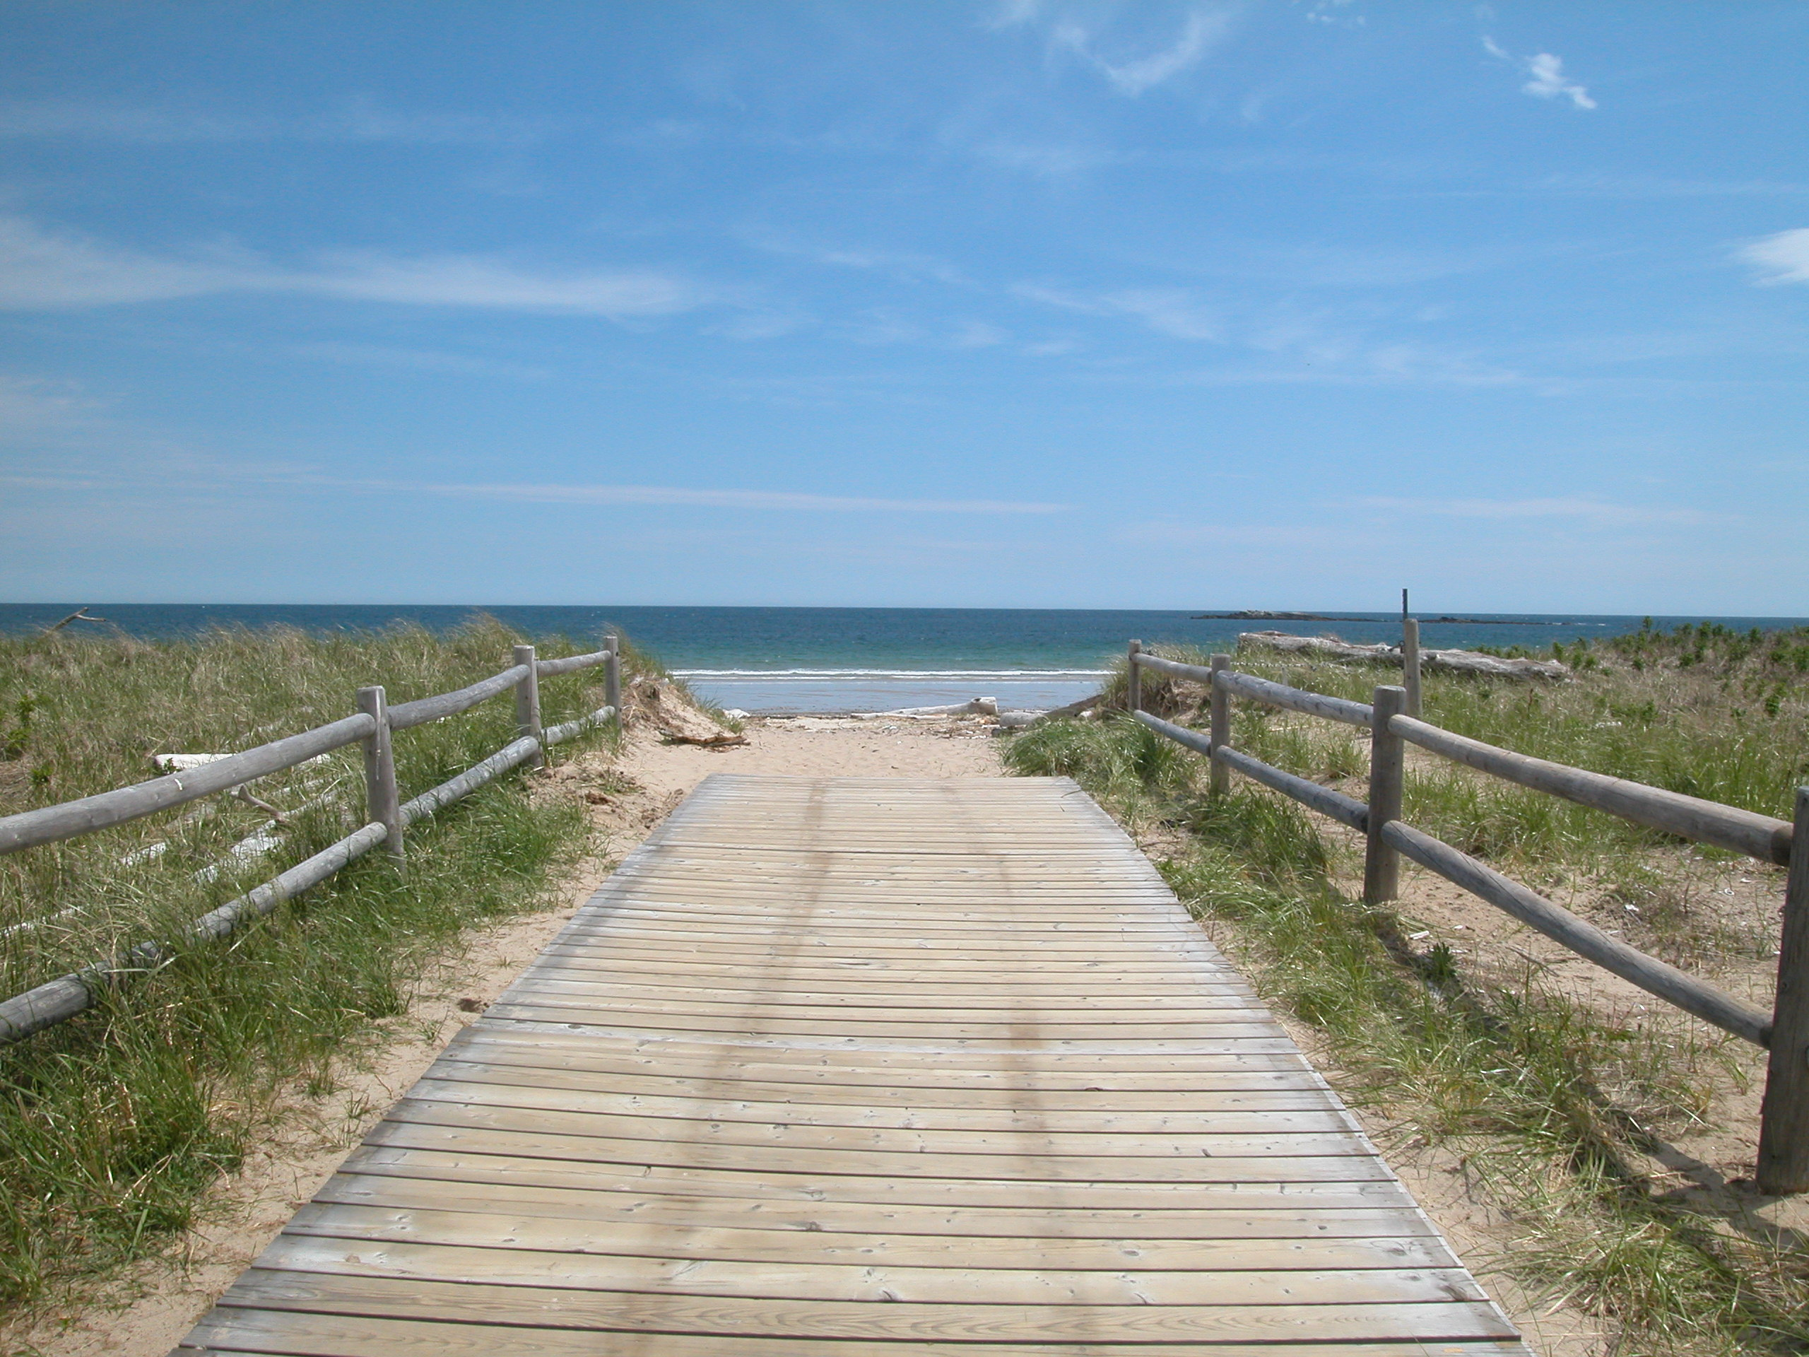

**Esperanza Stancioff**

**WHAT’S NEXT FOR ESIP…**

ESIP is exicted about several projects that it will be working on or that are nearing completion in the coming months.

**ESIP’s Coastal Development Indicators Fact Sheet,** currentlyin draft form, will deliver information on population density, locations of point sources, and amount and location of impervious surface for the Gulf of Maine and Bay of Fundy.

A **video guiding visitors on a tour of the ESIP webpage** will be released soon. Check back for information; details will be posted as they become available.

In the coming year ESIP hopes to complete watershed characterization of ESIP estuaries so that **watershed-estuary models** can be developed through a joint project with the US EPA’s Office of Research and Development.

ESIP is also developing a smart phone app which will allow everyone in the Gulf of Maine that is curious about nearby monitoring sites to obtain information and learn more about their watersheds. This **ICUC App** will also allow individuals to submit photographs at sites around the Gulf of Maine/Bay of Fundy and help build a photographic library of the status and changes to this vital region.



For more information on this or any of the ESIP products, please visit our website at www.gulfofmaine.org/esip.

**July 2014**