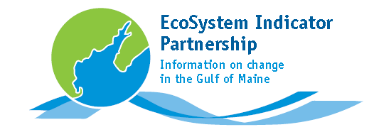

**ESIP - NERACOOS Webtools Workshop**

April 7, 2011

Seacoast Science Center

Rye, NH

9:00 - 9:30: Registration

9:30 - 9:45: Welcome: *Susan Russell-Robinson, DOI and Ru Morrison, NERACOOS*

9:45 - 10:30: Communicating the Science of Indicators: *Dave Kellam, Piscataqua Region Estuaries Partnership*

10:30: Break

10:45 - 12:00: Making Data Matter - Webtools to Support Decision-Makers

10:45 - 11:00: ESIP Monitoring Map: *Christine Tilburg, ESIP*

11:00 - 11:15: NERACOOS real time data: *Tom Shyka, NERACOOS*

11:15 - 11:30: EPA e-estuaries: *Naomi Detenbeck, EPA*

11:30 - 12:00: NERACOOS' other tools and future directions: *Tom Shyka, NERACOOS*

12:00: Lunch

1:00 - 1:15: ESIP Indicator Reporting Tool - Starting the Webtool Test Drive: *Christine Tilburg, ESIP*

1:30 - 2:00: Webtool Test Drive

Participants will work with a partner to try the various webtools. A series of questions will help guide participants through the exercise. Participants will be asked to comment on the utility and function of the tools.

2:00 - 2:30: Do the Tools Deliver?

Participants will share their experiences and discuss the strengths and weaknesses of the different tools. Participants will also be asked to provide suggestions on how the different tools might be improved.

2:30: Break

2:45 - 3:15: Getting the Tools Out

Participants will discuss and provide recommendations on how to best increase web presence for web tools.

3:15 - 3:30: Closing comments