Climate Change Conference Call - April 30, 2010

Participants:
Amanda Babson (EPA)
Gary Lines (Environment Canada)
James Hudson (Govt. NB)
Kyle McKenzie (NS Department of Environment)
Steve Perrin (Town of Bar Harbor)
Peter Slovinsky (Maine Geologic Survey)
Tom Trott (Suffolk University)
Marilyn ten Brink (EPA)

Greetings and Chair Update
Following introductions Gary Lines announced that he will be retiring in October. As of August, he will have worked for 35 years with Environment Canada and he stated that it was time to move into a different phase of his career. Christine Tilburg thanked Gary for all of his work with ESIP's efforts. Christine then noted that this will leave the Climate Change subcommittee with a vacant chair. She requested that if anyone is interested in filling in as chair of the subcommittee they send her a message.

Air Temperature Prepared Slides
The group then began by discussing the slides Christine had prepared and sent out prior to the call. She mentioned that the there were some left over items from the previous call that are covered in Slide 2. Gary recapped the slide stating that decadal variations in the air temperature data should not present an issue if the data is presented similarly to the Tables prepared for the slides. Work within his own climate section at Environment Canada seemed to show that removing cycles within the air temperature data did not provide further information. In fact, it appeared that more error was introduced by removing the variations.

US Air Trends, Maximum Trends and Minimum Trends
Christine then stated that most of the remaining slides touched on suggestions that were made during the last call. For example, Slides 3-6 provide information on annual air trends, maximum air trends, and minimum air trends. In addition, information about the lengths of record and years with minimum and maximum values is presented. Gary mentioned that he agreed with Christine's comments that the tables were becoming too busy. When he thinks of the data he focuses on what would be useful to present in the Reporting Tool versus Fact Sheet. He stated that the site numbers were not helpful. However, he felt that the length of record and annual trend provide valuable information.

The group also agreed that the maximum and minimum temperatures did not appear to provide useful information at this time.. However, the up and down arrows did add to the visual presentation of the data. Gary in particular stated that he would debate the value of the maximum information. Peter Slonvinsky agreed that after looking at the maximum temperatures he doesn't see the value in showing this data. Peter also stated that the trends in general are small. He wondered if some people might be interested in the variance associated with the trend. Christine stated that in the past she did provide information on the r² values as a means of showing strength of significance and the subcommittee had felt that this was too much information for the fact sheet but might be included in a peer-reviewed article. She suggested that it wouldn't be difficult to bold values that appear to meet the criteria for significance. The group liked this suggestion. (Action to be taken: Christine will use bold text for the tables in the fact sheet to denote significance of relationships - the subcommittee will have to determine the criteria for this).

Gary also wondered about calling the trends "annual". He also wondered about presenting the data in terms of centuries. Christine reminded the group of the previous discussion with respect to centuries and decades. The group decided to keep the analysis focused on decades.

With respect to the data tables, the group felt that the data should only be presented as one digit past the decimal point as temperatures are rarely presented with two significant figures past decimal points.

In discussing the minimum temperatures Steve Perrin stated that he had requested this analysis due to the timing of sea ice formation in the past 25 years changing. Peter stated that he felt the seasonal information presented later tells the story better than the minimum temperatures.

Air Data Arranged By Latitude and Proximity to Coast
The group then discussed Slides 7-10 which presented the data arranged by increasing latitude or proximity to coast. The group felt that this was interesting and suggested interesting further research but might not be vital as a figure in the fact sheet. Steve suggested that the information be summarized in the text and the group felt that this would be a good opportunity to provide the information. (Fact sheet: Sentence about changes with increasing latitude or proximity to coast line).

Seasonal Analysis
The group then discussed the example sites provided by Christine which separate out the data by season (Slide 12). The group, in general, felt that this was an interesting way to provide the data. Gary stated that he believed managers would be most likely able to use the information in this form (example: snow budgets) but again cautioned providing only 1 significant digit for the data. Peter stated that some of the trends really aren't significant and should be noted with a phrase such as "No Significant Change". He suggested that the numbers might not be important and the up and down arrows would suffice. (Action to be taken: In final tables seasons that show not significant change will be noted. In addition appropriate significant digits will be used).

Christine asked James Hudson to describe the example of visually presenting seasonal data that he previously sent to Christine. He discussed an example of providing a map of the Province with a circle at each site. The Circle was divided into four quadrants for each season. An example is given below:

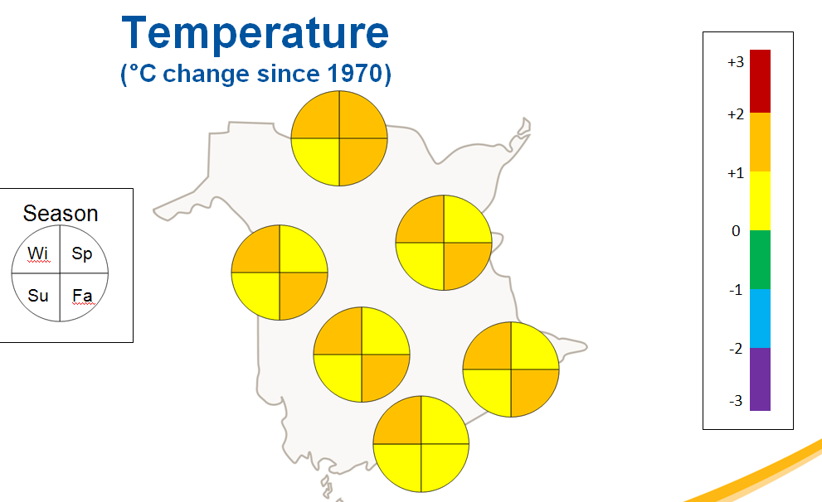

Christine suggested that similar figures be created for the air data. She stated that she does not have access to GIS and would appreciate some help in providing the figures. Peter stated that he'd be happy to help (Thanks Peter!).

The group discussed the seasonal divisions that Christine provided and Steve cautioned solar radiation often lags behind seasons as defined by certain months. Christine stated that the seasons chosen matched the seasons utilized by the Eutrophication Subcommittee (though that data might lump information from Spring-Fall) and previous climate change precipitation data. Gary stated that the seasons as defined by this work were selected originally as defined by the normal definitions used in climate modeling and trend analysis. Steve stated that for some coastal locations Spring never apparently comes and Fall lasts forever.

Next Steps
The next call will focus on finalizing the figures for use in the fact sheet. The call most likely will be in early June.

