Climate Change Conference Call - March 30, 2009 - Precipitation

Participants:
Verna de Lauer (COMPASS)
Patty King (Fisherman and Scientists Research Society)
Gary Lines (Environment Canada)
Peter Larsen (Bigelow Laboratory)
Marilyn ten Brink (U.S. EPA)

Greetings
After everyone had introduced themselves, Christine Tilburg reminded the subcommittee that the purpose of this call is to look at the initial analysis for precipitation that was done last summer and fall. The conference call used a series of slides that Christine sent out prior to the call. Christine also reminded the group that the data was originally analyzed by Holly Elwell, a graduate student at Tufts University.

Data Sources

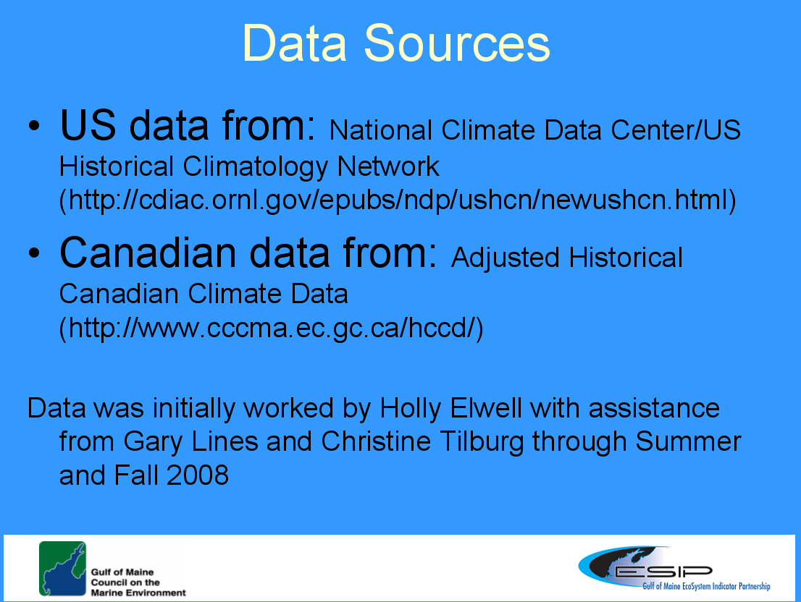

Gary Lines discussed the types of adjustments that were made to the data sets. He mentioned that the adjustments were undertaken by the organizations that house the datasets to remove non-climatic trends and are well documented.

Gary also mentioned that one must be very careful with precipitation datasets as there are extreme local variations and issues when the instrumentation is changed. Peter Larsen wondered if all of the data was analyzed as linear functions. Gary replied that it was.

Gary also mentioned that one of the assumptions that was made is that there is value in looking at where the trend is going. He wondered if the information on extreme events would be of more use to our users.

Distribution
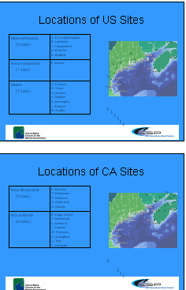
Marilyn ten Brink commented that the distribution of the sites is fairly even along the coast. However, she expressed concern regarding whether the locations capture the inland precipitation.

Peter mentioned that he thought that Farmington was misplaced on the figure. He also thought that the Gardiner location should be located to the East of Lewiston. Christine stated that she would look rigorously at the figures and correct the locations (Action to be taken: correct location figures on Slides 3 and 4).

Annual Precipitation Trend Figures and Table (Slides 5-7)
Gary mentioned that the figures for annual precipitation were quite interesting. He noted that for New Brunswick there is an approximately 1.4 mm increase overall. However, the figure shows that in the last 8-10 years there has been lower than average precipitation. He thought that if perhaps the data is shown as above or below an average value, the user would get some sense of flood versus drought years.

Site Specific versus Regional Conclusions.
Patty King wondered if the information in the fact sheet will include a link to the webpage. She is concerned that if the information is grouped together in its presentation the result will be too broad and not as useful. Gary agreed that this is one of the challenges. The effort is to take site specific data and try to present a regional conclusion. Verna de Lauer felt that it would be important to state in the fact sheet that conclusions are based on data available from the ESIP webpage.
Extreme Events (Slides 8-10)
Gary mentioned that he feels these simple graphs really are powerful in that they show a spike in events with over 25 mm of rainfall/snowfall towards the end of the century. This really gets at the utility of the information. Marilyn also agreed that the information is well presented as it is. She feels the focus should be on presenting the data with respect to both frequency and magnitude. She also feels that the ratio of snow to rain will be important.

Gary stated that when ESIP gives presentations to the users, the subcommittee will receive valuable information about the usefulness of these datasets.

Peter asked if there is value in breaking these data sets up based on seasonality. Christine replied that based on her look at the initial data, there is some seasonality present in the data. She also believes that the air temperature data will most likely be presented in a seasonal fashion and it might be nice to have these data sets analyzed similarly. Marilyn felt there is also value in looking at seasonality with respect to snowmelt. Peter thought that the USGS in Maine is looking at Spring freshets and that the data is leading researchers to believe that the freshets are coming earlier in the year.

Next Steps
It was generally agreed that the data needs to be looked at with a more rigorous statistical package. In addition, the group thought that the data should be looked at with seasons separated out. Christine suggested that she send out a message to the group requesting that anyone interested in looking at the data in connection with Gary and Christine on these specific issues contact her. The group agreed to meet again in a couple of months to look at the results from this effort.

