Climate Change Conference Call - October 22, 2008 - Sea Level

Participants:
Amanda Babson (AAAS at EPA)
Al Hanson (Canadian Wildlife)
Gary Lines (Environment Canada)
Esperanza Stancioff (UMaine/Maine Sea Grant)
Marilyn ten Brink (EPA)
Christine Tilburg (GOMC-ESIP)
Hal Walker (EPA)

Sea Level Powerpoint Slides
The conference call purpose was to go through the slides on sea level change that Christine Tilburg prepared. All slides available at www.gulfofmaine.org/esipplanning.
The group first discussed the data source as presented on Slide 2.

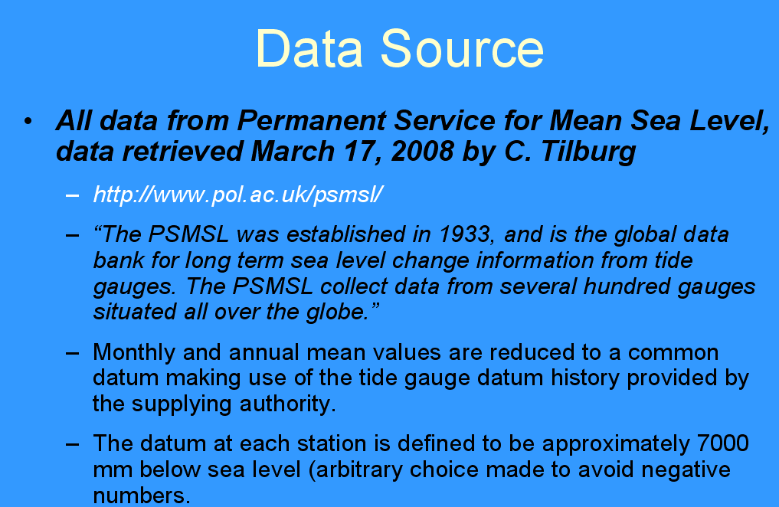
Slide 2

Gary Lines mentioned that as part of the former climate change task force headed up by Clean Air Cool Planet they looked at a number of indicators. For the sea level indicator, the Permanent Service for Mean Sea Level (PSMSL) was chosen as the main data source. This was selected as a source due to the presence of tidal gauge data throughout the region that would allow for comparisons. Al Hanson asked if Charles O'Reilly approved the Canadian data that was submitted to the PSMSL. Charles is with the Canadian Hydrographic Service and might have comments on the appropriateness of the Canadian sites. Gary stated that he assumed these sites had been approved by Charles but will connect with him to verify. (Action to be taken: Gary will contact Charles about potential issues with the PSMSL data). Christine mentioned that another thing the subcommittee needs to be aware of is that the data does include some estimates.

The subcommittee then discussed the questions as posed in Slide 3.
1. How many sites does the subcommittee feel are the minimum required (currently have 8)?
Gary mentioned that whether the subcommittee desires more sites or not - it is not likely that more sites are going to be located. Marilyn ten Brink suggested that the subcommittee should think of the data in two bins. One "bin" is highly QA'd and intercomparable (PSMSL). A second "bin" might be used to compile that uses other methodology or local sources. Gary agreed and stated that there are currently a lot of mapping efforts that are being done by various agencies. Christine agreed and mentioned that there is a wealth of LIDAR (Light Detection and Ranging) data that will be becoming available in the next 5 years. Gary agreed but thought that the focus of what we are discussing today is historical trends in the region. The high resolution data shows very recent changes in the shoreline.

2. What is the appropriate length of record (currently have 37 - 106 years)?
Al mentioned that he likes the approach of the table at the end of the slides - this is an excellent means of presenting the data. Marilyn agreed and pointed out that one of the messages of the data/table is that individuals/agencies can start collecting data now. Gary agreed and stated that it will be necessary for users to understand that the trends they see are based in part of the length of record. Marilyn commented that this speaks to the need for including textural background information.

Hal Walker mentioned that there are components in the sea level data that are natural variability, such as the North Atlantic Oscillation. (Hal sent out some articles about this topic that were forwarded to the subcommittee during the call).

3. What is more appropriate for managers? True sea level change or the relative sea level change (which includes crustal rebound/subsidence and other factors such as natural oscillations).
Gary stated that when he thinks of how managers approach a question such as sea level, he thinks in terms of the following questions: 1. Where are we now? 2. What is currently the trend? 3. What is occurring at this specific location? 4. What is happening as we move forward?

The group on the call felt that relative sea level rise is most likely more appropriate for managers. Marilyn pointed out we will need to provide links to further information if any of the users wish to tease out the true sea level change. Christine wondered if there is merit in trying to produce a peer-reviewed article or longer white paper to provide further details and in-depth information. Gary mentioned that the subcommittee itself can also be a resource to those looking for further information.

Sea Level Graphs
Marilyn mentioned that there are pros and cons to showing different kinds of regression lines. She wondered about providing a 10 year smooth average. Gary didn't know if this would be valuable as it is generally done to smooth out variability and there is not a lot of variability in the graphs. Christine mentioned that once the figures are being prepared for the fact sheet, she is not comfortable with using the Excel stats and regressions. The group agreed.

Hal mentioned that he e-mailed a recent paper to Christine for forwarding to the group on variations in the North Atlantic Oscillation and sea level rise. He feels that this level of complexity is appropriate for the peer-reviewed article. However, he thinks a simpler view is better for our users. Al agreed that he doesn't think ESIP needs to go into detail - but links can be made to other organizations (such as the Canadian Geologic Survey for subsidence estimates).

Gary wondered how the group (or not necessarily ESIP) can make available all the work on climate change that is going on in the Gulf of Maine. Christine mentioned that she sees this as a good potential interaction between the Climate Change Network (http://www.gulfofmaine.org/council/committees/climate_change_network.php) and ESIP. Al agreed that it would be helpful to connect with another associated group concerning projection scenarios.

Summary Table
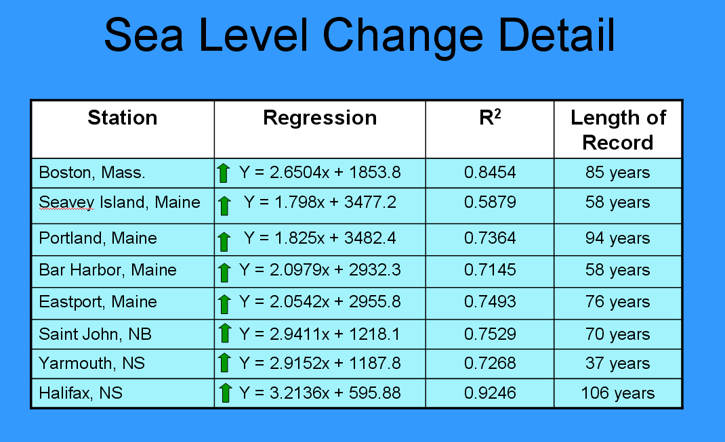

The group then discussed the summary table. Gary mentioned that he feels it is important to note that we do have variations in the trends. The next obvious question is why are the trends different. Hal commented that the components of the variation are different for different locations and the users will need to refer to the other documents we link to. Also, when you look at the global acceleration in sea level rise, the values that we are seeing in the Gulf of Maine are on the upper side of this uncertainty. We will need to succinctly point this out in the fact sheet. Amanda Babson asked if we should look at the rate in the last 35 years in light of the acceleration trends and issues with different lengths of record. Hal stated that he would advise against going to a short trend. He feels the trick is to keep it simple but put the trends in context. It is apparent that the rate is accelerating globally and a compelling argument can be made that the Gulf of Maine is also showing this acceleration.

Next Step
Christine will revise the summary table to include all sites in the PSMSL regardless of record. She will also convert some of these comments to bullets for discussion during a December conference call. She also suggests that the subcommittee attempt to answer some of Peter Slovinsky’s questions that he sent via e-mail. We will revisit these on the next call.

