**Climate Change Fact Sheet**

**Page 1**

**The importance of understanding climate change effects in the Gulf of Maine.**

Climate change is anticipated to have wide ranging effects on many elements of the Gulf of Maine region, including its ecosystems, habitats and coastal communities. The Earth's climate system is driven by several factors, including the amount of incoming sunlight, volcanic activity, land use changes, and the atmospheric concentrations of greenhouse gases and other pollutants. Over the last century, average global temperature has increased by about 0.6°C [1°F], in part due to increasing greenhouse gases from human activities.

The Intergovernmental Panel on Climate Change (IPCC) projects a global mean atmospheric temperature increase of 1.1°C to 6.4°C by 2100 (IPCC AR4, 2007). A rise in temperature of this magnitude and rate is likely to affect global patterns of storms and precipitation, raise global sea levels through the thermal expansion of the oceans and the melting of continental ice sheets and glaciers, increase ocean temperatures, reduce ocean salinity and affect ocean chemistry. All of these will have effects on ecosystems and human settlement. The extent of these global climate impacts will be influenced by many regional and local factors in the Gulf of Maine. In addition, these pressures interact with each other and with other non-climate related pressures, such as coastal development pressures, habitat degradation, pollution and changes in natural resources.

Potential changes in the aquatic environment in the Gulf of Maine as a result of climate change include increases in water temperature, decreases in salinity and changes in water quality and quantity. These changes will affect the sustainability of fisheries, including both targeted and traditional species used in the Gulf of Maine. As an example, conditions may no longer be favorable for some species, and exotic species may find a niche to colonize and outcompete, the rate of ecosystem change may be too rapid for species to adapt. Sea level rise will also be an important pressure on coastal habitats and ecosystems, for example, by fragmenting and adding to the loss of coastal wetlands.

Climate change mitigation and adaptation are recognized as essential strategies to reduce the vulnerability of the Gulf of Maine to these climatic changes.

**Focus Box: Why Indicators?**

Indicators are one of the best tools for making sense of the complex Gulf of Maine. Like the dashboard of a vehicle, indicators can work in concert with each other to provide a better understanding of a larger system. Indicators can be quite complex, like the Dow Jones Index, or very simple. Simple indicators themselves are often driven by complicated pressures and responses. The three indicators that ESIP has chosen for climate change in the Gulf of Maine region are:

1. Sea level

2. Air temperature trends, with an emphasis on seasonality

3. Precipitation trends, with an emphasis on extreme weather.

**Page 2**

**Sea level**

Sea level fluctuations on a global scale are a normal part of the geologic record. Since the last glacial period sea level has been fluctuating and risen at approximately 1.7 mm/year. Climate change has changed this pattern by increasing the rate of sea level rise, making it a significant indicator for assessing climate change in the region.

Sea level has been measured at various sites in the Gulf of Maine for approximately 100 years. The coastline of the region, whether sandy or rocky, is undergoing an average of 2 mm increase in sea level per year (see table below). Relative sea level takes into account not only the influence of global sea level changes, but also how the land mass is moving in relation to the sea. For example, crustal rebound in some locations in response to the last glacial period is causing lower relative sea level changes, while subsidence in other areas is causing higher relative sea level changes (in relation to the global average). On average, the Gulf of Maine region is undergoing just over 2 mm increase in sea level each year (Table 1). Some areas are experiencing lower rates, with less than 1 mm/year observed at several sites. Other locations are experiencing greater than average changes, such as Halifax and Yarmouth, Nova Scotia. Changes of 1.8-2.0 mm/year or greater are significant because many of the region's beaches, dunes and coastal wetlands formed when sea level rise was significantly lower.

|  |  |  |  |  |
| --- | --- | --- | --- | --- |
| **Site** | **Increase/Decrease** | **Annual Rate of Change (mm/year)** | **Length of Record** | **Rate of Change (1974-2004) (mm/year)** |
| **Buzzards Bay, Mass.** | **↑** | 0.5 | 20 years | * |
| **Woods Hole, Mass.** | **↑** | 2.9 | 74 years | 2.8 |
| **Cape Cod Canal, Mass.** | **↑** | 2.0 | 20 years | * |
| **Boston, Mass.** | **↑** | 2.7 | 85 years | 2.7 |
| **Seavey Island, Maine** | **↑** | 1.8 | 58 years | * |
| **Portland, Maine** | **↑** | 1.8 | 94 years | 0.07 |
| **Bar Harbor, Maine** | **↑** | 2.1 | 58 years | 1.0 |
| **Cutler II, Maine** | **↑** | 1.4 | 24 years | * |
| **Eastport, Maine** | **↑** | 2.1 | 76 years | 1.3 |
| **Saint John, New Brunswick** | **↑** | 2.9 | 70 years | * |
| **Yarmouth, Nova Scotia** | **↑** | 2.9 | 37 years | 3.8 |
| **Halifax, Nova Scotia** | **↑** | 3.2 | 109 years | 2.4 |
| **Gulf of Maine Averages** | **↑** | 2.2 | 60 years | 2.0 |

*\* This site did not have data for 1974-2004. Sites were selected both within the Gulf of Maine watershed and nearby to increase the amount of data available.*

Sea level rise, coupled with a potential increase in the intensity and frequency of extreme storm events, will place pressure not only on the functionality of the natural coastal environments such as wetlands, beaches, and dunes, but also on coastal communities and associated infrastructure. An increase in extreme precipitation, storminess and storm surges is expected to lead to more flooding, coastal erosion and impacts on water, transportation and other infrastructure that coastal communities rely upon.

**Air Temperature**

The climate of the Gulf of Maine region reflects global influences, but regional temperature is also influenced by regional and local aspects of the climatic system including topography, the passage of different weather systems, changing storm tracks, fluctuations in the jet stream, and changing ocean currents, warming and cooling sea surface temperatures and the decreasing amount of snow on the ground.

Analysis of air temperature trends in North America by the IPCC over the past 100 years found that the warming from 1950 to 1999 cannot be explained by natural climate variation alone. Rather the observed trends are consistent with the combination of natural variability and anthropogenic forcing from increasing levels of greenhouse gases and sulfate aerosols in the global climate system.

Changes in mean climate as indicated by air temperature are a major impact on our daily lives and our region’s economy, including emergency management, human health, viability and consistency of electrical power generation and transmission, fuel consumption for heating and cooling, tourism, transportation, and agriculture.

Air temperature therefore is one of most frequently used indicators of climate change and is currently recorded at more than 100 stations in the northeastern United States and the Canadian Maritime region.

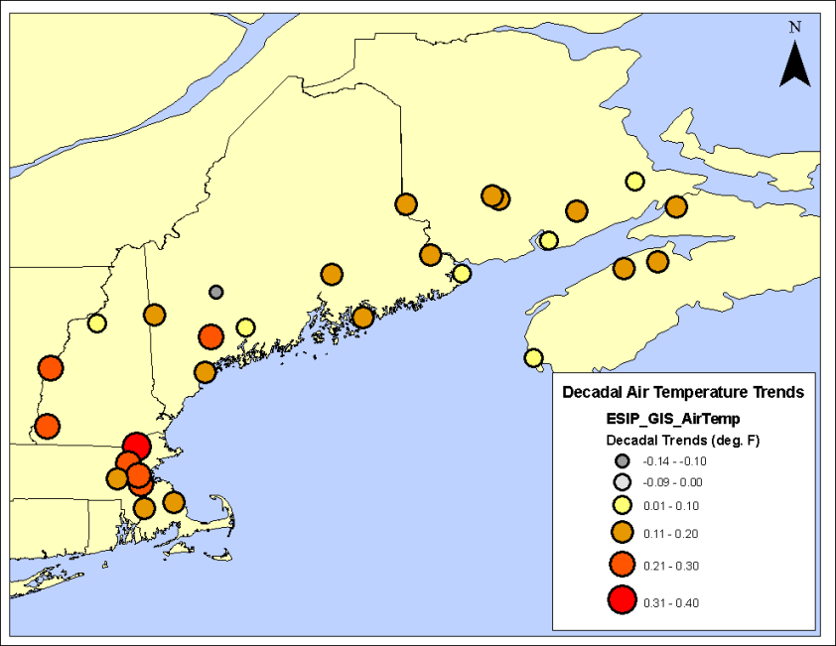

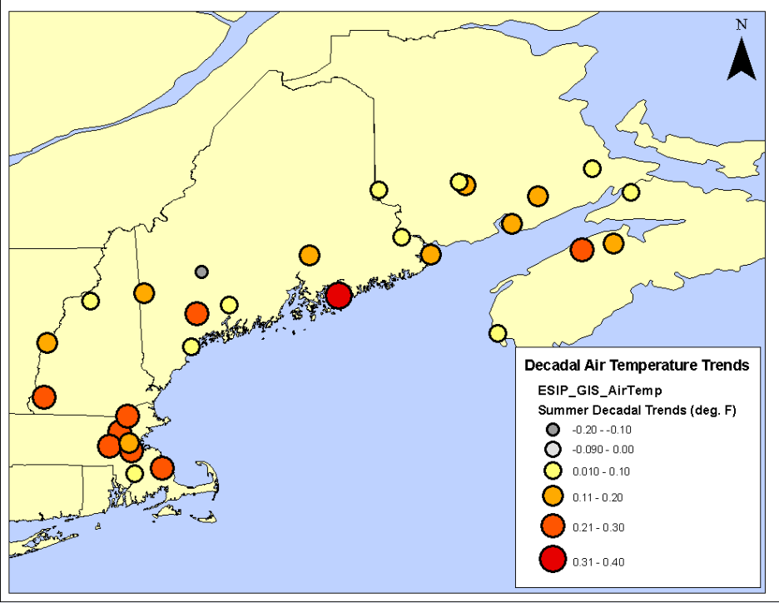**Figure: Average decadal trends for sites in the Gulf of Maine.**

Across the northeastern region, average air temperatures have been on the rise over the past 3 decades at all but one site. Most sites have exhibited 1-2 ◦ F per century increase, comparable to the observed increase in global temperatures. Some sites have shown as much as 3-4 ◦ F increase (based on the decadal trend). If we examine the trends by season, the change is even more dramatic. Winter trends of as much as 0.5 ◦ F per decade are observed at several sites in Maine. While some sites have limited data sets (20-30 years) most are longer which leads to more credibility in the trend result.

**Figure: Summer decadal trends for sites in the Gulf of Maine Watershed.**

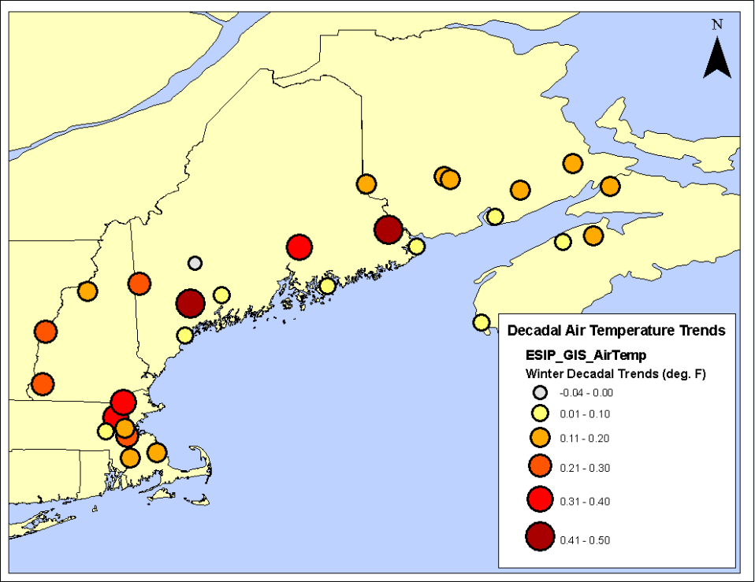

**Figure: Winter decadal trends for sites in the Gulf of Maine Watershed.**

**Page 3**

**Precipitation**

Precipitation is critical for sustaining human well-being and quality of life as well as Gulf of Maine ecosystems. In this region, precipitation comes in a variety of forms including rain, snow, ice pellets, and freezing rain. Ecological systems depend on precipitation for hydration and human communities depend on the replenishment of water sources for residential, municipal and industrial water supplies and forgrowing crops. In addition, precipitation is important for the region’s tourism economy. More snow in winter is better for winter tourism, and fewer rainy days during the warm season is better for summer tourism.

Climate change will likely lead to changes in precipitation and atmospheric moisture. This is mainly due to changes in atmospheric circulation, a more active hydrological cycle, increased evapotranspiration and increases in the water holding capacity of the atmosphere because warmer air holds more moisture. Water vapor in the atmosphere is also a critical greenhouse gas.

Temperature and precipitation are intricately linked in the climate system. Over the past century there has been a 2 % increase in global precipitation, but that change has not been uniform over time or geography. Precipitation tends to be much more variable over short distances when compared to temperature, and this is reflected in both global and regional records.

Over the Gulf of Maine this has been demonstrated, where the average increase has been an approximate 5% increase in precipitation, it is very seasonal and site dependent with some sites showing small decreases. As well, extreme precipitation events have been on the increase (see text box on impact of extreme precipitation).

All sites across the northeast region show increasing precipitation over the period of record. Some sites show increases of as much as 50 mm per decade in annual precipitation. At the same time, sites in the more northern portions of the region indicate lessening snow cover. This can be attributed to the increase in average temperature with seasonal precipitation falling as rain more than snow, combined with more vigorous and earlier spring melt.

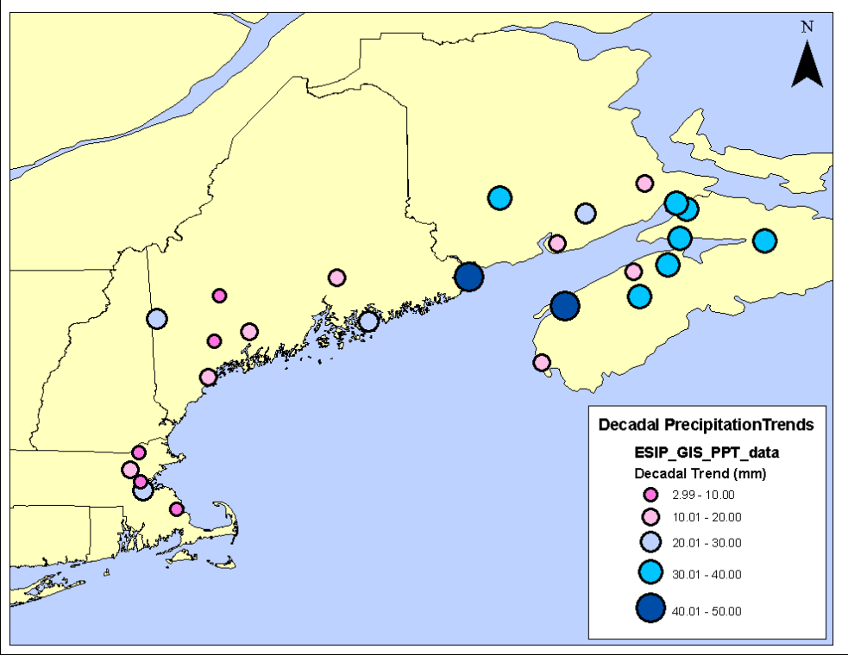

**Figure: Decadal precipitation trends for the Gulf of Maine.**

**Page 4**

**Focus Box/Case Study: Extreme precipitation trends and impacts on wastewater systems**

Intense precipitation events, such as those that result in more than 50 mm of rain in 48 hours, have the potential to affect significantly the region’s agriculture, built environment, wastewater treatment, and streams and rivers. The average number of extreme precipitation events for the entire region is currently 2.6 events per year; however this varies across the region with more than 4.0 events per year occurring at several coastal sites including New Brunswick and Nova Scotia.

Intense precipitation events are complex phenomena that can result from several different types of weather events. Examples include strong frontal systems where there is a large temperature contrast between air masses, tropical systems (including hurricanes), which gain their energy from warm sea surface temperatures, and air mass instability leading to the buildup of large cumulonimbus clouds (along with thunder and lightning and the possibility of tornadoes), all of which can result in localized heavy precipitation events.

In general, a storm with more energy and more moisture will tend to increase its severity and therefore amount of precipitation. When these events occur, especially heavy rainfall, they have a direct physical impacts on water management systems. Most communities have inadequate or antiquated management structures that are vulnerable to any new intense event that may occur. One example is where communities have a combined storm and waste water piping system. When extreme rainfall events occur, they may be handled by the storm portion of the pipe design but are much too large for the existing wastewater system. Such occurrences result in flow-through ofuntreated waste into aquatic systems impacting species in that environment. With an increase in intense precipitation events, communities need to plan to address the likely accompanying increase in overflow events.

**Obtaining data: Indicator Reporting Tool**

All data used for the three indicators discussed in this fact sheet are available for graphing and downloading via ESIP's Indicator Reporting Tool. The tool (available at www2.gulfofmaine.org/esip/reporting) uses familiar mapping programs to enable users to locate climate change data in the region and build graphs for the time periods of interest. Snapshots such as those provided by the tool can provide critical information in a timely fashion for those faced with making decisions quickly. Questions such as the following can be answered using the tool:

1. Is sea level rising more quickly in the Boston area versus Yarmouth, Nova Scotia?

2. How many extreme precipitation events were there in my area in 2007?

3. Has air temperature risen more quickly in the last 15 years?

**Will have image from the Indicator Reporting Tool included.**