**Coastal Development Conference Call - January 24, 2011**

**Participants:**

Chris Feurt (UNE/WERR)

Jennifer Hackett (DFO)

Anita Hamilton (DFO)

Liz Hertz (Maine SPO)

Becca Newhall (NOAA)

Betsy Nicholson (NOAA)

Daniel Savard (NB Dept. of Env.)

Marilyn ten Brink (EPA)

Christine Tilburg (GOMC - ESIP)

**Point Source Update**

This conference call made use of ten powerpoint slides to aid the discussion. After the introductions Christine Tilburg updated the group on some outstanding issues remaining for the point source indicator. She reminded the group that there had been a request to separate the point sources into industrial versus WWTP/STP. The Provincial data that was delivered had the WWTP/STP separated. Christine stated that her NPDES data pull from Diane Gould did not categorize the sources. Marilyn ten Brink suggested that Christine connect with Diane Gould to see if this would be possible. *(Action to be taken: Christine will talk with Diane Gould this week after the ESIP Steering Committee call).*

Christine also reminded the group that there had been a request to add the hydrological layers to the figure with the locations of known point sources. She did this and found the figure to be very overcrowded. She suggested that users would be able to do this using the Indicator Reporting Tool (www2.gulfofmaine.org/esip/reporting) and showed an example for the Annapolis River Valley (copied below).

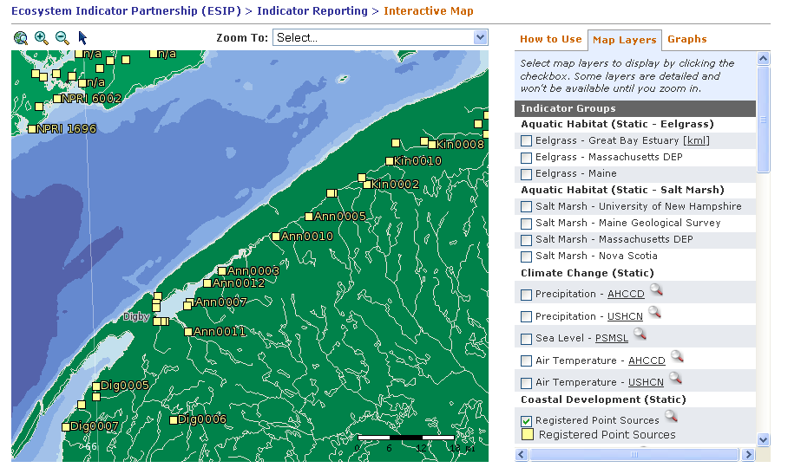

Marilyn thought that the Indicator Reporting Tool could be used in this capacity but wanted the fact sheet to include a focus box on at least one watershed with the fluvial component present. Anita Hamilton asked if it would be possible to have different colors in the Indicator Reporting Tool showing industrial versus treatment plants. Christine stated that already the Indicator Reporting Tool is using around 20 different colors for symbols associated with all of the ESIP indicators. However, when the user clicks on a site the lat/long pull up at this time. Perhaps the type of facility could also be called up at the same time. She will look into this. *(Action to be taken: If we do obtain the facility type information, import that into the Indicator Reporting Tool).*

**Employment and Population Density**

The group then discussed the population and employment data. Christine stated that Laura Hayes (USGS) and Jennifer Hackett (DFO) are working with recent Census and StatsCan data at the census tract level to obtain information at the fine scale for the two most recent decades. She suggested that these two indicators be approached at two different levels. The most recent data would be analyzed at the fine scale. Unfortunately, census tract level does not extend back very far digitally. She suggested using the coarser/county level data to bring in all of the data from the 1700s that is available. Marilyn thought that this is a good approach as users could work with the fine scale data for making decisions while the coarser data would show trends. Liz Hertz agreed with this.

There was some discussion regarding why employment data is considered important with Marilyn focusing on the weight that economic drivers have in decision making. She stated that employment density links into the economic part of the equation.

Christine asked if the group felt all of the population or employment for a county should be used, even if the county itself does not fully lie in the Gulf of Maine (as opposed to including a percentage of the total). Liz stated that it is necessary to represent how the data is delivered and use the full numbers. However, the figure also needs to include the full counties.

The group discussed some work being done by the NOAA Coastal Services Center. Betsy Nicholson agreed to forward the information to the full subcommittee. Daniel Savard also asked that some information be forwarded regarding an upcoming meeting in Quebec.

**Next Steps**

Christine suggested that the next call be held in March and look at the coarser population and employment data. The group agreed with this approach.