**Coastal Development Conference Call - October 19, 2009**

**Participants:**

Chris Feurt (UNE/WERR)

Liz Hertz (Maine SPO)

Justin Huston (NS Department of Fisheries and Aquaculture)

Dave Mountain (Boston University and Town of Newbury Planning Board)

Betsy Nicholson (NOAA)

Marilyn ten Brink (EPA)

Christine Tilburg (GOMC - ESIP)

Carol Tukey (Topsham Maine Planner)

**Point Sources**

After greetings "around the table" subcommittee members on the call discussed the effort to bring together point source information for the States and Provinces. Christine Tilburg went over the information she has (shown in the slide below).

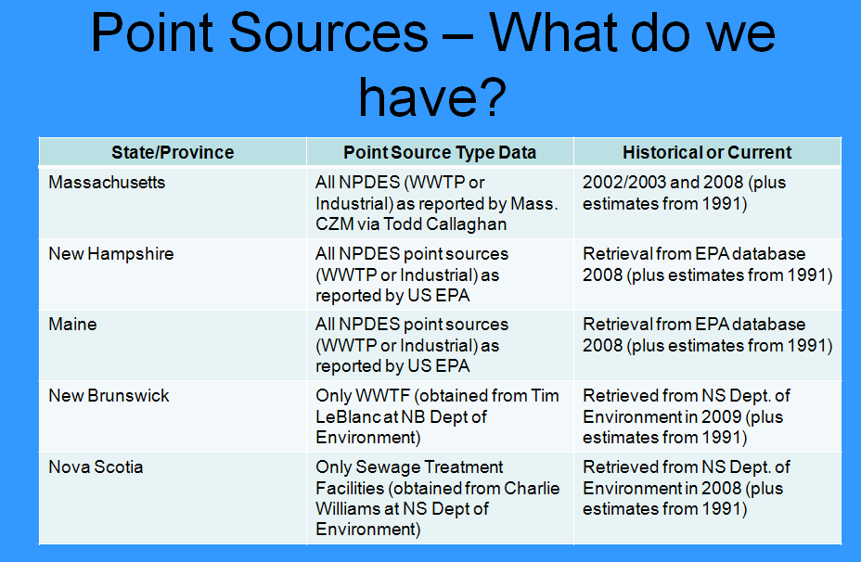

Marilyn ten Brink asked if discharge information was available. Christine replied the she only has lat/longs and permit IDs. She's been informed by multiple individuals that she would need to go through each permit individually to obtain discharge or monitoring information. David Mountain asked if there is a way to treat this indicator as a work in progress. **Perhaps presenting as a focus box the information for 2008.** He wondered about the large difference in the number of discharges according to the 1991 report (2024) as opposed to the recent set of data (860). Christine stated that she thinks a lot of the difference in these numbers is due to differences in spatial coverages/definitions. She thinks it would be misleading to present total 1991 values to total 2008 dates. Marilyn wondered if it would be better to present the information in a table or map. Members on the call thought a map might be better. It was suggested that Christine look at the 1991 locations mapped to the 2008 locations and compare the differences. *(Action to be taken: Christine will start the mapping process with the Maine points).*

**Watersheds**

Christine then discussed the watershed delineation effort that the Eutrophication Subcommittee has just completed. She stated that portions of the coast were not included in the various watersheds if they did not possess features of interest to the eutrophication/nitrogen loading effort. Justin Huston mentioned that areas like the portion of York County around Wells Harbor that aren't included are problematic from the coastal development point of view. Carol agreed stating that a lot of population would be left out if we disregard these portions of the coast. Chris Feurt suspected that the Coastal Development Subcommittee has different interests that the Eutrophication subcommittee.

Chris also though that Wells Harbor might not include the correct portion of the landscape. Dave Mountain also thought that the Merrimack River might have been left out and should be included. Marilyn proposed that Christine and she connect later about how to capture the remaining watersheds. *(Action to be taken: Christine will connect with Marilyn in the coming weeks).*

Justin commented that it's important to be consistent with jurisdictions for watershed delineations. He stated that Nova Scotia has officially delineated watersheds. *(Action to be taken: Christine needs to obtain the official watershed delineations for Nova Scotia - look into obtaining the official watersheds for other States and Provinces).*  Liz stated that Maine also has official watersheds. Christine stated that Dave Courtmanche (a member of the Eutrophication Subcommittee) assisted with the Maine delineations. Liz felt that Dave's input would be satisfactory.

**Employment and Population Data**

Christine then suggested that the group look at the employment and population data. She presented several slides that looked at the data from a watershed OR county persective. Marilyn asked what seasonally adjusted data means. Christine stated that it is a statistical treatment of the data that removes seasonally fluctuations in the work force. This is in fact **the opposite** of what the subcommittee was hoping to utilize. However, given that this is the format the data is delivered in - it will likely suffice to include text about the magnitude of seasonal fluctuations in employed individuals.

Dave also pointed out that by prorating the areas the populations might be underestimated. Marilyn agreed that this might be true. She stated that the subcommittee could provide opportunities for looking at finer scales by referencing to other documents (perhaps through the ESIP library). She also stated that workshops or case studies could provide information at a finer scale.

Regarding the employment graph example, Dave didn't know if he believed the year to year data was presented in an appropriate fashion. He wondered if the economy fluctuated to such a large degree. Liz Hertz commented that with respect to Maine data, there was a huge economic meltdown in the 1990s. She wouldn't be surprised to see large variations in the employment data.

**Presenting Data Based On Watersheds**

Christine asked the group if they still felt that presenting data by watershed was more appropriate that presenting data by counties. Justin asked for clarification regarding how the numbers were worked up. If 50% of a county was included in a specific watershed, then the total population (or employment) numbers for that county were then multiplied by 50%. Chris wondered if watersheds are appropriate when speaking with managers. Marilyn stated that one of the reasons the decision was made to go to watersheds was the value in keeping the environmental unit intact.

**Time Scale**

Justin commented that the challenge with respect to the data is getting the Canadian information together. He feels that going back to 1900 makes sense. He does not know what the value would be in going further back. Dave agreed. Dave stated that much of the population boom in the region was directly tied to highway construction. With respect to Massachusetts, the whole population hasn't changed greatly. However, there has been large scale movement across the state. Justin agreed that the same thing (referred to as coastal pull/urbanization trend) was true in Nova Scotia.

**Next Steps**

Christine suggested that she follow up on the watershed and point source suggestions. She'll also plot the employment and population data for each watershed. She hoped that the subcommittee could come back together for a call in December. Members on the phone thought that these were the logical next steps.