**Coastal Development Conference Call - October 31, 2011**

**Participants:**

Justin Huston (NS Department of Fisheries and Aquaculture)

Julia Knisel (Mass CZM)

David Mitchell (NS Department of Fisheries and Aquaculture)

Becca Newhall (NOAA)

Daniel Savard (NB Dept. of Env.)

Marilyn ten Brink (EPA)

Christine Tilburg (GOMC - ESIP)

Carol Tukey (Town of Harpswell)

*\* Slides were prepared for use with this conference call*

**Point Sources**

Following introductions around the conference call "table" the group immediately started with discussion of Slide 2: Point sources. The slide contained a table showing each State or Province along with number of wastewater facilities and industrial facilities, when the data was available. Christine Tilburg stated that she has been unable to track down industrial data for New Brunswick. ***(Action to be taken: Christine will send a reminder to Daniel Savard regarding this hole in the data and the individuals she initially contacted).*** Marilyn ten Brink reminded the group that there have been discussions regarding how to include the metadata for this information. Christine stated that the information on the source of the data will be provided below any table or figure in the fact sheet. In addition, that information will be available through the Indicator Reporting Tool also. Marilyn had some concern about listing when the data was pulled and how frequently the source is updated. **These two items need to be included in the metadata.**

**Coarse - Population**

Christine reminded the group as to the history of the coarse population indicator data. Fine scale population information (at the census track level (US) or subgroup level (CA) is not available except for recent census years. The group had agreed to present full county data (for counties that are either fully or partially within the Gulf of Maine watershed) from 1900s to present (if available). Becca Newhall stated that it isn't immediately obvious what counties are included in this definition and it was agreed to list out each county. ***(Action to be taken: Counties to be included in figure descriptions).*** Marilyn stated that it is important for the subcommittee to articulate the questions that the indicator is supposed to be addressing.

Christine walked the group through Slides 3-6. Becca stated she found Slide 5 (Percent change by decade) to be slightly confusing. She thought that presenting the data as bar graphs might be more effective. She found the information interesting (NH's surge in population). She also mentioned that it is important to minimize the number of tables as most people don't understand tables. Marilyn stated that she does not Slide 6 as it's difficult to see shifts up and down because of the log scale. Daniel agreed.

Daniel stated that he found the percent change slide (Slide 5) to be interesting as it shows sustained growth and has implications in terms of infrastructure, etcetera for New Brunswick. Becca wondered if each decade could be shown in a similar fashion to Slide 10. That would illustrate how much population is increasing and also allow the reader to more easily separate states and provinces. This would possibly lead to five separate small figures. Daniel stated that the problem is that the values for the Provinces are so small.

Justin Huston stated that it would be best to show a figure for total population changes and one showing percent changes. Perhaps this could be covered with text below graphs showing percent changes by decade (similar to Slide 11). Daniel wondered if a pie graph would be more useful.

Marilyn stated that these kinds of figures also help underscore the fact that regulatory changes in Massachusetts will have greater impact on the coast than other States or Provinces that have fewer individuals. Becca agreed that in terms of coastline Maine has the greatest but Massachusetts' population effects have a greater impact when regulations are changed. Daniel stated that this was a good point. Marilyn wondered if a table such as the one below might be best (especially if combined with a pie chart?) (see below).

Becca felt that it was important to show how total population has changed by decade. She wondered if a pie chart or other chart could be included in a column.

Marilyn stated that it might be more efficient/helpful to hammer out what questions should be answered with the indicators in an e-mail discussion. Then the figures could be revised/fine-tuned based on the discussion. Daniel liked this idea and stated that a webinar might be helpful too. ***(Action to be taken: Christine will start the e-mail discussion once these notes are sent out. Once the questions have been discussed a conference call (or webinar) will be scheduled for December or January).***

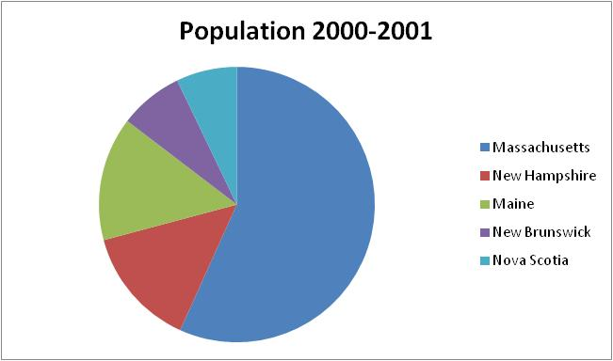

|  |  |  |  |  |
| --- | --- | --- | --- | --- |
| **State/Province** | **Population (year)** | **Length of Coast** | **Amount of landmass** | **Percent change over 1980-2000** |
| **Massachusetts** | **4974945 (2000)** | **?** | **11606 km2** | **11.62%** |
| **New Hampshire** | **1235786 (2000)** | **?** | **66682 km2** | **34.24%** |
| **Maine** | **1274922 (2000)** | **?** | **83706 km2** | **13.36%** |
| **New Brunswick** | **651048 (2006)** | **?** | **66682 km2** | **7.59%** |
| **Nova Scotia** | **638385 (2006)** | **?** | **28854 km2** | **16.30%** |

**Fine - Population**

Justin expressed some concern about including full counties in the coarse estimate. In particular he feels that Nova Scotia will be overestimated by the inclusion of Halifax. Christine agreed and stated that this was the reason that a fine scale (at the census track level (US) or subgroup level (CA) was estimated. Christine went over the numbers arrived at from this fine-scale analysis (Slide 12). Marilyn stated that the fact sheet should discuss the current population at the higher resolution with fairly recent changes included. The coarser scale resolution will encompass a longer time scale.

**Employment**

The group then discussed the employment density data. Becca wondered if it would be more useful to look at the number/percentage of people unemployed as that is what people hear on the news. Daniel stated that employment matters but not unemployment. The group discussed what the original intent with the indicator was. Justin stated that it was to know how many people are working in the watershed as a pressure. Julie Knisel stated that at a broader scale it's important to know how many people are affecting the coast. Showing employment signifies that pressure on the coast. Marilyn also pointed out that potential economic impact. Justin stated that he's OK looking at pure values if the purpose of the indicator is to look at employment pressure.

Marilyn asked the group what they noticed when they looked at Slide 9. Daniel stated that his take-away was that New Brunswick's impact is puny and small compared to Massachusetts. Christine stated that she likes Slide 11 (with text). Justin and Marilyn agreed that this slide best summarized the employment information.

**Next Steps**

The group agreed to have an e-mail discussion around the purpose of the population data and what questions it is important to answer with that data. A call will likely be held in December or January to finish up this indicator and to discuss best ways of showing the data spatially ***(Action to be taken: Christine will put together a figure showing spatial population coverage).***

Marilyn suggested that the NOAA tool (http://stateofthecoast.noaa.gov/) might be a good place to begin the e-mail discussions.