**Coastal Development Conference Call - September 2, 2010**

**Participants:**

Chris Feurt (UNE/WERR)

Anita Hamilton (DFO)

Al Hanson (Canadian Wildlife)

Liz Hertz (Maine SPO)

David Mitchell (NS Department of Fisheries and Aquaculture)

Kathryn Parlee (EC)

Madelaine Patterson (Coastal CURA)

Marilyn ten Brink (EPA)

Christine Tilburg (GOMC - ESIP)

**Introductions and Background**

Following introductions Christine Tilburg provided some background information on the work she has done for the subcommittee in the past couple of months. She stated that the subcommittee had not met very frequently in the past year. However, both Christine and Marilyn ten Brink (Chair) felt that the subcommittee's work will now accelerate. Christine explained that the Climate Change and Aquaculture Fact Sheets should be out before the end of 2010. She expects the Eutrophication and Aquatic Habitats Fact Sheets out in the first half of 2011 and then hopes the Coastal Development Fact Sheet will follow.

**Point Source Work**

Christine then reminded the group that during the last conference call she presented information for the point source indicator. She has collected data from several sources (see Table below) and compiled the information. Each lat/long was checked against a basemap with the Gulf of Maine's watershed delineated (see Figure below). Christine

Point source summary:

|  |  |  |  |  |
| --- | --- | --- | --- | --- |
| **State/Province** | **Point Sources with lat/long** | **Point Sources without lat/long** | **1991 Estimate** | **Notes** |
| Massachusetts | 449 | 3 | 695 | EPA delivered NPDES |
| New Hampshire | 70 | 0 | 246 | EPA delivered NPDES |
| Maine | 462 | 4 | 453 | EPA delivered NPDES |
| New Brunswick | 179 | 31 | 149 | *Only Wastewater plants - delivered by NB DEP |
| Nova Scotia | 76 | 6 | 475 | Combined from STP from NS DEP and industrial point sources |
| **TOTAL** | **1236** | **44** | **2018** |  |

*All data checked for duplicates using lat/longs and permit numbers

stated that she is uncomfortable comparing directly between the 1991 values and the more recent values. She is unsure how the 1991 values were determined. For example, she wonders if the Massachusetts value from 1991 included all of Massachusetts or only a portion.

Al Hanson mentioned that even if the values increase for the two provinces it might actually be a positive change as people move away from septic systems. There was general agreement on the call that there has been a decrease in industrial point sources. Marilyn wondered if it would be possible to segregate out sewage point sources. Christine stated that she'll look into the data for each state and province and segregate the data if possible *(Action to be taken: Christine will try to segregate the data for point sources to represent the sewage treatment plants separately, if possible).*

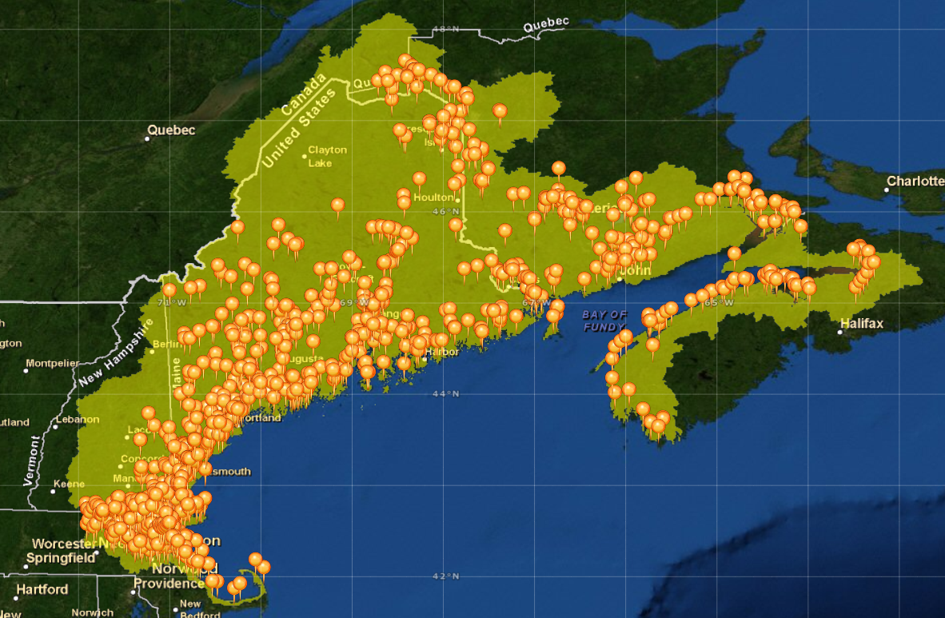

Christine asked for comments on the figure above specifically. She would like to use a similar figure in the fact sheet. Liz Hertz stated that she wasn't sure the figure was illustrative at this scale. Christine agreed that the density of point sources makes it difficult to see individual points. However, she likes the larger scale as you can see the point sources along river valleys. Liz thought it would be helpful to put the rivers on the figure. Christine wondered if blowing-up the southern section would help. The group liked this idea. *(Action to be taken: Christine will modify the figure as discussed).*

E-mail from Chris Feurt (9/6/2010): "I was very impressed by the image of the point sources in the Gulf of Maine. This kind of visual representation of cumulative impacts is powerful. Seems like we could use this type of image and combine it with graphics that show amount of discharge to work with the permitting agencies to give a more clear picture of the implications of policies."

Just thinking out loud. That is why I had the comment that this kind of information seems much more appropriate to the federal level or state level where the permits are granted.

Chris

Anita Hamilton wondered if the data will be published in a location other than the fact sheet. Christine stated that all of the data and locations will be available through the Indicator Reporting Tool (www2.gulfofmaine.org/esip/reporting). The data will be available both through the tool itself and downloadable as web services and KML (for Google Earth users). Anita stated that the real value here will be in helping individuals access this information.

**Population and Employment Density**

Christine then stated that she is ready to move forward with the population and employment densities. She needs assistance in a timely fashion from someone with GIS experience. Marilyn stated that some students at EPA ORD could probably assist. *(Action to be taken: Christine will remind Marilyn of this request for assistance).*

**Outstanding Questions**

Christine then asked if there are any outstanding questions. Marilyn wondered if the scale we are looking at data is really useful for municipalities. She wondered what the roadblocks are for those individuals trying to access data. Liz stated that if we look at the question from a municipal viewpoint she is not sure what additional information ESIP provides. Christine stated that this is a question ESIP frequently wrestles with. ESIP's users are defined as decision-makers from all scales. She feels there is value in being able to compare local areas to the larger region. Kathryn Parlee later e-mailed the following comment: "I was curious about the discussion regarding the value of the indicators to municipalities. I don't work directly with municipalities but it would seem to me that being able to see/track point sources within a watershed or along a river system would be useful for downstream municipalities. I would think that downstream municipalities with existing water quality problems or concerned about potential water quality problems would be interested to see upstream inputs, and could use this information to develop municipal water quality monitoring programs (i.e. what sort of contaminants they might want to monitor for) or highlight to county/state/province wide authorities the need to look at policy surrounding effluent?"

Marilyn wondered if the delineated watersheds should be part of the figure. Christine stated that it would be possible - but not all watersheds are delineated. Christine wondered if a focus box on a specific watershed might be helpful. Liz stated that this might be helpful.

Chris Feurt stated that she thinks users of this type of data are higher-up than individuals at a municipal effort. Christine agreed that she thinks the users will be more focused on regional issues. Marilyn stated that a part of the fact sheet should focus on scale issues.

**Next Steps**

The group agreed to have another conference call in a couple of months to look at the further work Christine will do on point sources and (hopefully) the initial population and employment density data.