Fisheries Conference Call – April 3, 2014

Participants:
Tony Charles (Saint Mary’s University)
Graham Goulette (NOAA)
David “Moe” Nelson (NOAA)
Laurel Smith (NMFS)
Christine Tilburg (GOMC)

Dominant Species Metric
The call opened with a brief reminder as to the state of the dominant species indicator. Christine Tilburg reminded the group that during the last call it was requested that she expand the figures (in terms of landings and dollar value) to four or five species. David “Moe” Nelson asked whether the Massachusetts values represented only the Gulf of Maine. (Action to be taken: Verify that all Massachusetts landings are included. Christine checked 4/3/14. All of Massachusetts landings are included. Discussion on 9/5/12 centered on the amount of Massachusetts landings that needed to be included. Subcommittee members felt that excluding New Bedford landings would greatly skew the data.)

Members on the call felt that both dominance by weight and landed value are important in telling the full story with respect to fisheries in the Gulf of Maine. Some of the figures produced for the call had six species included (as opposed to five). The group felt that limiting the figures to 5 species would be helpful. It was felt that readers could easily note how much catch is covered by a limited number of species. Christine suggested that she put the correct figures in with the notes from this call. The figures are added to these notes. *The colors for each species remain the same throughout the States and Provinces – example: Black fill is always lobster.

Census of Marine Life – Gulf of Maine
Christine then started the conversation with respect to this subcommittee’s final two indicators: diversity and population by subregion. Christine stated that the Census of Marine Life effort appears to look at these two metrics in detail. Her preference would be to use that information instead of recalculating specifically for ESIP’s fact sheets. The group felt using the information put together for the Census of Marine Life would be more efficient and practical. Christine suggested that she write a quick two-pager about how the Census of Marine Life addressed these two indicators. During the next call the group can read through the document and discuss whether this plan would work. (Action to be taken: Christine will write a brief summary of the Census of Marine Life results with respect to these two indicators).

New Brunswick & Nova Scotia

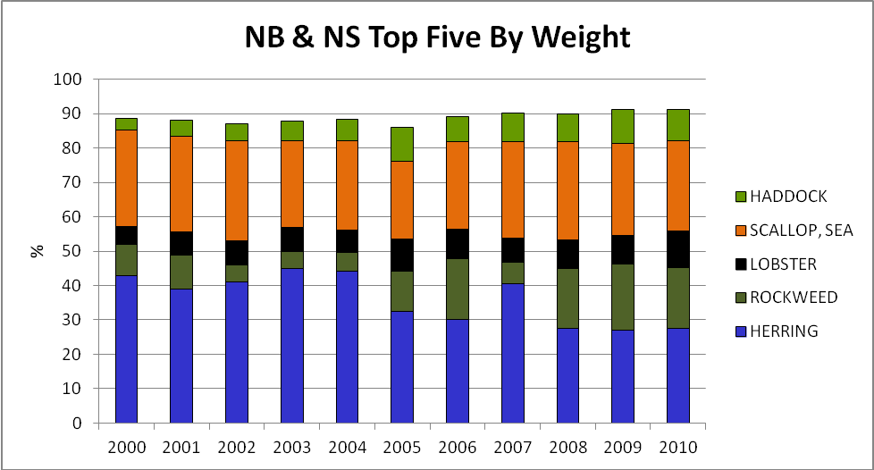

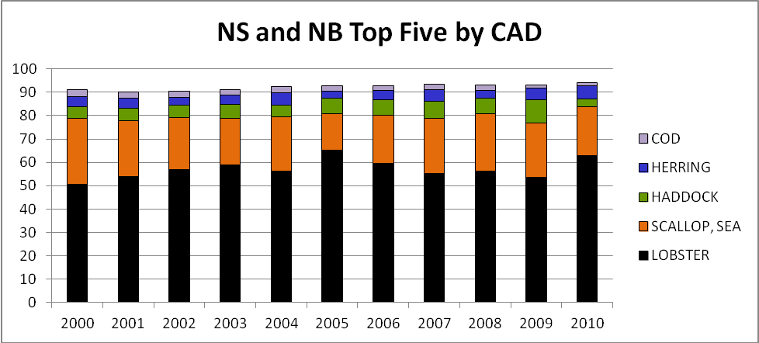

Maine

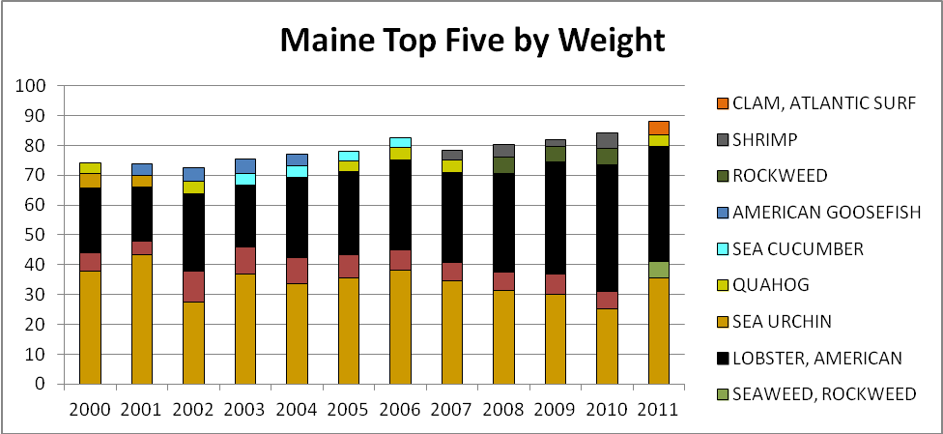

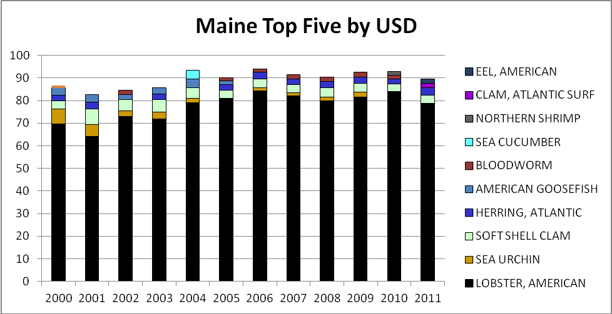

New Hampshire

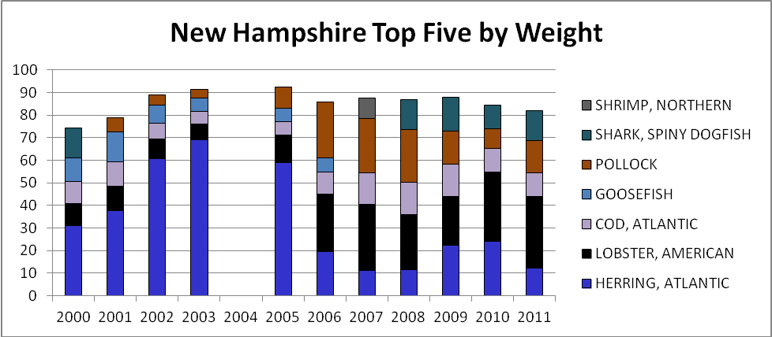

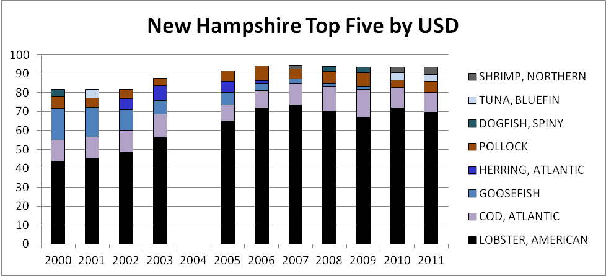

Massachusetts (Full state)

