**Eutrophication Subcommittee Conference Call - October 30, 2009**

**Participants:**

Chris Deacutis (URI)

Mike Doan (Friends of Casco Bay)

Jim Latimer (US EPA)

Richard Moore (USGS)

Marilyn ten Brink (EPA)

Christine Tilburg (GOMC - ESIP)

Phil Trowbridge (NH DES)

*0.75 hour in-kind added for all participants.*

***\* This conference call made use of a series of slides.***

**SPARROW**

Jim Latimer went over the SPARROW results for both nitrogen and phosphorus. There was some discussion regarding SPARROW's tendency to over predict for low gradient coastal rivers. Keith Robinson confirmed that the calculation is on the high side for these types of areas. Jim mentioned that in comparing the results from the NLM model for Great Bay to the SPARROW results there was a 25% difference. Christine Tilburg asked what other estuaries in the air the NLM has been used with. Jim thought that Great Bay is the only estuary contained in ESIP's area that has NLM calculations.

Christine mentioned that several individuals have asked about the Merrimack River. Jim reminded the group that they only considered the estuaries of interest. The Merrimack doesn't really have an embayment associated with it.

Phil Trowbridge mentioned a spreadsheet model that they are also using for Great Bay. The model requires stream flow information, good salinity data, and off-shore salinity data among other parameters. So far he's having pretty good success calculating the predicted loading.

Christine reminded Jim that she had previously sent the information for stream gauges in Canada. Jim agreed to follow up with the data.

**Dissolved Oxygen - Continuous Sondes**

Christine then stated that she needs guidance regarding presenting the continuous dissolved oxygen data. The group discussed the datasets listed on the slide captured below. With respect to the NEERS, SWMP data for Wells and Great Bay it was suggested that she not wait for Jeremy Miller and Michele Dionne to send the data. *(Action to be taken: Christine will try to obtain data from the centralized NOAA data management office.)* The CICEET data was removed from the list as those samples are actually grab samples. Phil agreed to send the NH data. With respect to the GoMOOS buoys, the group decided that only the nearshore buoys would be of interest (there might be only one of these).

The group then discussed the need to keep surface and bottom samples separate. Christine stated that she is having trouble imagining how this data will be presented. Jim thought that there are two ways of presenting the data:

1. For a few select sites, the dissolved oxygen information will be looked at over time through the continuous sondes.
2. The grab samples will provide a more widespread data set (over space)

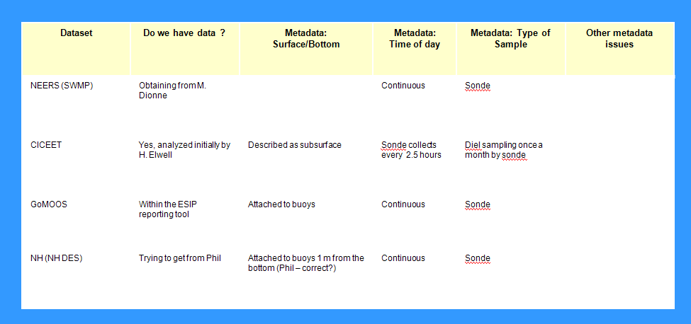

Chris Deacutis asked if anyone is familiar with the MATLAB protocol written by Dan Codiga (at URI). A routine has been written that takes data out of time series based on the type of event that has been designated. For example, it can be used to determine how many times the values went below a certain number and for how long. Chris stated that he'd forward a recent paper written on the subject. Jim thought that this program is good for looking at the data but wondered if it would be good for our audience. The group thought that if the audience is composed of managers, they might be more interested in knowing how frequently the numbers dip below a threshold. However, care has to be given to not "prescribe" a threshold. Christine thought that staying away from the term "threshold" might help. Chris stated that more and more people are becoming comfortable with the idea that below 4 there are problems. Jim thought that the MATLAB information might be good in another focus box.

It was suggested that Christine start with the few examples where continuous sonde data exits. Figures can be prepared looking at daily dissolved oxygen minimums and daily average for % saturation from July - September. She was cautioned to only look at days where a complete record exists.

Christine wondered how far back in time the group is interested in. Jim stated that he is personally interested in changes over significant lengths of record. However, he worried about the amount of work involved. Phil stated that the work has already been done for Great Bay back to 1998 and it was not a tremendous effort.

**Next Steps**

Christine suggested that she try to work through the continuous sonde data and have another call in early December.