Contaminants Conference Call March 3, 2010
Participants:
Adria Elskus (U Maine/USGS)
Diane Gould (EPA)
Gareth Harding (BIO)
Steve Jones (UNH)
Wendy Leo (MWRA)
David Page (Bowdoin)
Charlie Strobel (EPA)

Shellfish Sanitation Data
Following greetings the subcommittee members began discussing the Shellfish Sanitation data table that Christine Tilburg drafted for the call. There were some questions regarding the units of the various columns (km² or acres). Christine agreed to verify and correct any unit issues. (Action to be taken: Christine will look into inconsistencies with the units). There was also some confusion regarding a New Hampshire number that seemed suspect. Steve Jones agreed to look back at the file for the correct number. (Action to be taken: Steve will verify New Hampshire values).

Christine asked how the information might be best provided in the fact sheet. The group discussed the possibility of using tables or charts. Diane Gould wondered about providing a map with bar graphs of the information. The group felt that this might be the best approach. (Action to be taken: Christine draft some figures as discussed).

David Page wondered about the values provided for different States and Provinces. He's curious as to why some of the States and Provinces have lower percentages of open shellfish beds. The group also discussed the differences between conditionally approved, restricted, or conditionally restricted. Christine agreed to go back to the data originators and ask for some written explanation of the values. (Action to be taken: Christine will search out answers regarding the percentages approved).

Gulfwatch Data
Christine then mentioned that she has the Gulfwatch QA/QC'd data from the 1990's through 2008. She's also working to have all of the data input into the Indicator Reporting Tool (www2.gulfofmaine.org/esip/reporting). This is great news for both the Gulfwatch and ESIP teams. David Page asked about the 18 year report that is in draft form for the Gulfwatch data. David thought that it would be best to use the data analysis already completed for the writing of the report and translate it to fit ESIP's needs. The group agreed that this was an efficient and possible way forward.

Sediment Triad Data
Christine stated that this agenda item was suggested by Peter Wells. As Peter wasn't on the call, the group agreed to shelve it. David did state that although true sediment quality data is not common, one can analyze sediment data and supplement it with additional information. Christine suggested that there might be better ways to present the data that triangle diagrams - which according to at least one caller "are real snoozers." It was suggested that Christine look at some of the ways NOAA, EPA or Phil Trowbridge (PREP) have presented the data. Christine had been working on an idea that is sketched out below:

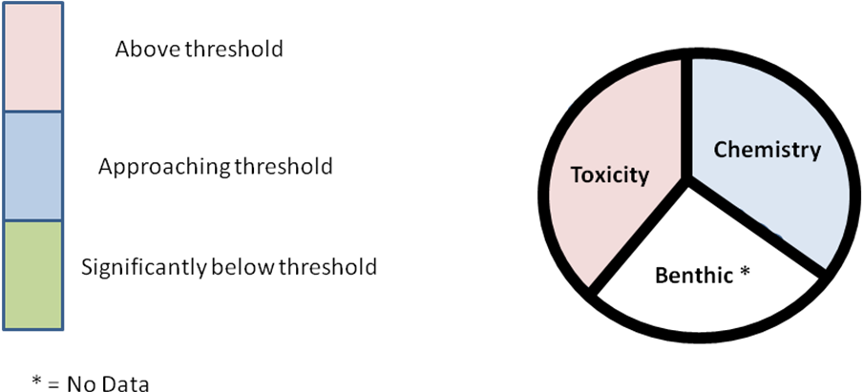

Next Steps
The group discussed a follow-up conference call at the end of April/beginning of May. Christine asked if the group was interested in using Google's Doodle planner for finding a convenient time for this call. The group decided to give it a try on the great reviews from Adria and Diane. Christine will present the shellfish data in figure and tabular form at the next call.

