**EcoSystem Indicator Partnership**

**Working Together for a Healthy Gulf**



# What is the Ecosystem Indicator Partnership?

**Priority indicators**

**The ESIP toolbox**

**Be part of the answer. Be part of our team.**

**Gulf of Maine Council**

### Aquaculture

Two web tools for accessing information on environmental indicators and monitoring environmental health in

Nearly 20 years ago, the premieres of New Brunswick and Nova Scotia, and the governors of Maine, Massachusetts, and New Hampshire

**A sea beside the sea**

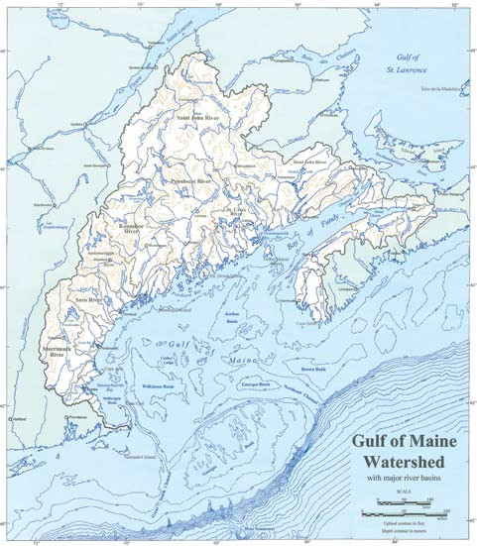

The Gulf of Maine is bordered by Massachusetts, New

The Ecosystem Indicator Partnership (ESIP) is a committee of the Gulf of Maine Council for the Marine Environment (GOMC).

* Production/area for aquaculture
* Economic value of aquaculture

Gulf of Maine are now available on the ESIP web site.

ESIP has identified key indicators for each theme area and has analyzed and released fact sheets for four themes. Two more will be released in 2013 and 2014: Contaminants and Coastal Development.

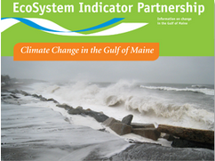 recognized the beauty and diverse array of wildlife habitats in the Gulf of Maine and the reliance of the region on its natural resources. They formed the

the Gulf of Maine Council on the MarineHampshire, Maine, New Brunswick, and Nova Scotia. It covers 93,000 square kilometers (36,000 square miles) of ocean and has 12,000 kilometers (7,500 miles) of coastline.

### Aquatic Habitats

**Monitoring map**

Environment (GOMC) to maintain and enhance

This committee is made up of more than 100

expert advisors from local, state, provincial, and federal governments, along with academics and partners from non-government organizations. We are committed to identifying key indicators for

* Extent of eelgrass
* Extent of salt marsh
* Locations of tidal restrictions

The map displays information on all known monitoring locations for the seven theme areas within the Gulf of Maine. It identifies what is being monitored and provides information on where the data can be found.

Environmental quality in the Gulf of Maine and allow for sustainable resource use by existing and future generations.

The Gulf of Maine is one of the world’s most biologically productive environments. Its marine waters and shoreline habitats host some 2,000 species of plants and animals. Land and ocean

seven theme areas, compiling the relevant data,

and engaging decision- makers in using

environmental indicators and trends when making

choices related to the Gulf of Maine.

### Climate Change

* Sea level change
* Precipitation trends and anomalies
* Air temperature trends and anomalies

#### www2.gulfofmaine.org/esip/map.

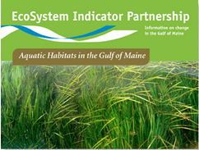

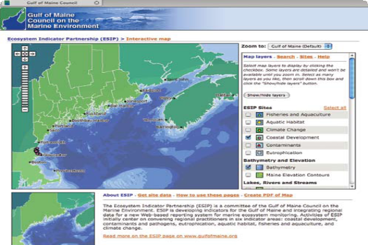

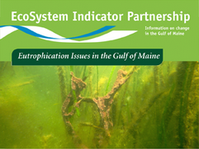 processes interact to regulate temperatures and bring nutrients to this rich region of the ocean.

GOMC mobilized regional resources to devise what had previously not existed: a suite of scientifically

### Coastal Development

objective methods for assessing the state of the environment of the Gulf of Maine and for evaluating the short- and long- term responses to best management practices. This was in reaction to observing increasing negative impacts of water use, waste management, community development, fisheries, recreation, and tourism, on the health of the

* Point sources/Known discharge
* Population density
* Employment density
* Impervious surface coverage

### Contaminants

marine and coastal environments in recent decades.

GOMC formed the Ecosystem Indicator Partnership to work collaboratively with

* Shelfish Sanitation data

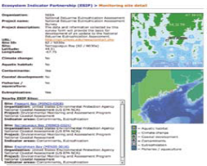

* Gulfwatch/Mussel Watch data

|  |  |  |
| --- | --- | --- |
| **Indicator Area** | **Parameter** | **What’s needed** |
| Aquaculture | Lease areas and economic value | Need data for New Hampshire |
| Aquatic Habitats | Tidal restriction | Need data for Massachusetts |
| Coastal Development | Impervious surface | Need data for Nova Scotia and New Brunswick |
| Contaminants | Sediment triad (toxicology, chemistry, and benthic community) | Need data for Nova Scotia and New Brunswick |
| Eutrophication | Grab samples for chlorophyll a and secchi depth | Need data for Nova Scotia and New Brunswick |
| Eutrophication |  |  |
| Stream gauge | Need data for Nova Scotia and New Brunswick |
| Eutrophication | Nitrogen loading | Need data for Nova Scotia and New Brunswick |

* Sediment contaminant concentrations

### Eutrophication

regional experts in order to develop just

such a suite of indicators, as well as to integrate

regional indicator data and make it easily

accessible for decision-makers through a web-

based reporting tool.

* Nitrogen and Phosphorus loading
* Water clarity
* Dissolved oxygen
* Chlorophyll a

## Indicator reporting tool

### Fisheries

This tool provides easily accessible data

ESIP’s initial focus is in seven indicator areas:

* Aquaculture
* Aquatic Habitats
* Climate Change
* Coastal Development
* Contaminants
* Eutrophication
* Fisheries

There is a subcommittee for each of these areas. Relying on a consensus-based process, these subcommittees selected priority indicators for each of the indicator areas.

* Ocean jobs
* Dominant species metric
* Two others in progress

For the selected priority indicators. It

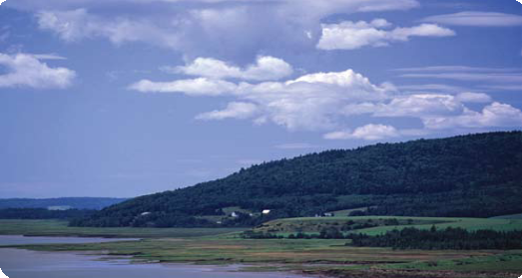

enables users to display and visually assess data, and provides a graphing function to view status and trends at specific sites or for specific time periods. Data are automatically updated on a regular basis, providing the user with the most current information. **www2.gulfofmaine.org/esip/reporting.**

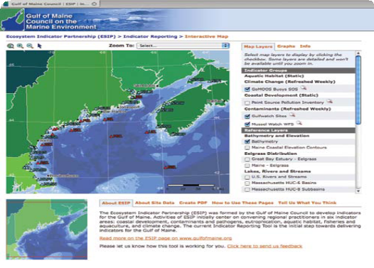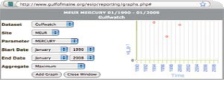

Contribute to a better understanding of the Gulf of Maine and improve the quality of this beautiful and precious environment. For today. For tomorrow.

## Ways you can contribute

* Join a subcommittee.
* Provide data for this group of indicators.
* Submit short articles, insights, and ideas for ESIP’s monthly Journal Entries.
* Direct your colleagues to the ESIP web site and tools.

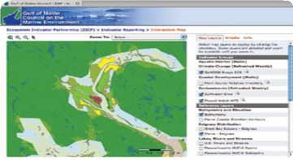

**EcoSystem Indicator Partnership**

**Information on change in the Gulf of Maine**

For more information on any of the ESIP products, please visit our web site at **www.gulfofmaine.org/esip.** You may also contact the ESIP program manager at [**ctilburg@securespeed.us**.](mailto:ctilburg@securespeed.us) We always welcome new members to our work.