Aquatic Habitat Extent Conference Call - December 10, 2010

Participants:

Seth Barker (Maine DMR)
Robert Buchsbaum (Mass. Audubon)
Jim Latimer (EPA)
Christine Tilburg (GOMC - ESIP)

* 0.5 hours of in-kind was added for each participant on this call.

Salt Marsh Update
After initial greetings the group began discussing the revised salt marsh figures that Seth Barker produced. Seth stated that Massachusetts and Nova Scotia's delivered files were limited to the geographic extent of the Gulf of Maine watershed. There was some discussion of how this watershed has been defined. Christine Tilburg stated that the watershed layer (below in lighter green) was created by the Gulf of Maine Council's State of the Gulf Report team when they determined that there was no previously defined watershed layer available. The group thought that the watershed delineation on Cape Cod

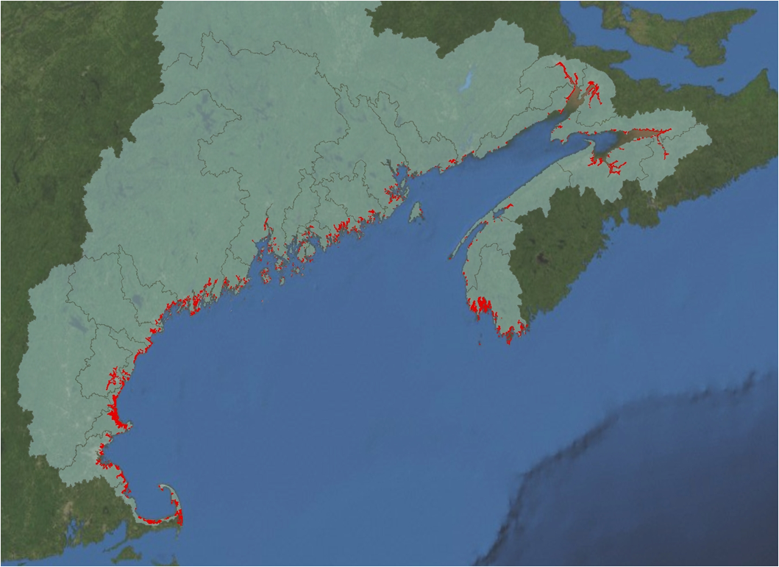

is quite arbitrary, but as Christine wants to keep the same layer used for all of ESIP - everyone agreed that it was acceptable.

Specific to the salt marsh, Jim Latimer asked if the file is showing only presence/absence. Seth stated that it is. Christine mentioned that in the Indicator Reporting Tool (www2.gulfofmaine.org/esip/reporting) several of the salt marsh layers are available as more than presence/absence. For example, users can see for New Hampshire the following layers: salt marsh, salt marsh/open water, salt marsh/dead trees, etc).

The group also discussed the acreages associated with Chatham and whether they should be removed from the calculations. The group agreed to remove the Chatham acreage (Action to be taken: Christine will revise figures and calculations minus the Chatham acreage).

Regarding the comparison to historical values found in the literature, Christine stated that she is comfortable with the values Seth has produced from the GIS figures. Some of the differences in calculations might be due to different definitions of the Gulf of Maine and older aerial photography. Robert Buchsbaum mentioned that the value for Massachusetts seems closer to a reference he has from 1985 (Alan Hankin et al - Christine has a PDF of this file in case anyone is interested).

Tidal Barriers Update
Christine then updated the group on the work that Jen Steele (intern: Dalhousie) has been doing this semester on the tidal restriction data. She stated that a call will likely be held in February 2011 to look at the results from Jen's work.

