Aquatic Habitat Extent Conference Call - October 18, 2010

Participants:

Seth Barker (Maine DMR)
Robert Buchsbaum (Mass. Audubon)
Giancarlo Cicchetti (US EPA)
Chris Deacutis (URI)
Naomi Detenbeck (EPA)
Jim Latimer (EPA)
Randy Milton (NS DNR)
Christine Tilburg (GOMC - ESIP)

* 0.5 hours of in-kind was added for each participant on this call.

Salt Marsh Update
After initial greetings the group began discussing the salt marsh figure and Excel files that were sent out prior to the call. Seth Barker did the GIS work for the subcommittee and briefly explained the file that summed acres of salt marsh. He stated that many of the files included landscape other than salt marsh and therefore he isn't completely sure that he has the correct classifications included. He requested that individuals on the call do a reality check with the proposed values and their knowledge. He stated that checking against published values would be helpful - though more difficult for the States or Provinces that have coastline outside of the Gulf of Maine. Randy Milton stated that he would check the value for Nova Scotia. (Action to be taken: Christine will check the values against published literature for the next call).

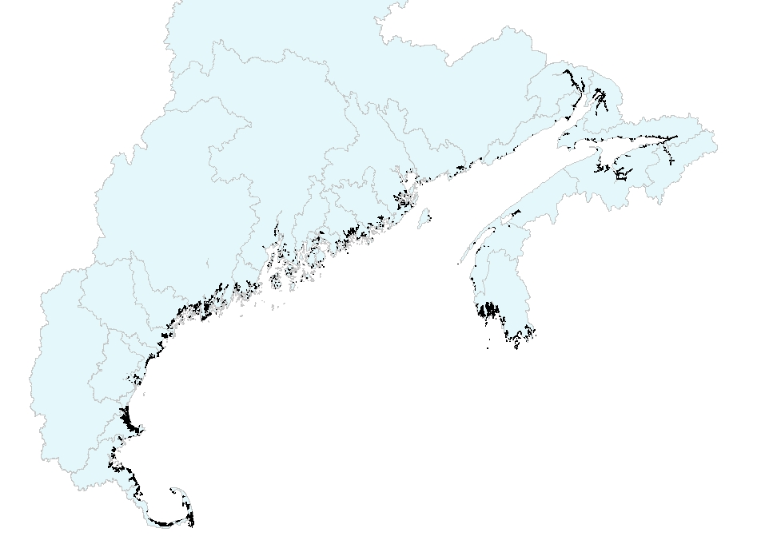

Christine Tilburg wondered about the Nova Scotia classifications. The group generally thought that the classifications stood for high marsh, low marsh - but further details are needed. Randy stated he would look into the metadata and send the correct classifications on to Seth and Christine

Christine also mentioned that she has some concern regarding how old some of the GIS layers are. She stated that the Maine data uses photography from the 1960s and that Massachusetts' layer uses imagery from 1993 (Robert Buchsbaum confirmed this - although the analysis itself was revised in 2005). Giancarlo Cicchetti agreed that this might pose a problem. He also stated a concern with methodological differences. The New Hampshire values look odd and he wondered if the reason for this involved different methodologies. Chris Deacutis agreed the NH values looked odd. Seth stated that the sum acres for New Hampshire and Massachusetts were provided within the files while the Maine and Nova Scotia values were calculated. Robert thought that the Massachusetts values look correct. Randy stated that the photography used for the Nova Scotia file was obtained in the late 1990s and early 2000s.

Jim Latimer stated that the data might need to be normalized to the coastline. Once all the data is obtained some thought needs to go into how the information will be presented.

The group generally agreed that the metadata needs to be obtained and provided for the next call. (Action to be taken: Christine and Seth agreed to locate and provide the appropriate metadata).

Tidal Barriers
Christine provided a brief update on the tidal restrictions indicator. A graduate student at Dalhousie University is working on the data as part of a semester project for a GIS class. She is obtaining the most recent information for tidal barriers for each State and Province and bringing them into a single layer and spreadsheet. Her project must be completed in December so Christine proposed having the next call in December to finish up the salt marsh information and begin the tidal marsh indicator. The group agreed with this approach.

Timeline
Christine is hoping that the fact sheet for this subcommittee is published in June 2011. She's proposed the following schedule:

December 2010: Call to finish up salt marsh and begin tidal restrictions work
February 2011: Call to finish up all indicators
March - May 2011: Draft and series of reviews for fact sheet
June 2011: Release fact sheet

