Annual ESIP Steering Committee Meeting
June 10, 2010
Portland, Maine

Attendees: Jim Cradock (Yellahoose - AM only), Adria Elskus (USGS/U. Maine), Diane Gould (EPA), Jennifer Hackett (DFO - AM only), Anita Hamilton (DFO - AM only), Pat Hinch (retired - AM only), Jim Latimer (EPA), Gary Lines (EC - AM only), Kathryn Parlee (EC - PM only), Susan Russell-Robinson (DOI), Marilyn ten Brink (EPA), Christine Tilburg (GOMC), Jay Walmsley (DFO - AM only), Peter Wells (Acadia/Dalhousie)

Introductions
The meeting opened with introductions around the table. Susan asked that each individual talk about all of their various positions (aka, their many hats). Adria Elskus commented that this was an interesting exercise and asked that a short biography be collected from each Steering Committee member. (Action to be taken: Christine Tilburg will collect bios from every Steering Committee member).

Council Interactions
Susan Russell-Robinson reminded the Steering Committee that the focus of the morning portion of the meeting was to have a discussion with chairs from other Gulf of Maine Council committees. She asked that each guest discuss how the development of ESIP indicators might be helpful to their own committee efforts. In addition, she asked for their perspective on what other products need to be released from ESIP (or the Council). Each guest was also asked to state what their top accomplishment in the past 2 years was and where they hope the committee is going.

Anita Hamilton: Habitat Restoration: Anita stated this particular committee has been partnering with NOAA and administering a specific grant program. Recent efforts have involved Jim Cradock (IT) and the committee manager (Slade Moore). Anita mentioned that there has been a strong push to push out a barrier removal tool-kit. She's hoping that there is a meeting soon for the committee to pull the partnership together. Susan stated that ESIP is starting to think of possible Tier 2 indicators. She wondered if an appropriate Tier 2 indicator might be barriers to fish passage. Anita thought that this would be very helpful. The group discussed a report on barriers that should be available on the BoFEP website. (Action to be taken: Christine will look for this report and forward it to the greater group). Adria mentioned that there is a Center for Excellence in Massachusetts that might be of interest.

The group continued to discuss inventories of coastal barriers including the report by BoFEP. Adria brought up Project SHARE which is attempting to map out culverts and remove them one by one (http://www.salmonhabitat.org/docs/bmp_guide/bmp_es.pdf). Susan mentioned a recent report stating that fish spawning has decreased relatively recently in the Connecticut River. She stated that she believes that the Gulf of Maine is going to become a critical habitat for many species. In essence the Gulf of Maine is becoming a cradle for many organisms.

Adria asked about the Great Waters Initiative. Susan stated that the project seems to be faltering as the original idea (Gulf of Maine as a treasure) has become diluted as more groups tried to join the project.

Gary Lines: Climate Change Network: Gary brought the group up to date with the current efforts of the Climate Change Network. He also mentioned a recent addition to the Council team that is working on communication and outreach ("The face of the Council"). Gary also stated that a recent effort (involving Keeley and Tremblay) surveyed individuals on top items of climate change importance. He discussed the critical nature of enabling communities to deal with climate change. He stated that ESIP has an important role in highlighting gaps in monitoring (ESIP 2.0 issue?). Susan wondered about Tier 2 indicators focusing on where communities have joined StormSmart Coast projects. Gary is hoping that a lot of information will start to flow with respect to climate change data soon. The challenge is how to package and deliver the information and it is his belief that ESIP is where the data can be delivered. Jennifer Hackett stated that the first step has been in trying to get the public to accept that climate change is occurring. The next step is to start to assess cumulative impacts.

The last item Gary wanted to point to involved recent activities by numerous jurisdictions to obtain LIDAR mapping. He stated that this will be another very large dataset. However, at this time the effort hasn't quite matured yet.

Peter Wells: Gulfwatch: Peter stated that the Gulfwatch data set involves blue mussel tissue samples collected over the past 17 years. The program has collected and analyzed samples following EPA standards. Current issues that Gulfwatch is wrestling with include the fact that the program is old and there are other analytes of interest. In addition, there is no funding for analysis in 2010. The project team is keeping samples and freezing them - but funding needs to be found. Gulfwatch is the only program in the Gulf of Maine that is long-term.

Demonstration of Indicator Reporting Tool
Christine then provided an update on current revisions to the Indicator Reporting Tool. The attendees then broke into three smaller groups to work with the tool on various computers. Suggestions and corrections were brought to Christine and Jim Cradock's attention and a list was created for future revisions.

Subcommittee Reports
1. Climate Change: Gary mentioned that the subcommittee is working on ways of presenting data that are quick and understandable. The current effort is to nail down solid figures and text for the fact sheet focused on sea level rise, precipitation anomalies, and air temperature. Christine stated that she wants the fact sheet out by October (when Gary retires). Gary stated that EC has hired his replacement and the individual will begin "shadowing" him soon.

2. Aquaculture: Christine presented information for this subcommittee as John Brawley was not in attendance. She stated that the information has been collected and discussed for both of the aquaculture indicators. She is hoping that the fact sheet will be out in December (perhaps for the Maine Working Group/Council meeting).

3. Eutrophication: Jim Latimer stated that the nitrogen loading and dissolved oxygen indicators are fairly complete. The subcommittee is working on crunching numbers for secchi depth and chlorophyll a.

4. Aquatic Habitats: Christine presented information on this subcommittee as there is no chair (and not one necessarily needed). She stated that the eelgrass distribution map and analysis had been completed. The salt marsh data has been collected for all States and Provinces (Jennifer Hackett discussed the agreement Christine and Jennifer signed with New Brunswick for the data layer). The final indicator involves tidal barriers.

5. Contaminants: Adria stated that the three indicators for this subcommittee are Gulfwatch/Mussel Watch, shellfish sanitation data, and the sediment quality triad. She mentioned that Christine has come up with a potential way to present the indicator data (see example below). The subcommittee intends for the fact sheet to include a case study, a focus box on economic repercussions, and a side-bar discussing the Seals as Sentinels program.

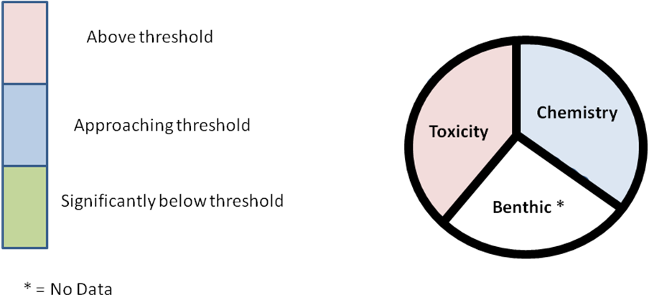

6. Fisheries: Christine again presented information for this subcommittee as there is no chair. In this case a chair is desperately needed. The group suggested that Rob Stevenson might be interested as his position responsibilities have changed recently. Susan agreed to connect with Pete Colosi (NMFS) and Jamie Geiger (FWS).

7. Coastal Development: Marilyn ten Brink brought the group up to date on the committee progress. She mentioned a need for co-chair to assist as she's getting bogged down. She brought up questions about the importance of scale and issues surrounding data availability. Susan discussed the St. Croix waterway project that has been continuing work on developing impervious surface data. A workshop is currently being planned and completion of the project is expected in the next 9 months. A request was made to ask Justin Huston to become assistant chair once again.

ESIP 2.0 Discussion
The afternoon began with a discussion of what the next phase of ESIP indicators should encompass. Christine suggested several ideas with the group focusing on the idea of between subcommittee indicators. Jim Latimer provided an example of the Buzzards Bay Health Index that incorporated numerous raw indicators. The group felt that a goal of ESIP 2.0 should be to integrate the indicators and attempt to determine how they work together. It might be that there are new indicators that bridge several subcommittees. The following was given as an example: an indicator that combines culvert removal and the number and size of fish.

Susan mentioned that the SPARROW model is an integrative indicator; it spatially represents land use patterns. She stated that the indicators need to very visual. Susan also mentioned the upcoming Coastal Zone Canada meeting in Prince Edward Island. ESIP will be presenting as part of a special session. Then next Coastal Zone meeting in the US will be July 2011 in Chicago.

Adria commented that the bridge indicators will be difficult as they might point to spurious relationships. Marilyn stated that she feels caution should also be shown due to scaling complicating issues. However, it agreed that these indicators could be vital signs of the health of the ecosystem. Susan wondered if a new data discovery effort needs to be initialized. Jim Latimer didn't know if a data discovery effort was needed but thought that a literature search on integrative indicators would be helpful. (Action to be taken: In the coming months Christine will start a literature search on this topic). Other examples of integrated indicators were discussed. One in particular is the environmental assessment indicator for streams/rivers (IBI).

David Keeley wondered if there is an organization that is a voice in the Region for continual monitoring. He suggested that NeCODP (Northeast Coastal and Ocean Data Partnership) and ESIP might fill this role. Christine thought that NERACOOS (Northeastern Regional Association of Coastal Ocean Observing Systems) is strongly aligned to fulfill this. Marilyn thought that there isn't really a spokesperson filling this role. Some discussion focused at this point on other regional organizations and their funding vehicles. David reiterated that he thinks ESIP would be a good spokesperson to agitate for better monitoring.

Susan felt that people are still very land-based in their approach to the environment. She mentioned the phrase "Today's Coast is Tomorrow's Ocean". Susan stated that her vision is that ESIP becomes the authoritative place people go to obtain information. David stated that in his opinion ESIP needs to be about communication and marketing - not new ideas. Susan stated that ESIP has become more interactive lately with the ESIP poster (allows people to write on it) and Christine's latest meeting where the audience voted on the indicators that would be presented. She would like the Indicator Reporting Tool to become more useable and user-friendly.

Spotlight Proposal
David updated the Steering Committee on the progress with the Spotlight Proposal. He asked for suggestions on groups that might be interested in partnering on the project with ESIP. He mentioned that MOP/NERACOOS/NROC/COMPASS are organizing a workshop to talk about indicators. They've hired Bob Bowen and Jack Wiggin to head the project. They will be conducting a series of interviews that will likely be helpful to ESIP. Lee Sochasky and the St. Croix Waterway Commission was brought up. David wondered about any groups looking at regional eelgrass trends. Hilary Neckles and Paul Calaruso were discussed. Peter Wells thought that BoFEP's salt marsh team might be a good partner.

With respect to climate change, NESCOM (Lisa Rector) or NEIWPCC (Beth Card) were brought up. Jim Latimer stated that he would reconnect with Beth.

Susan wondered about summer hires. Are there programs that have interns that could do some tasks? Similar to the work that Holly Elwell (intern from EPA) did a couple of years ago. The suggestion was made to define an ESIP Intern Program. Other organizations with interns might include AMERICORP and the Island Foundation. David agreed to look into the Island Foundation.

The Cape Cod Commission was also mentioned. Diane stated that ESIP needs to find a market for regional data. Why would someone choose ESIP to do even a statewide analysis? Other suggestions: Trout Unlimited, Brook Trout Joint Venture, Audubon Society, Fish and Wildlife Foundation Funds, National Parks (Acadia, Cape Cod, Fundy National Park, Campobello). Susan stated that she would look into the possibility of a park-based project.

Recognition
Susan closed the meeting by recognizing the efforts of all of the Steering Committee members over the past year. She thanked everyone for their continued passionate support and hoped that the coming year brings success.

