**Steering Committee Conference Call: April 24, 2012**

**Participants**

Heather Breeze (DFO), Adria Elskus (U Maine/USGS), Jim Latimer (EPA), Matt Liebman (EPA), Kathryn Parlee (EC), Marilyn ten Brink (EPA), and Christine Tilburg (GOMC).

**1. ESIP Panel at Maine Fishermen's Forum**

During the annual meeting in Boson it was requested that the figures provided by ESIP for discussion at the Maine Fishermen's Forum (March 2) be shared with the Steering Committee. Christine Tilburg provided the three ESIP figures that were used in the presentation.

Figure: USD in Ocean Jobs (ENOW dataset)

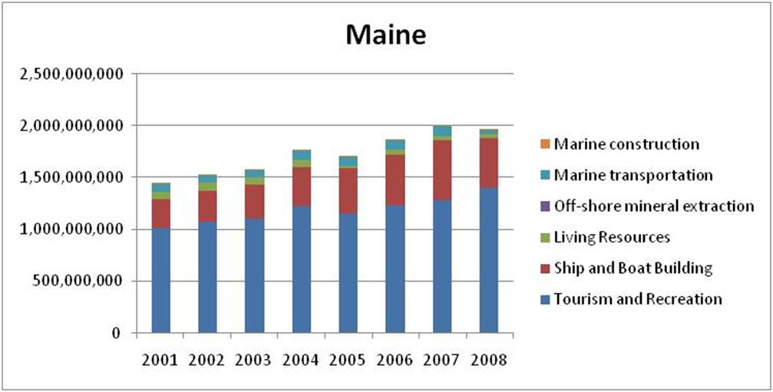

Christine stated that some of the audience members did not understand how to read the above graph. Some in the audience wondered if the sectors at the top of the column represented a cummulative number from the top of the sector down through any other colors. Jim Latimer agreed that he finds stacked bar graphs confusing. In particular it is difficult to read changes in any sector other than the bottom one. Adria Elskus agreed that it is hard to interpret trends with this type of figure. Jim stated that he prefers it when the columns are side by side.

Figure: Living Resources (USD, ENOW dataset)

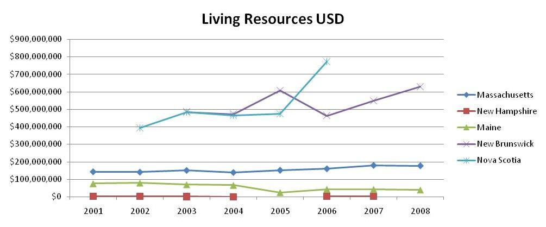

The Steering Committee also discussed the figure focused only on living resources. Christine explained that living resources includes aquaculture. She stated that the audience felt that the Maine numbers looked incorrect. Christine confirmed with NOAA that self-employed data are not currently included. NOAA staff have agreed to provide that information for inclusion.

Steering Committee members were also interested in how NOAA is providing the data. Christine agreed to provide a link to one of NOAA's tools utilizing the ENOW data: **http://www.csc.noaa.gov/snapshots/.**

Figure: % of Annual Landings (dollars) by top three species in Maine

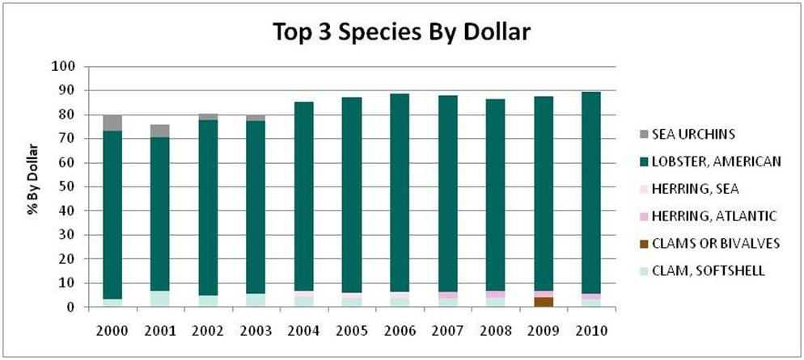

The group also discussed the figure above and the dominant species metric (percentage of harvest that is based on two or three species).

**2. ESIP and the new Action Plan**

During the March meeting ESIP's intersections with the new GOMC Action Plan were discussed. Christine has put together a table showing how ESIP relates to the various goals and outcomes. The table was included with the agenda for this call. The group discussed the importance of including the table with the June Council and Working Group briefing notes or consent agenda. Marilyn ten Brink thought that the table might be very useful in discussing the value of ESIP to the Council.

**3. Suggestions For Targeted Release of Eutrophication Fact Sheet**

The Eutrophication Fact Sheet should be released in the following week. There have been issues with importing all of the data into the Indicator Reporting Tool which have delayed the process. For past fact sheet releases a list of individuals or organizations that should be notified has been produced. Christine is looking for suggestions of targeted release for the current fact sheet. Individuals on the call suggested: Long Island Sound, NEERS, ACCESS, ACAP groups (Kathryn to send contacts), Southern NEPs (Buzzards Bay and Rhode Island). ***(Action to be taken: Christine will ensure that these groups are included in the release of the fact sheet.)***

**4. Upcoming Meetings**

Finally the group discussed upcoming meetings that ESIP can present at. Heather Breeze suggested Coastal Zone Canada (June). Kathryn Parlee agreed to get some of the hard copies of the eutrophication fact sheet to Heather. Adria suggested NAC-SETAC at the end of June. Christine agreed to send her some documents. NEIWPCC was suggested along with the Ocean Planning Summit (May 21-23). Christine agreed to look at those agendas to determine if it someone could have ESIP materials there for distribution. ***(Action to be taken: will follow up with various Steering Committee members in preparation for these meetings)***