**Steering Committee Conference Call: December 16, 2014**

**Participants**

Adria Elskus (USGS, UMaine), Jim Latimer (EPA), Matt Liebman (EPA), Abe Miller-Rushing (DOI), Kathryn Parlee (EC) and Christine Tilburg (GOMC)

**1. Directional Committee**

Christine Tilburg updated the Steering Committee on Directional Committee activities. The Directional Committee had a very productive call on December 11. The current framework can be summed up in the following diagram. Ecosystem Health (or condition) is the basis for the ecosystem services that form most of ESIP 2.0. ESIP 1.0 indicators, biodiversity, and other similar indicators are depicted in the green box at the bottom of the figure. The four subgroups are then based upon that foundation but explore important ecosystem services. Jim Latimer stated that there was a concern about discussing the ecosystem in terms of services and leaving out the “nonvalued” portions of the ecosystem. The ESIP 2.0 framework allows many of those indicators to be captured in the “ecosystem health” or “ecosystem condition” box at the bottom.

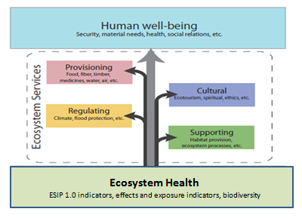

Adria Elskus asked if the focus will be on humans and services with ESIP 2.0. Jim stated that the new indicators will filter in the services subgroups or will join the ESIP 1.0 indicators in the green box. Adria wondered if there will be new subcommittees. Christine stated that she does envision new ESIP subcommittees. Matt Liebman wondered what happened to the DPSIR framework. Christine stated that ESIP 1.0 was loosely based on the DPSIR approach and many of those indicators fit into the “ecosystem condition/health” box at the bottom. Jim mentioned that the Directional Committee has provided examples of the types of indicators but the subcommittees will make final decisions after discussions and verification that datasets are available. Adria liked the idea of basing ESIP 2.0 on services as that seems to be more useful to managers. Abe Miller-Rushing wondered if the Steering Committee needs to take a step back and think about the intended audience. Christine agreed that would be helpful. In general Abe stated that he likes the framework and how the ESIP 1.0 indicators will fit in.

**2. Coastal Development Fact Sheet**

It appears that there might be funding available for the Coastal Development Fact Sheet design and printing. Christine brought the subcommittee back together to start focusing on the first draft of the fact sheet. Right now she is hoping funds will be made available from Environment Canada. If those funds come through the Coastal Development fact sheet will need to be released by March 31. Matt wondered what the role of the Steering Committee is with respect to the fact sheet. Christine stated that the Steering Committee usually reviews the fact sheet twice before publication. Matt also wondered how the State of the Gulf Report also fits with the fact sheets. Christine stated that ESIP’s fact sheets always point to relevant State of the Gulf Reports in the “For More Information” portion of the website (see: http://www.gulfofmaine.org/2/esip-fact-sheets/eutrophication-fact-sheet/).

**2015 Conference Calls**

It is time to set up Steering Committee calls for the first part of 2015. Please reserve the following dates in your schedules.

January 20 at 11:00 AM ET

February 24 at 11:00 AM ET

March 24 at 10:00 AM ET

April 28 at 10:00 AM ET

May 26 at 10:00 AM ET