**Steering Committee Conference Call: November 19, 2010**

**Participants**

Adria Elskus (USGS/U Maine), Jawed Hameedi (NOAA), Carolyne Marshall (EC), Kathryn Parlee (EC), and Marilyn ten Brink (EPA).

**1. Indicator Reporting Tool**

With the upcoming Council/Working Group meetings and the planned NERACOOS-ESIP workshop, the Indicator Reporting Tool is becoming more of a focus for Christine and Jim Cradock. Revisions have been occurring over the past couple of months. Examples are: Among these are: a GoogleMaps lookup when selecting sites for graphing (as suggested at the June ESIP meeting). In addition, more and more datasets have been uploaded including: locations of known point sources - updated 2010. Other improvements include the availability of some layers as KML. Christine will be revising the Indicator Reporting Tool Users Guide in the coming months also.

Carolyne Marshall and Adria Elskus both requested the link to the tool. You can access the Tool through the ESIP webpage (www2.gulfofmaine.org/esip)

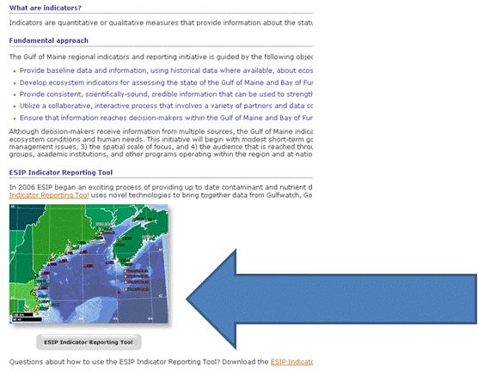

Or by directly going to: **www2.gulfofmaine.org/esip/reporting**

Christine mentioned that the Tool is currently not graphing but Jim Cradock is working on it. She requested that the Steering Committee work through the Tool and make any quick revision requests at this time.

**2. NERACOOS-ESIP Workshop Invites**

During the October 2010 Steering Committee call there was a discussion about the upcoming NERACOOS-ESIP Workshop. This agenda item follows up with requests for suggestions of the invitation list. Christine mentioned that The Nature Conservancy, LIS, and several researchers at USM with a Fisheries tool are among potential invitees. Christine asked if Marilyn ten Brink knew the status of the EPA *e-estuaries* project. She stated that the project had recently received funds and was revitalized. She suggested that Naomi Detenbeck be invited. She also thought that NOAA's CAN-VIS group might be of interest. Marilyn thought it would be worth looking at presentations from recent Coastal Geotools meetings for possible individuals (http://geotools.csc.noaa.gov/default.aspx).

**3. Upcoming Working Group and Council Meetings**

The upcoming Working Group (December 6-7) and Council (December 8) meetings in Portland, Maine will include sessions for subcommittees to discuss accomplishments and directions for growth. Christine is looking for topics that should be included in ESIP's presentation. Marilyn suggested that one of the accomplishments of ESIP lies in ESIP's history of providing a "place" for individuals from different organizations to interact and learn from each other.

**4. Conference Calls 2011**

Please let Christine know if you have any known conflicts with the proposed Steering Committee conference calls listed below for 2011 (already!).

January 25 10:00 AM ET

February 22 10:00 AM ET

March 22 10:00 AM ET

April 26 10:00 AM ET

May 24 10:00 AM ET

June 21 10:00 AM ET

**5. Fact sheets to designer!**

Christine was also excited to announce that the Aquaculture Fact Sheet has now gone to the designer. She's hoping that the Climate Change Fact Sheet will go out in the next couple of weeks. Environment Canada is assisting with the contract for the design work. We're excited to see what Peggy Issenman does with these fact sheets after her stellar work with the general ESIP fact sheet.

**Next Call: December 14th at 10:00 AM ET**