**Steering Committee Conference Call: November 24, 2015**

**Participants**

Heather Breeze (DFO), Adria Elskus (USGS), Jim Latimer (EPA), Kathryn Parlee (EC), and Christine Tilburg (GOMC)

**1. ICUC Release**

Christine Tilburg updated the Steering Committee on progress towards the release of the ICUC app. At this time Tesera is planning on loading the app into the GooglePlay and iTunes stores the first week of December. Originally the team had hoped to release the app the first week of December. Although the contractors (US: Sara Ellis, CA: Donald Killorn) have been working hard to get permission to post the brackets at specific sites they are still waiting for some responses. Consequently Christine proposes to do the release the first week of the new year with ESIP’s normal “Happy New Year” email. Once the app is released Christine will be working with local groups on press releases (Example: with Casco Bay Estuary Partnership).

**2. 2016 Calls**

Christine included call dates in the agenda for the Steering Committee for 2016. If you have a conflict with any of these dates please connect with Christine:

January 26 at 10:00 AM ET

February 23 at 10:00 AM ET

March 29 at 10:00 AM ET

April 26 at 10:00 AM ET

May 31 at 10:00 AM ET.

**3. Ecosystem Services**

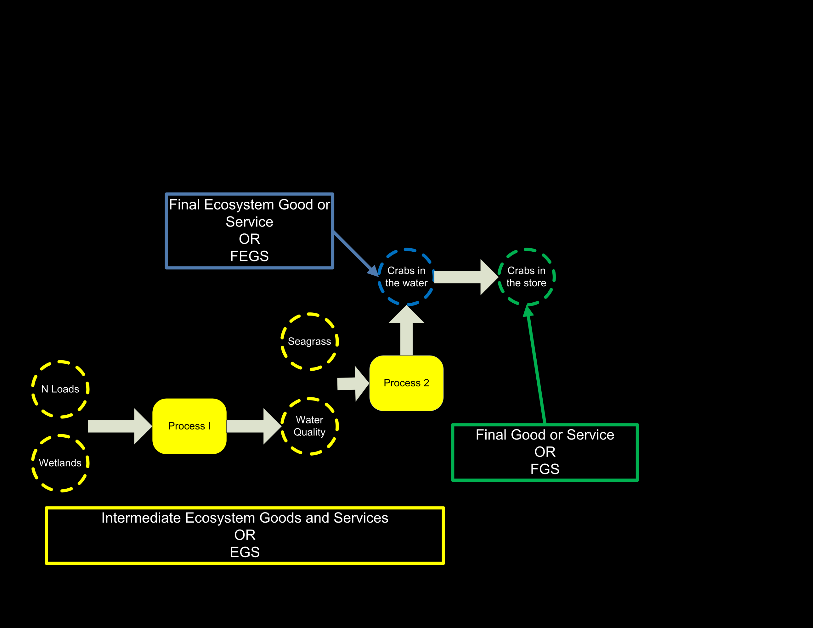Christine then turned the call over to Jim Latimer to lead a conversation about ecosystem services based on a call that the two of them had with Paul Ringold (EPA). Christine mentioned that she has had a hard time wrapping her head around the ideas but has come to think they are very helpful. Jim walked the group through a series of slides (composed of some of Paul’s and some revised slides that Jim has put together). Jim used the slides to discuss FEGS (Final Ecosystem Goods and Services), FGS (Final Goods and Services), and iEGS (Intermediate Ecosystem Goods and Services). Christine mentioned that Slide 4 (below) is the most clear to her. Jim discussed how much of ESIP 1.0 is incorporated into the yellow portion of the slide. Kathryn Parlee wondered if users of this model have to start with the Final Goods and Services (FGS) and then work backward to the ecosystem goods. Christine didn’t think that was the case. Jim stated that the FEGS remind him of classical ecology.

Jim went through several slides that looked into the key terms in more detail. Adria Elskus mentioned that it would be easier to understand if the Ringold slides were consistent with the colors used to represent the different terms. Jim also discussed that there are quite a few people working on this topic at EPA. At this time they haven’t tried to use the model with estuaries and coasts. They are planning a meeting in the future to look into this topic. Both Christine and Adria stated they were interested in attending that meeting.

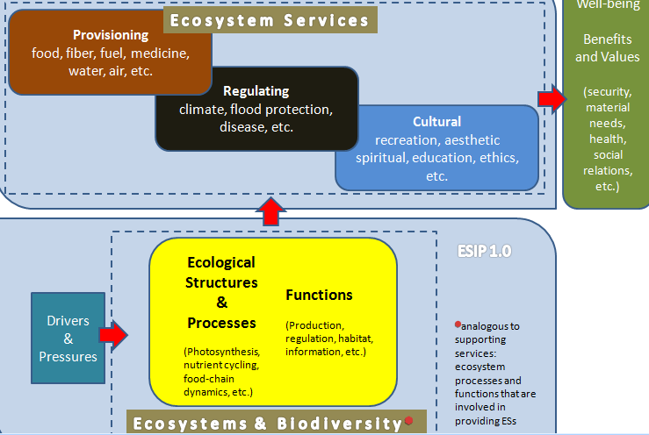Kathryn expressed some concern that the model only touches on provisioning services. She wondered if the other categories of services (cultural and regulating) can be incorporated into the model. Christine stated that she was hoping that the Steering Committee December call could focus on discussing how the FEGS/FGS model would work with the ESIP 2.0 flow (copied below). The group thought that this would be a good step forward. Christine cautioned that she really needs the group to think about this topic PRIOR to the call. She will send out the two models/diagrams one week prior to the call***. (Action to be taken: Materials will be sent out one week before call so that Steering Committee members can prepare prior to the call for an in-depth conversation).***