**Annual Steering Committee Meeting – May 2016**

**Participants**

Adria Elskus (USGS), Jim Latimer (EPA), Matt Liebman (EPA), Abe Miller-Rushing (DOI), Pete Murdoch (USGS), Kathryn Parlee (EC), Christine Tilburg (GOMC) and Jed Wright (USFWS).

**1. USFWS Introduction**

Christine Tilburg opened the annual meeting with a return to Abe Miller-Rushing’s comments earlier this spring that he would find it helpful if a certain amount of the ESIP Steering Committee calls were spent learning about projects that other members are involved in. These projects do not necessarily need to be linked to ESIP activities – it is meant more as a “show and tell” with three to six slides. Consequently, Christine asked Jed Wright (USFWS) to attend the beginning of the ESIP meeting and discuss projects the USFWS has that might intersect ESIP’s own interests.

Jed provided hand outs and discussed some USFWS projects with an associated focus on aquatic connectivity. Some of his talk focused on the “Beginning with Habitat” project. He also discussed specific projects to protect habitat such as 58 seabird islands and 65 Atlantic salmon riparian properties. Four examples he went into in more detail were Flag Island (seabird island protection), Machias River (diadromous fish riparian protection), Cascade Brook (salt marsh restoration), and Outer Green Island (seabird restoration). One project of particular interest to ESIP is the Maine barrier survey which looked at every road crossing in Maine to see if there are barriers to the water flow. One of ESIP’s Aquatic Habitat indicators is barriers to tidal flow.

Jed also discussed Regional Conservation Opportunity Areas (RCOAs). The regional models can also be supplemented with state data. Jed mentioned how areas of importance are selected (a process that should include stakeholders). Steering Committee members then talked with Jed about specific areas of interest. Matt Liebman was particularly interested in how USFWS collects information on stream temperature. Steering Committee members were also interested in cost estimates for removing barriers and optimizing fish passes.

Jed also provided information on Ben Letcher's data visualization site:

<http://ecosheds.org>. Jed thought Ben would be a good individual to have on a future call. ***(Action to be taken: Add to list of potential “presenters” on Steering Committee calls).***

**2. Change in ESIP Steering Committee calls**

Christine reminded the group that there had been a request to include more discussions such as the previous one with Jed Wright into Steering Committee calls. Christine suggested that either a member of the Steering Committee or suggested individual could spend the first 15-20 minutes on every other call discussing their own projects that might inform the work of ESIP. She stated that people can volunteer or she might request different speakers. As an example she stated that Matt Liebman might do the first one and discuss the recent watershed theme paper for the State of the Gulf report. Pete Murdoch mentioned that he might be able to provide information on parallel efforts. ***(Action to be taken: Set up a schedule for these discussions on upcoming conference calls).***

**3. Updates on ESIP projects**

**EPA/ORD Watershed Project**: Jim provided information on the watershed project that he has headed up for the last 2.5 years. The project goal is to develop concepts relating watershed characteristics and estuary condition. He described how the watersheds were delineated and both watershed characteristic and response indicators are being utilized with the project.

**ICUC:** Christine provided an update on the ICUC smartphone app. She described some of the features that will be part of the second phase of the project (“clustering” and offline synchronization). Abe wondered if it is time for the project to scale up. The Steering Committee brain stormed some groups that might be interested in the app: Maine Geological Survey, Casco Bay, Sea Grant. Abe also mentioned a recent proposal to look at Storm Surge in the bays (Penobscot, Bass Harbor, and Bagaduce). If the project is funded he hopes the ICUC app can be involved. ***(Action to be taken: Christine needs to come back to these ideas).***

**ETF-ECW:** Christine and Kathryn Parlee provided information on a Eastern Charlotte Waterways project to add additional ICUC sites.

**4. Ecosystem Services**

Jim walked the Steering Committee through some of the recent discussions with respect to ESIP 2.0 and ecosystem services. Christine provided some background information on the Directional Committee (Robin Anderson, John Brazner, Jawed Hameedi, Jeff Hyland, Jim Latimer, Hilary Neckles, David Page, Paul Stacey, and Shannon Sterling). Jim presented the ESIP 2.0 framework that was derived from the Directional Committee. He then discussed the current work with the Final Ecosystem Goods and Services (FEGS) concept which takes the Millennium Ecosystem Assessment and further refines the idea of FEGS and regular economic goods and services. Jim stressed that FEGS are beneficiary driven which is a different way to approach the issues. However, the idea is very helpful when discussing and thinking about ecosystem services.

**Link to EPA webpage discussing FEGS: https://gispub4.epa.gov/FEGS/FEGS_home.html.**

The group discussed causal chains as a way of fleshing out the concept. One of Jim’s figures is included below:

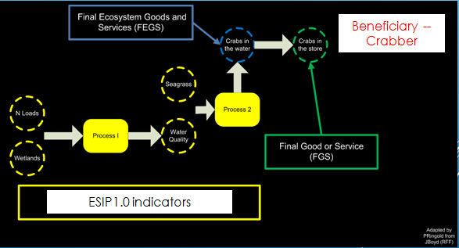

The Steering Committee wondered what thematic areas ESIP subcommittees might utilize in Phase 2. Peter Murdoch mentioned that the only reason to have the broader groups is to divide people up. Perhaps creating broader committees focused on the Millennium Assessment would then allow the individuals in the groups to determine the appropriate beneficiaries.

Abe stated that a danger and benefit of this methodology is that it is very focused on beneficiaries. Christine agreed but stated that the list of beneficiaries that ESIP might derive will not need to be all inclusive. The group wondered if it would be helpful to have agency champions for the subcommittees. Examples might be: Kathryn and climate change, Jim and the Clean Water Act priorities, and Pete for USGS issues.

The group agreed that it would be best to do a pilot study and spend a year working out the details and appropriate indicators for the pilot study. Christine liked this approach as she wants the subcommittee work to be as clear as possible. The group then discussed what the pilot study might be based on. Kathryn brought up the two “themes” being used for the upcoming GOMC meeting:

* Coastal Resiliency / Vulnerability of Coastal Infrastructure to Extreme Weather Events (drivers include rain and temperature)
* Links between Changing Climate, Ocean and Ecosystem Health, and Sustainability of Coastal Resources such as Sustainable Fisheries, Migratory Birds, and Wetlands

The group then discussed potential pilots and a draft schedule. It was agreed that the July Steering Committee call will focus on a report back from the GOMC meeting. August’s conference call will involve creating a draft timeline with concrete dates. ***(Action to be taken: Reserve time on the Steering Committee calls for these activities).***

**5. Other Ecosystem Service Activities**

Pete Murdoch then discussed other activities that he is aware of in the US that include ecosystem service-type information. He discussed some of the projects that resulted from the Hurricane Sandy effort particularly with respect to coastal resiliency. Pete also discussed a report on environmental metrics that is due out. The report includes socio-economic metrics. The hope is to expand this effort out to other federal groups. ***(Action to be taken: Report to be forwarded to Steering Committee once Pete has permission).*** Pete also discussed the Integrated Sentinel Monitoring Network (ISMN http://www.neracoos.org/sentinelmonitoring).

The group discussed a risk and resilience document that focuses on climate change. The discussion included a focus on social justice and environmental health. Pete described how there are different tiers to climate risk beginning with the triage tier defined by the clear deterioration (Figure below). He also discussed mapping places that are more vulnerable to losing ecosystem services.

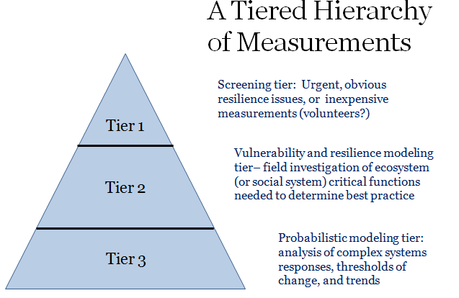

*\*Please let Pete know if you would like to use this figure elsewhere.*

Also of interest, Pete discussed an earth system framework that can be used to look at the importance of ecosystem services. From Pete’s talk: “The “planetary boundaries” doughnut concept (Rockstrom et al, 2009) and its environmental justice corollary “social foundations” (Raworth, 2012) provides a framework for rigorous measurement of environmental and social factors affecting resilience.”

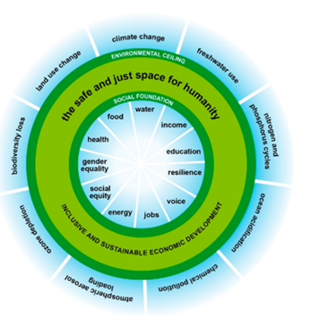

*\*Please let Pete know if you would like to use this figure elsewhere.*

**6. 10th Year birthday!**

The Steering Committee closed out by celebrating the 10th year anniversary for ESIP. So much has been accomplished. It’s exciting to think about what the next 10 years will bring!