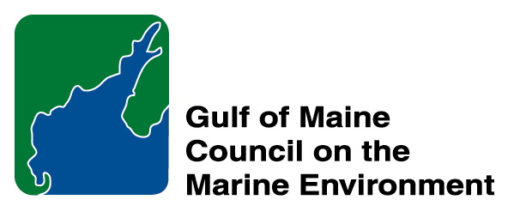 | 2014 Gulf of Maine Council Visionary Award  Nomination Form

The Gulf of Maine Visionary Award is presented annually to an individual or organization within each of the five Gulf of Maine jurisdictions of Massachusetts, New Hampshire, Maine, New Brunswick, and Nova Scotia. The Awards recognize innovation, creativity, and commitment to marine protection by businesses, environmental organizations, or individuals who are making a difference to the health of the Gulf of Maine.
* As the Council celebrates our 25th Anniversary, we seek to recognize the value of young people as well as experienced leaders in working to protect the Gulf of Maine ecosystem. We welcome and encourage nominees of all ages (including students or youth organizations) for our 2014 Gulf of Maine Visionary Awards and Longard Volunteer Award.

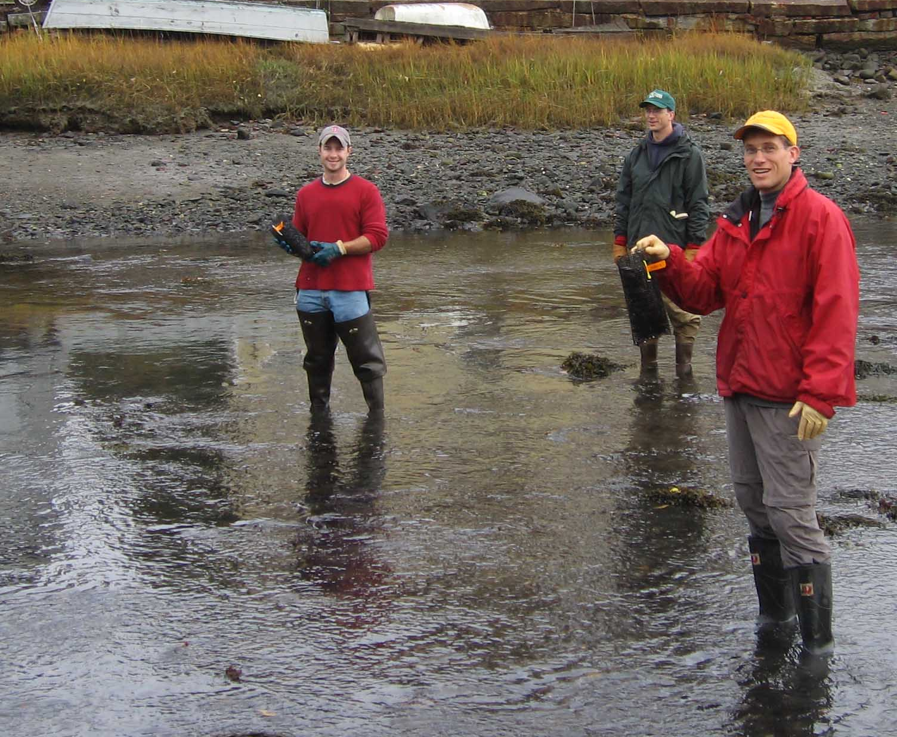 | Nomination instructions:  - Individuals or organizations may make nominations. Self-nominations are not accepted.  - The nominee must reside in Maine, Massachusetts, New Brunswick, New Hampshire, or Nova Scotia. The nominee’s contributions must have occurred in the Gulf of Maine watershed.  - Visionary Award nominees may be paid professionals or volunteers.  - Nominations must be made on this nomination form. Nominations with missing information will not be considered. Attachments will not be accepted.  - Nominations must be emailed to jleblanc@gulfofmaine.org by the close of business on March 30, 2014. Please rename the nomination form with _LastNameofNominee added to the file name.
Questions? Please contact Council Coordinator Joan LeBlanc at jleblanc@gulfofmaine.org
To view a list of past award winners, please visit: http://www.gulfofmaine.org/2/opportunities/

Nominee information
Name (as it will appear on the award plaque if selected): Samuel B. Merrill, PhD
Affiliation: Catalysis Adaptation Partners, LLC (formerly Univ. of Southern Maine, New England Environmental Finance Center)
Mailing address: PO Box 531, Scarborough, ME, 04074
Phone: 207-615-7523
Email: smerrill@catalysisadaptation.com

Brief background on why the individual/organization is being nominated:

2014 GOMC Visionary Award Nomination for Sam Merrill

Dr. Samuel Merrill is being recognized for his 12 years of outstanding service to the New England Environmental Finance Center, the University of Southern Maine, EPA, and New England communities and the environment. From 2001 to 2013, Dr. Merrill served as director of the EPA-sponsored New England Environmental Finance Center (NE EFC) and Associate Research Professor at the Muskie School of Public Service at the University of Southern Maine (USM). As the NE EFC’s founding director, Dr. Merrill was a driving force for the program’s establishment and he built the entire program from scratch. During his first several years at the NE EFC, Dr. Merrill focused his efforts on providing communities with information on the financial and environmental benefits of adopting “smart growth” approaches to land use and development. Over the past 5-6 years, however, his focus shifted to helping communities understand the financial implications of sea level rise and storm surge, and various adaptations to these phenomena.

One of Dr. Merrill’s most significant accomplishments at the NE EFC was the development of the Coastal Adaptation to Sea level rise Tool (COAST) software package. This software tool models the costs of adapting to sea level rise and increased storm surges, and is able to help predict and visualize damages from ranges of sea level rise and storm surge frequency and intensity and the relative benefits of alternative adaptation responses. COAST output shows costs versus benefits (avoided costs) of stakeholder-derived adaptation scenarios. These outputs have proven effective in helping communities generate policy and finance innovations necessary for a robust response to the combined threats of sea level rise and storm surge.

A recent example of how Dr. Merrill has used COAST to help communities plan for sea level rise and storm surge is his work with Portland, Maine and the NH coastal communities of Seabrook, Hampton, and Hampton Falls. In 2011, the EPA’s Climate Ready Estuaries program awarded funds to the Casco Bay Estuary Partnership and the Piscataqua Region Estuaries Partnership to further develop and use COAST in sea level rise adaptation planning processes in Portland and the Hampton/Seabrook estuary area. Dr. Merrill and the NE EFC worked with municipal staff, elected officials, and other stakeholders to select specific locations, vulnerable assets, and adaptation actions to model using COAST. The NE EFC then collected the appropriate base data layers, ran the COAST simulations, and provided visual, numeric, and presentation-based products in support of the planning processes underway in both locations. These products, which were completed in 2012, helped galvanize support for the local adaptation planning efforts. Through facilitated meetings they also led to stakeholders identifying specific action steps and beginning to determine how to implement them.

Under Dr. Merrill’s leadership, the NE EFC also accomplished a number of projects over the years that exemplify the double bottom line, whereby environmental and societal costs and benefits are considered when contemplating projects. Examples of this include the Capacity Building for Sustainable Communities project and the Financial Training and Technical Assistance for Small Public Water Systems project. Dr. Merrill also conducted extensive outreach to help spread the word on the NE EFC and its various tools and services. These included a May 2011 webinar on COAST as part of a quarterly series of Federal Highway Administration-sponsored webcasts on the application of geospatial information systems (GIS) and other geospatial technologies to transportation. Another example of the outstanding work Dr. Merrill has done on climate change resiliency and adaptation is a report he wrote for the Maine Department of Transportation on transportation infrastructure needs in the face of climate change. Titled “Cost-Efficient and Storm Surge-sensitive Bridge Design for Coastal Maine,” it provided the basis for the development of storm surge-sensitive design standards and approaches for large, tidally influenced transportation structures along the Maine coast.

Dr. Samuel Merrill deserves to be recognized for his innovative approach to raising awareness about the financial implications of sea level rise and storm surge, which has led many Gulf of Maine communities to begin planning for climate change and other ecosystem changes.
Summary that will be read during the awards ceremony if nominee is selected. This text will also be used in media releases (not to exceed 2,000 characters, including spaces and punctuation):

Dr. Samuel Merrill is being recognized with a Gulf of Maine Council Visionary Award for his innovative approach to raising awareness about the financial implications of sea level rise and storm surge, which has led many Gulf of Maine communities to begin planning for climate change and other ecosystem changes. From 2001 to 2013, Dr. Merrill served as director of the EPA-sponsored New England Environmental Finance Center (NE EFC) and Associate Research Professor at the Muskie School of Public Service at the University of Southern Maine. As the NE EFC’s founding director, Dr. Merrill was a driving force for the program’s establishment and he built the entire program from scratch. During his first several years at the NE EFC, Dr. Merrill focused his efforts on providing communities with information on the financial and environmental benefits of adopting “smart growth” approaches to land use and development. Over the past 5-6 years, however, his focus shifted to helping communities understand the financial implications of sea level rise and storm surge, and various adaptations to these phenomena.
A recent example of how Dr. Merrill has used COAST to help communities plan for sea level rise and storm surge is his work with Portland, ME and the NH coastal communities of Seabrook, Hampton, and Hampton Falls. In 2011, the EPA Climate Ready Estuaries program awarded funds to the Casco Bay Estuary Partnership and the Piscataqua Region Estuaries Partnership to use COAST in sea level rise adaptation planning processes in Portland and the Hampton/Seabrook estuary area. Dr. Merrill worked with municipal staff, elected officials, and other stakeholders to select specific locations, vulnerable assets, and adaptation actions to model using COAST. The NE EFC then collected the appropriate data layers, ran the COAST simulations, and provided visual, numeric, and presentation-based products in support of the planning processes underway in both locations. These products, which were completed in 2012, helped galvanize support for local adaptation planning efforts. Through facilitated meetings they also led to stakeholders identifying specific action steps and beginning to determine how to implement them.

Name and contact information of person making the nomination:
Name & Affiliation: Melville P. Coté, Jr., U.S. Environmental Protection Agency
Address: Five Post Office Square (OEP06-1), Boston, MA 02109
Phone: 617-918-1553
Email: cote.mel@epa.gov

The mission of the Council is to maintain and enhance environmental quality in the Gulf of Maine and to
allow for sustainable resource use by existing and future generations.

Massachusetts Office of Coastal Zone Management • 2002-2003 Secretariat
GOMC • c/o NHDES • PO Box 95 • Concord, NH, US • 03302-0095 • Phone (603) 225-5544

The mission of the Council is to maintain and enhance environmental quality in the Gulf of Maine and to
allow for sustainable resource use by existing and future generations.

Nova Scotia Environment • 2013-2014 Secretariat

