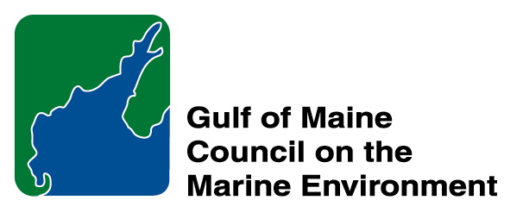 | 2014 Gulf of Maine Council Visionary Award  Nomination Form

The Gulf of Maine Visionary Award is presented annually to an individual or organization within each of the five Gulf of Maine jurisdictions of Massachusetts, New Hampshire, Maine, New Brunswick, and Nova Scotia. The Awards recognize innovation, creativity, and commitment to marine protection by businesses, environmental organizations, or individuals who are making a difference to the health of the Gulf of Maine.
* As the Council celebrates our 25th Anniversary, we seek to recognize the value of young people as well as experienced leaders in working to protect the Gulf of Maine ecosystem. We welcome and encourage nominees of all ages (including students or youth organizations) for our 2014 Gulf of Maine Visionary Awards and Longard Volunteer Award.

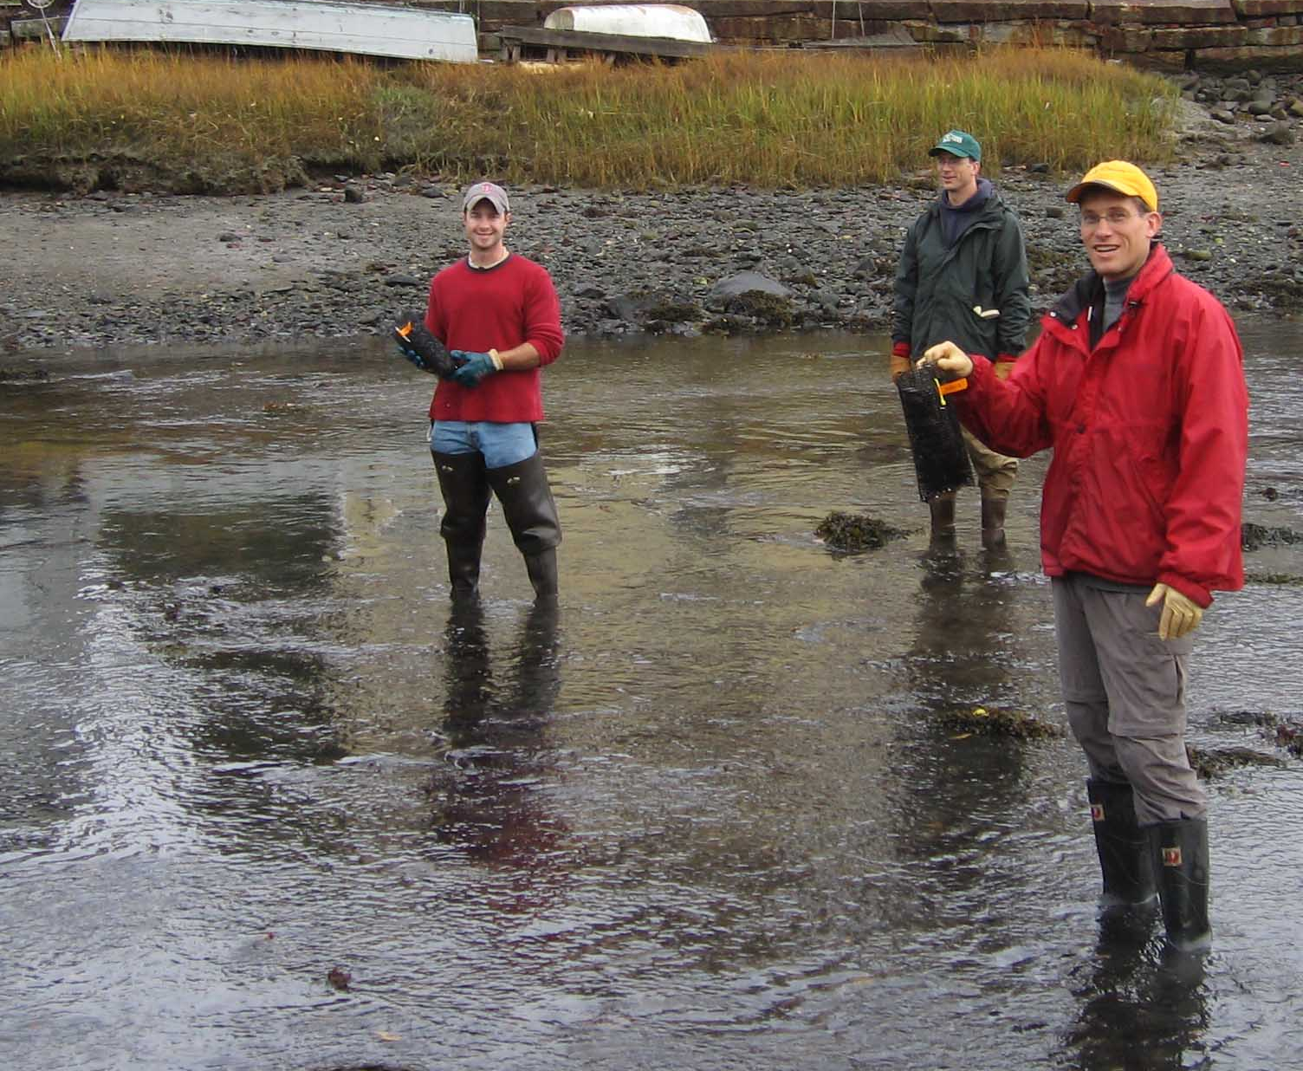 | Nomination instructions:  - Individuals or organizations may make nominations. Self-nominations are not accepted.  - The nominee must reside in Maine, Massachusetts, New Brunswick, New Hampshire, or Nova Scotia. The nominee’s contributions must have occurred in the Gulf of Maine watershed.  - Visionary Award nominees may be paid professionals or volunteers.  - Nominations must be made on this nomination form. Nominations with missing information will not be considered. Attachments will not be accepted.  - Nominations must be emailed to jleblanc@gulfofmaine.org by the close of business on March 30, 2014. Please rename the nomination form with _LastNameofNominee added to the file name.
Questions? Please contact Council Coordinator Joan LeBlanc at jleblanc@gulfofmaine.org
To view a list of past award winners, please visit: http://www.gulfofmaine.org/2/opportunities/

Nominee information
Name (as it will appear on the award plaque if selected): Dr. Nick Hill
Affiliation: Fern Hill Institute for Plant Conservation
Mailing address: 424 Bentley Rd., RR#1, South Berwick, NS, B0P 1E0
Phone: (902)538-9574
Email: fernhillns@gmail.com

Brief background on why the individual/organization is being nominated:

I would like to nominate Nick for his efforts to restore Big Meadow Bog on Brier Island and conserve critically endangered populations of eastern mountain avens.

Summary that will be read during the awards ceremony if nominee is selected. This text will also be used in media releases (not to exceed 2,000 characters, including spaces and punctuation):

Nick has been spearheading the effort to understand the degradation of Big Meadow Bog on Brier Island, the impacts of this degradation on a globally rare plant, Eastern Mountain Avens (Geum peckii), and conducting field studies designed to guide restoration of the site. Nick is part of a collaborative team working on this restoration effort, but has been the go-to person for virtually all aspects of the work, spent many hours doing field work and been most active in coordinating other collaborators efforts and keeping collaborators informed about results and needs.

This project is important for a number of reasons. Big meadow is a rare type of raised bog/fen complex that occurs over basalt bedrock – an unusual combination in Nova Scotia. At 100 hectares it is also our larger peatlands with deep peat soils that store a substantial amount of carbon. Efforts to drain the bog for agriculture began in the 1950s and the bog has been gradually drying out ever since. As the bog dries, the plant community has shifted to more upland species and has become attractive as gull breeding habitat. In fact, the largest colony of breeding herring gulls in the province now breeds in Big Meadow Bog. The combination of drying conditions and high nutrient loads resulting from herring gull excretion now threaten the overall health of this large bog/fen complex and the focal point of one of the two primary populations of eastern mountain avens in the world. Nick’s efforts to identify key environmental stressors and the ecological conditions most important for sustaining eastern mountain avens are critical for identifying ways to effectively restore the site.

Name and contact information of person making the nomination:
Name & Affiliation: Dr. John Brazner
Address: Nova Scotia DNR – Wildlife Division, 136 Exhibition Street, Kentville, NS B4N 4E5
Phone: (902)679-6247
Email: braznejc@gov.ns.ca

The mission of the Council is to maintain and enhance environmental quality in the Gulf of Maine and to
allow for sustainable resource use by existing and future generations.

Massachusetts Office of Coastal Zone Management • 2002-2003 Secretariat
GOMC • c/o NHDES • PO Box 95 • Concord, NH, US • 03302-0095 • Phone (603) 225-5544

The mission of the Council is to maintain and enhance environmental quality in the Gulf of Maine and to
allow for sustainable resource use by existing and future generations.

Nova Scotia Environment • 2013-2014 Secretariat

