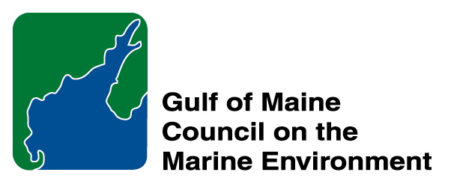 | 2014 Gulf of Maine Council Visionary Award  Nomination Form

The Gulf of Maine Visionary Award is presented annually to an individual or organization within each of the five Gulf of Maine jurisdictions of Massachusetts, New Hampshire, Maine, New Brunswick, and Nova Scotia. The Awards recognize innovation, creativity, and commitment to marine protection by businesses, environmental organizations, or individuals who are making a difference to the health of the Gulf of Maine.
* As the Council celebrates our 25th Anniversary, we seek to recognize the value of young people as well as experienced leaders in working to protect the Gulf of Maine ecosystem. We welcome and encourage nominees of all ages (including students or youth organizations) for our 2014 Gulf of Maine Visionary Awards and Longard Volunteer Award.

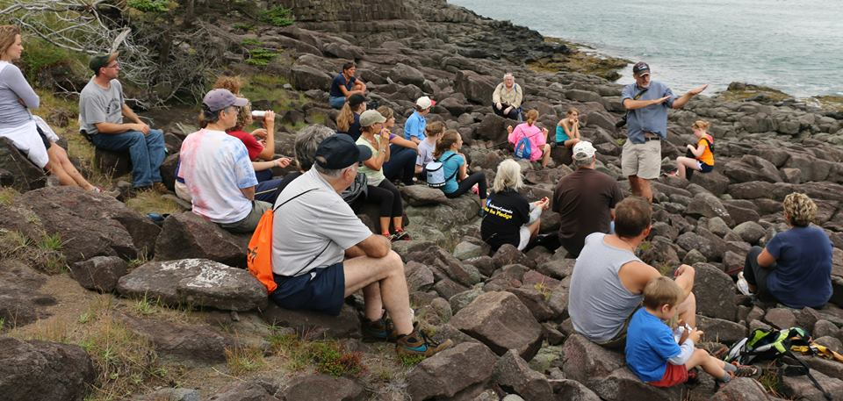 | Nomination instructions:  - Individuals or organizations may make nominations. Self-nominations are not accepted.  - The nominee must reside in Maine, Massachusetts, New Brunswick, New Hampshire, or Nova Scotia. The nominee’s contributions must have occurred in the Gulf of Maine watershed.  - Visionary Award nominees may be paid professionals or volunteers.  - Nominations must be made on this nomination form. Nominations with missing information will not be considered. Attachments will not be accepted.  - Nominations must be emailed to jleblanc@gulfofmaine.org by the close of business on March 30, 2014. Please rename the nomination form with _LastNameofNominee added to the file name.
Questions? Please contact Council Coordinator Joan LeBlanc at jleblanc@gulfofmaine.org
To view a list of past award winners, please visit: http://www.gulfofmaine.org/2/opportunities/

Nominee information
Name: Jonathan Riley & Gregory Turner
Affiliation: Fundy Erratics
Mailing address: 11 Water Street, Digby, NS, B0V 1A0
Phone: 902-245-4715
Email: jriley@digbycourier.ca

Brief background on why the individual/organization is being nominated: Education is integral to understanding the complex ecological nature of the Gulf of Maine watershed. Also key is the engagement of citizens of all ages that reside along the shores. Through the hikes, interpretive talks and the wonderful social constructs the Fundy Erratics Group has opened doors for many to explore and discover the natural assets present in the Bay of Fundy. Jonathan’s weekly articles in the local paper – the Digby County Courier- Have brought the Fundy into our homes and hearts. Greg’s advocacy and environmental stewardship are well known and respected. His post retirement Tour Company is an adventure for participants – Gael Tours.

Summary that will be read during the awards ceremony if nominee is selected. This text will also be used in media releases :
For Jonathan Riley (Digby) and Greg Turner - Gael Tours (Smith’s Cove)
Fundy Erratics
This was written by a Member of Fundy Erratics in response to our suggestion that we nominate Jon and Greg.
Jonathan and Greg share a love for the outdoors, for learning, for socializing and physical activity. They are passionate about their mission in life and also about sharing a healthy lifestyle with like minds. Jonathan and Greg have an interest in our Fundy shores and local wilderness areas. Jonathan’s boundless energy and Greg’s educational insights married well with their mutual desire to share our local beauty with others. After a couple of successful hikes, The Fundy Erratics hiking group was formed. Jonathan and Greg have led monthly treks for all age groups and ability levels. We have scaled the rocky shores of Long Island, maneuvered the gorge to the S.S Princess Louise monument, counted kilometers between Digby Neck Coves, witnessed breath taking views of Gulliver’s spectacular beauty and taken more subtle and relaxing walk along the impressive Red Head beach. We’ve witnessed the rush of waterfalls, learned about rock formations, fossils and plant life. We’ve conversed with owls under the full moon. Jonathan and Greg have stretched the hiking season into winter with snowshoe hikes. We’ve joined up with Clare and Annapolis County recreation on guided snowshoe trails, hot apple cider, barbecued treats and prizes. There are over 130 members in the Fundy Erratics group. We’ve had school age children, organized groups, seniors and even dogs! We share pictures, car rides, links to hiking opportunities, safety sessions and more. We reach out to ill members and enjoy the camaraderie of belonging. When the forecast is good, we check the facebook page and head out together. As one member attested, “whoever thought I would be part of a hiking group and in my own community and having this much fun? “ Thank you, Jonathan and Greg for promoting fun and healthy living in our own back yard!
The Board’s nomination..
The seed for Fundy Erratics was started during a group hike from Point Prim to the Princess Louise Monument in Sept. 2012. The hike was part of the Lights Along the Shore Lighthouse Festival There was so much interest and after that hike, people were asking us when is the next hike. Jonathan Riley and Greg Turner discovered they had a mutual interest in hiking and exploring the natural beauty of the area. Jonathan came up with the name, Fundy Erratics, set up the Facebook site and now they are hiking at least once a month. The hikes tend to be off the beaten path. Some hikes have been quite a challenging like the adventure along the basalt outcrops of the Bay of Fundy shore of Digby Neck and Long Island or the red sandstone ledges at the edge of St. Mary's Bay where Nicole Oliver interpreted the geology. They hiked to the highest point on Digby Neck with a spectacular view of Gulliver's Cove . They have hiked at night in Keji where they used recorded owl sounds to call a barred owl to the trees above us on the trail and sat quietly while a white-tailed buck deer came very close. One Keji adventure was a 20 km excursion into the back country to enjoy the crisp fall air and beautiful colours of the season. One hike during the January thaw this year found them in Clementsport exploring a beautiful waterfall. They have snowshoed at the Digby Pines and at the community trail in Cornwallis. They did return to the Bay of Fundy shore again in Sept. 2013 to hike to the Princess Louise monument. This time, Jonathan told the spellbinding story of the shipwreck of the Princess Louise in stages when they stopped for breaks along the shore. There is a something for everyone during these hikes, nature, history, a chance to catch up with old friends and make new ones. Its lots of fun and there is a real sense of community. There are people from as far away as Clare and up the Valley. Some hikers have set personal goals to improve their fitness. Our hike in April will mark a year for Fundy Erratics. Participants are all ages some have personal goals for fitness. I made the comment to Greg that I have winter camped and hiked but now I am too old, his response was we have folks in their 70's . I guess that does not cut it!
The key here is the best practices philosophy that includes being well dressed and prepared with water, food etc. Jonathan will be presenting at the NS Hiking summit in Parrsboro NS Friday April 11, 2014 to Sunday April 13, 2014. There is no cost with the exception of what you have to wear and the travel to the meeting location. Good time had by all!
Greg is a retired science teacher who coached the Digby High Award Winning Envirothon Teams for many years and in ‘retirement’ he started Gael Tours which are also a hiking experience that explores the natural assets of the area. I know I can’t promote his business but it does demonstrate his passion. Jonathan is a Reporter for the Digby County Courier. He is a brilliant photo-journalist who brings the need for understanding and respect for the natural world to his readers weekly. Jonathan lives it and gives that gift to others.
From his website.. Greg Turner - Meet Your Interpreter "Leading people to discover the features of this amazing area is a natural extension of a passion I have for nature, history and culture. A life-long resident of the area, I am retired after 31 years as an educator at Digby Regional High School. Hiking, soccer, photography, birding and discovering new things about the flora and fauna of Nova Scotia are my past-times."

Name and contact information of person making the nomination:
Name & Affiliation: Kris Herron, Digby Area Board of Trade
Address: 1971 Culloden Road, Digby, NS, B0V 1A0
Phone: 902-247-3078
Email: krisherron80@gmail.com

The mission of the Council is to maintain and enhance environmental quality in the Gulf of Maine and to
allow for sustainable resource use by existing and future generations.

Massachusetts Office of Coastal Zone Management • 2002-2003 Secretariat
GOMC • c/o NHDES • PO Box 95 • Concord, NH, US • 03302-0095 • Phone (603) 225-5544

The mission of the Council is to maintain and enhance environmental quality in the Gulf of Maine and to
allow for sustainable resource use by existing and future generations.

Nova Scotia Environment • 2013-2014 Secretariat

