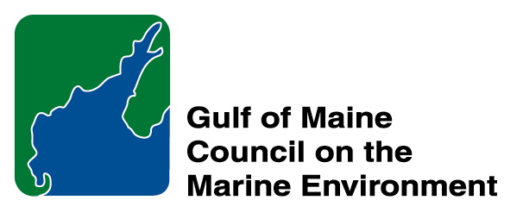 |  | 2014 Gulf of Maine  Longard Award  Nomination Form

The Longard Gulf Volunteer Award is bestowed each year in memory of Art Longard, a founding member of the Gulf of Maine Council on the Marine Environment and long-time Working Group member. The Award is given to an individual from one of the five states and provinces bordering the Gulf of Maine. The Longard Award recognizes individual commitment to volunteer programs dedicated to environmental protection and sustainability of natural resources within the marine, near shore, and watershed environments of the Gulf of Maine.
* As the Council celebrates our 25th Anniversary, we seek to recognize the value of young people as well as experienced leaders in working to protect the Gulf of Maine ecosystem. We welcome and encourage nominees of all ages (including students or youth organizations) for our 2014 Gulf of Maine Visionary Awards and Longard Volunteer Award.

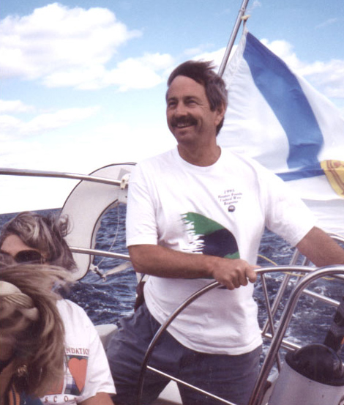  Art Longard | Nomination instructions  - Individuals or organizations may submit nominations. Self-nominations are not accepted.  - The nominee must be resident of Maine, Massachusetts, New Brunswick, New Hampshire, or Nova Scotia. The nominee’s contributions must have been to the Gulf of Maine watershed.  - Longard Award nominees must have contributed to the Gulf of Maine in their capacity as a volunteer, NOT as a paid professional.  - Nominations must be made on this form. Attachments will not be accepted.  - Nominations must be emailed to jleblanc@gulfofmaine.org by the close of business on March 30, 2014. Please rename the nomination form with _LastNameofNominee added to the end of the file name.
Questions? Please contact Council Coordinator Joan LeBlanc at jleblanc@gulfofmaine.org.

To view a list of past award winners, please visit: http://www.gulfofmaine.org/2/opportunities/

Nominee information
Name (as it would appear on the award plaque if selected): Carol “Krill” Carson
Mailing address: 11 Clarence Soule Drive; Middleborough, MA 02346
Phone: 508-566-0008
Email: krillcarson@mac.com

Brief background on why the individual/organization is being nominated:

Krill is the founder, president, and ongoing inspiration propelling the non-profit New England Coastal Wildlife Alliance (NECWA) based in southeast Massachusetts. Founded in 2005, NECWA is a grass roots environmental organization that supports a variety of research and educational outreach activities that focus on the cetaceans, seabirds, seals, basking sharks, ocean sunfish and other coastal marine wildlife of New England. Among the diverse activities sponsored by NECWA are offshore excursions to view whales, seabirds, and other marine wildlife, rescue and relocation efforts of stranded ocean sunfish and sea turtles, a community-sighting network for basking sharks and ocean sunfish, beach clean-ups, and educational marine wildlife presentations. Of particular note are the authentic wildlife experiences provided for interns who will become the next generation of biologists, resource managers, and marine policy makers. Run completely by volunteers and with supportive partnerships, all funds coming into the organization go directly to the important work done by NECWA on behalf of coastal wildlife. NECWA conducts additional outreach through its website (www.necwa.org/), news blog (www.necwanews.blogspot.com), and quarterly digital newsletters.

Short in stature but large in vitality and enthusiasm, Krill received her nickname during the years she researched great whales with the Provincetown Center for Coastal Studies and served as crew member onboard the Dolphin fleet whale watching vessels out of Provincetown, Massachusetts.

Summary that will be read during the awards ceremony if nominee is selected. This text will also be used in media releases (not to exceed 2,000 characters, including spaces and punctuation): Same as above

Name and contact information of person making the nomination:
Name: Dr. Jean Kenyon
Affiliation: U.S. Fish & Wildlife Service, National Wildlife Refuge System
Address: 47-672 Hui Kelu St. Apt 4; Kaneohe, Hawaii 96744
Phone: 808-239-6525
Email: jkenyon@hawaii.edu

