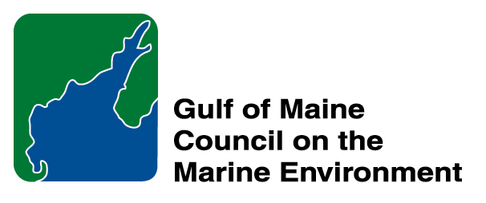 |  | 2014  Susan Snow-Cotter Leadership Award Nomination Form
The Susan Snow-Cotter Leadership Award is bestowed in memory of Susan Snow-Cotter, a long-time friend of the Council and Working Group. The Award is given to an individual from one of the five states and provinces bordering the Gulf of Maine. The Susan Snow-Cotter Leadership Award honors coastal management professionals who exemplify outstanding leadership or exceptional mentoring in the Gulf of Maine watershed. As former Director of the Massachusetts Office of Coastal Zone Management, Susan was recognized as a leader who exhibited unwavering passion, enthusiasm, and insight to develop pragmatic approaches to coastal management challenges. The Council presents this award to a professional who has demonstrated exceptional leadership in coastal and ocean planning and management by:

- Developing pragmatic approaches;
- Building collaborative efforts through mobilizing and unifying others around an issue or initiative; and/or
- Serving as a strong and supportive mentor to emerging coastal management professionals.

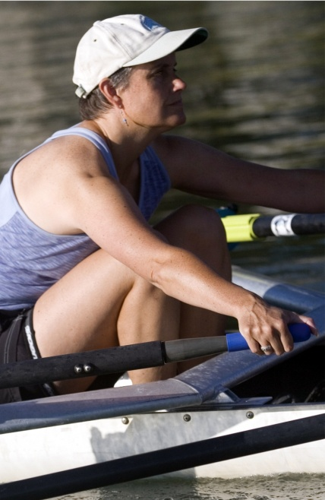  Susan Snow-Cotter | 0BNomination instructions  - Individuals or organizations may submit nominations. Self-nominations are not accepted.  - The nominee must be resident of Maine, Massachusetts, New Brunswick, New Hampshire, or Nova Scotia and his/her work be conducted primarily in the Gulf of Maine region.  - The nominee’s contributions must have occurred in the Gulf of Maine watershed.  - Nominations must be made on this form. Attachments will not be accepted.  - Nominations must be emailed to jleblanc@gulfofmaine.org by the close of business on March 30, 2014. Please rename the nomination form with _LastNameofNominee added to the end of the file name.
Questions? Please contact Council Coordinator Joan LeBlanc at jleblanc@gulfofmaine.org

To view a list of past award winners, please visit: http://www.gulfofmaine.org/2/opportunities/

Nominee information
Name (as it would appear on the award plaque if selected): Steve Miller
Affiliation (if applicable): Great Bay National Estuarine Research Reserve
Mailing address: 89 Depot Road, Greenland NH 03840
Phone: 603-294-0146
Email: Steve.Miller@wildlife.nh.gov

Brief background on why the individual/organization is being nominated:
Steve Miller has dedicated his life to improving the natural environment for people as well as ecosystems. He has a love of coastal and marine environments, so it should be no surprise he lives in Portsmouth with his wife and pet dog and cats. Steve has been working for many years within the watersheds of Great Bay and throughout the seacoast of NH to increase awareness of environmental problems and promote better management of our coastal resources.

As the Coastal Training Program Coordinator, Steve has cultivated several critical areas in support of coastal management over the past ten years and several of these projects have blossomed into successful, regionally known programs. For example, he is co-chair of the Coastal Adaptation Workgroup (CAW), lead developer of the Climate Summit Workshops, and community outreach specialist on several local NEERS Science Collaborative Projects. Steve’s spirit of collaboration and leadership in these projects have rallied planners, scientists and coastal managers to contribute meaningfully to these projects, which are having benefits for the citizens of the broader seacoast region, from southern Maine to Northern Massachusetts. Through this work, our communities are becoming better prepared to protect our coastal resources and our own future in the face of development pressures and climate change.

Outside of work, Steve has a rich personal and civic life. Before becoming CTP coordinator (and continuing on since then), he has made significant contributions to preserve and restore coastal ecosystems by leading the Advocates for North Mill Pond, the Hodgson Brook Restoration Plan, and the Portsmouth Conservation Commission. His personal vision for a healthy tidal ecosystem in North Mill Pond has led to several assessments of watershed and habitat health, and restoration actions that range from rehabilitated shorelines to stormwater treatment retrofits. Stormwater and all its negative impacts to coastal ecosystems is a pet peeve for Steve. Steve was closely involved with developing demonstration sites for vegetated buffers with the City of Portsmouth to illustrate how good stormwater and wetland buffers can be built and maintained. But he is also good at planning for fun, having led the popular ‘Paddle on the Pond’ for many years in Portsmouth and he has participated in the Nubble Light Challenge (open water swim race).

Steve is also a natural teacher and his skills for informal education are often used effectively at work to persuade people to rethink their relationship with nature. Steve directed the education department at the Seacoast Science Center for many years. He still holds outdoor workshops for Great Bay National Estuarine Research Reserve as well as teaches in the Watershed Ecology Institute each year (a two-week summer program aimed at teachers).

Steve has dedicated his career and personal life to preserving and restoring coastal ecosystems through improved watershed management. Over the past several years, many aspects of his skills as a teacher, a unifying presence and valued collaborator have come together and attracted great teams of professionals and laypersons to achieve great progress in coastal resource management for the region. This would be a great time to recognize and reward his long and arduous path.

Summary that will be read during the awards ceremony if nominee is selected. This text will also be used in media releases (not to exceed 2,000 characters, including spaces and punctuation):
Steve has been working throughout the watersheds of seacoast of NH to increase awareness of environmental problems and promote better management of our coastal resources. As the Coastal Training Program Coordinator, Steve has cultivated several critical areas in support of coastal management over the past ten years and several of these projects have blossomed into successful, regionally known programs. For example, he is co-chair of the Coastal Adaptation Workgroup (CAW), lead developer of the Climate Summit Workshops, and community outreach specialist on several local NEERS Science Collaborative Projects. Steve’s spirit of collaboration and leadership in these projects have rallied planners, scientists and coastal managers to contribute meaningfully to these projects, which are having benefits for the citizens of the broader seacoast region, from southern Maine to Northern Massachusetts. Through this work, our communities are becoming better prepared to protect our coastal resources and our own future in the face of development pressures and climate change.
Outside of work, Steve has made significant contributions to preserve and restore coastal ecosystems by leading the Advocates for North Mill Pond, the Hodgson Brook Restoration Plan, and the Portsmouth Conservation Commission. His personal vision for a healthy tidal ecosystem in North Mill Pond has led to several assessments of watershed and habitat health and restoration actions that range from rehabilitated shorelines to stormwater treatment retrofits. Steve is also a natural teacher and his skills for informal education are often used effectively at work to persuade people to rethink their relationship with nature. Steve directed the education department at the Seacoast Science Center for many years. He still teaches outdoor workshops and the Watershed Ecology Institute.
Steve has dedicated his life to preserving and restoring coastal ecosystems through improved watershed management.

Name and contact information of person making the nomination:
Name: David Burdick
Affiliation: Jackson Estuarine Laboratory, UNH
Address: 85 Adams Point Road, Durham, NH 03824
Phone: 603-862-5129
Email: david.burdick@unh.edu

