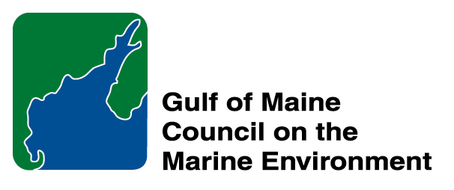 |  | 2014  Susan Snow-Cotter Leadership Award Nomination Form
The Susan Snow-Cotter Leadership Award is bestowed in memory of Susan Snow-Cotter, a long-time friend of the Council and Working Group. The Award is given to an individual from one of the five states and provinces bordering the Gulf of Maine. The Susan Snow-Cotter Leadership Award honors coastal management professionals who exemplify outstanding leadership or exceptional mentoring in the Gulf of Maine watershed. As former Director of the Massachusetts Office of Coastal Zone Management, Susan was recognized as a leader who exhibited unwavering passion, enthusiasm, and insight to develop pragmatic approaches to coastal management challenges. The Council presents this award to a professional who has demonstrated exceptional leadership in coastal and ocean planning and management by:

- Developing pragmatic approaches
- Building collaborative efforts through mobilizing and unifying others around an issue or initiative, and/or
- Serving as a strong and supportive mentor to emerging coastal management professionals.

  Susan Snow-Cotter | 0BNomination instructions  - Individuals or organizations may submit nominations. Self-nominations are not accepted.  - The nominee must be resident of Maine, Massachusetts, New Brunswick, New Hampshire, or Nova Scotia and his/her work be conducted primarily in the Gulf of Maine region.  - The nominee’s contributions must have occurred in the Gulf of Maine watershed.  - Nominations must be made on this form. Attachments will not be accepted.  - Nominations must be emailed to jleblanc@gulfofmaine.org by the close of business on March 30, 2014. Please rename the nomination form with _LastNameofNominee added to the end of the file name.
Questions? Please contact Council Coordinator Joan LeBlanc at jleblanc@gulfofmaine.org.

To view a list of past award winners, please visitwww.gulfofmaine.org/2/opportunities.

.

Nominee information
Name: Daniel R. Martin
Affiliation: The Baldwin Group on contract to the NOAA Coastal Services Center and Office of Coastal and Ocean Resource Management
Mailing address: 175 Edward Foster Road, Scituate, Massachusetts 02066
Phone: (781) 844-4897
Email: Daniel.Martin@noaa.gov

Daniel Martin has devoted his 25-year career to coastal and ocean management in the Gulf of Maine (GOM). He has improved data and tools that GOM decision makers use every day. It is fitting that Daniel would be considered for the Susan Snow-Cotter award, as she was not only his colleague but an avid supporter of using maps for ocean planning. Daniel has helped the NE be the national technological leader and innovator in this endeavor.
With an M.A. in marine affairs from URI and a B.S. from UMass, he started at Woods Hole Oceanographic Institution (WHOI) in 1988 and spent the early nineties at the URI Coastal Resources Center and WHOI before joining the MA Coastal Zone Management Office.
His early coastal management years were pioneering and influenced state and federal agencies. At that time, geospatial technology was relatively new, such as the use of historical data to measure shoreline change and inform GOM policy decisions. Later these methods of converting from paper to digital would be widely adopted.
Leaving state government in 1998, Daniel came to NOAA. His work greatly influenced data and tool development for ocean planning. Currently, Daniel works on two high-profile digital government projects, the NE Ocean Data Portal and MarineCadastre.gov. His ability to translate between policy and technical users saw the development of an ocean planning architecture that supports state, regional, and federal goals. The NE leads in regional ocean governance, and its ever-improving ocean planning tool is due largely to Daniel’s contribution.
Daniel’s ocean-planning and federal-geospatial influence has been felt well beyond the GOM. His collaborations span from GOM and AK to the U.S. territories, U.K., Canada, and Australia, with many using his projects to help design their systems. He is a highly collaborative and amicable colleague whose work continues to foster Susan’s belief in mapping for management solutions.

Name and contact information of person making the nomination:
Name: Betsy Nicholson
Affiliation: NOAA Coastal Services Center and Office of Ocean and Coastal Resource Management
Address: 35 Colovos Rd, Suite 148, Durham, NH 03824
Phone: 617-869-9148
Email: Betsy.Nicholson@noaa.gov

