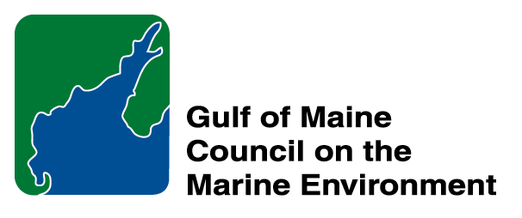 |  | 2014  Susan Snow-Cotter Leadership Award Nomination Form
The Susan Snow-Cotter Leadership Award is bestowed in memory of Susan Snow-Cotter, a long-time friend of the Council and Working Group. The Award is given to an individual from one of the five states and provinces bordering the Gulf of Maine. The Susan Snow-Cotter Leadership Award honors coastal management professionals who exemplify outstanding leadership or exceptional mentoring in the Gulf of Maine watershed. As former Director of the Massachusetts Office of Coastal Zone Management, Susan was recognized as a leader who exhibited unwavering passion, enthusiasm, and insight to develop pragmatic approaches to coastal management challenges. The Council presents this award to a professional who has demonstrated exceptional leadership in coastal and ocean planning and management by:

- Developing pragmatic approaches;
- Building collaborative efforts through mobilizing and unifying others around an issue or initiative; and/or
- Serving as a strong and supportive mentor to emerging coastal management professionals.

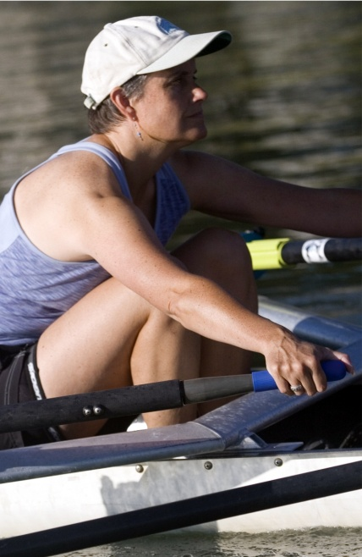  Susan Snow-Cotter | 0BNomination instructions  - Individuals or organizations may submit nominations. Self-nominations are not accepted.  - The nominee must be resident of Maine, Massachusetts, New Brunswick, New Hampshire, or Nova Scotia and his/her work be conducted primarily in the Gulf of Maine region.  - The nominee’s contributions must have occurred in the Gulf of Maine watershed.  - Nominations must be made on this form. Attachments will not be accepted.  - Nominations must be emailed to jleblanc@gulfofmaine.org by the close of business on March 30, 2014. Please rename the nomination form with _LastNameofNominee added to the end of the file name.
Questions? Please contact Council Coordinator Joan LeBlanc at jleblanc@gulfofmaine.org

To view a list of past award winners, please visit: http://www.gulfofmaine.org/2/opportunities/

Nominee information
Name (as it would appear on the award plaque if selected): Steve Miller
Affiliation (if applicable): Great Bay National Estuarine Research Reserve
Mailing address: 89 Depot Road, Greenland NH 03840
Phone: 603-294-0146
Email: Steve.Miller@wildlife.nh.gov

Brief background on why the individual/organization is being nominated: Summary that will be read during the awards ceremony if nominee is selected. This text will also be used in media releases (not to exceed 2,000 characters, including spaces and punctuation):

Steve Miller is the Coastal Training Program Coordinator at the Great Bay National Estuarine Research Reserve. His job is to make sure that the people who should be using science in their decision making have access to it and understand it in the Great Bay Watershed. This is a difficult job, and part of what makes it difficult is that fact that you can not hand “science” over to people and expect utilization. To actually make sure that science is considered when municipal and business leaders are making difficult choices, leaders need ongoing support from people they have an established relationship with. Steve has excelled at bringing both training and extension practitioners and municipal leaders together to foster an environment of trust, of expanding knowledge, and of productivity. A town planner from Exeter NH recently told me “When I think of Steve Miller at the Great Bay Reserve I think of the phrase "essential services". Although typically used to describe utilities, for land use board volunteers and so many others trying to grasp the complex ecological relationships within our vulnerable systems in the seacoast New Hampshire region, Steve's role at the Reserve is an essential service.”

Steve has been regionally recognized as an EPA “Climate Leader” for his work as the co-chair of the NH Coastal Adaptation Workgroup, and has presented at numerous regional and national conferences to promote the uniquely effective partnership. The New Hampshire Coastal Adaptation Workgroup (NHCAW) is a collaboration of 19 organizations working to help communities in New Hampshire’s Seacoast area prepare for the effects of extreme weather events and other effects of long term climate change. NHCAW helps communities learn about and utilize existing resources and locate additional assistance to better prepare for climate effects in order to protect their social, economic, human and environmental health. NHCAW provides communities with education, facilitation and guidance. As a part of his role with CAW, Steve has helped prepare content, co-produced a regional climate assessment, worked with speaker and scientist, facilitated community meetings and workshops, helped to start a similar organization in Newburyport MA, and has hosted two “Climate Summits” at the Great Bay NERR. The NH Climate Summit ensures that all of the communities, agencies, and scientists are aware of innovative science, community successes and challenges, and emerging trends in climate science and adaptation efforts in the region. His efforts to advance climate adaptation in New Hampshire communities ensures that people who want to work on this issue in the seacoast region all have access to information, technical assistance, emerging science, and a community of people who want to work with them.

Although Steve’s efforts on climate adaptation over the past five years have been monumental, they are only one piece of his portfolio as the Coastal Training Program Coordinator at the Great Bay NERR. In his twelve years at this position, he has tirelessly worked with municipal elected and volunteer boards on the most critical issues in New Hampshire. Saltmarsh protection, land use regulations, planting buffers, and offering environmental communication and planning workshops have all been topics Steve’s program has offered. His work includes expansive efforts to bring stormwater science and management to municipalities and businesses, and Steve led the effort to install porous pavement and concrete at the Reserve’s visitor center as well.

His work has had a huge impact on the seacoast region of New Hampshire, and CAW has been held up as a state, regional and national leader in how to provide coordinated assistance to communities who will need to adapt to climate change impacts. In addition to his impressive body of work, Steve is a constant advocate for environmental stewardship at work and in his personal pursuits. He has been a member of the Portsmouth conservation commission for years, continuing to work for the earth and for his own community. As a person, Steve has a level of integrity that is difficult to match. He is exceedingly hard working and his expectations for himself lift the entire network of people around him to a higher plane. He has a special blend of practicality alongside a sincere expectation that we can change the world. And I think he will.

Name and contact information of person making the nomination:
Name: Cory Riley
Affiliation: Great Bay National Estuarine Research Reserve, Manager
Address: 225 Main Street, Durham NH
Phone: 603 868 1095
Email: cory.riley@wildlife.nh.gov

