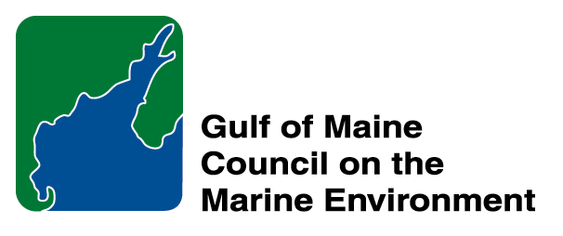 |  | 2014  Susan Snow-Cotter Leadership Award Nomination Form
The Susan Snow-Cotter Leadership Award is bestowed in memory of Susan Snow-Cotter, a long-time friend of the Council and Working Group. The Award is given to an individual from one of the five states and provinces bordering the Gulf of Maine. The Susan Snow-Cotter Leadership Award honors coastal management professionals who exemplify outstanding leadership or exceptional mentoring in the Gulf of Maine watershed. As former Director of the Massachusetts Office of Coastal Zone Management, Susan was recognized as a leader who exhibited unwavering passion, enthusiasm, and insight to develop pragmatic approaches to coastal management challenges. The Council presents this award to a professional who has demonstrated exceptional leadership in coastal and ocean planning and management by:

- Developing pragmatic approaches;
- Building collaborative efforts through mobilizing and unifying others around an issue or initiative; and/or
- Serving as a strong and supportive mentor to emerging coastal management professionals.

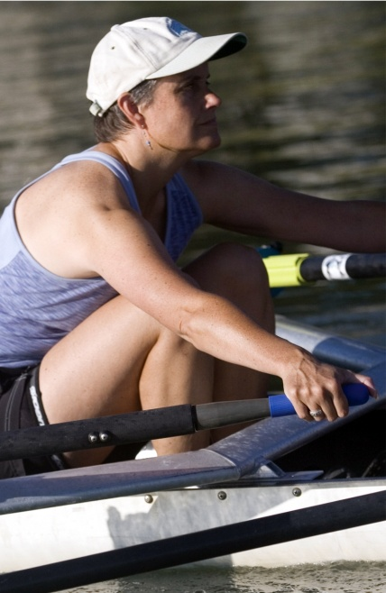  Susan Snow-Cotter | 0BNomination instructions  - Individuals or organizations may submit nominations. Self-nominations are not accepted.  - The nominee must be resident of Maine, Massachusetts, New Brunswick, New Hampshire, or Nova Scotia and his/her work be conducted primarily in the Gulf of Maine region.  - The nominee’s contributions must have occurred in the Gulf of Maine watershed.  - Nominations must be made on this form. Attachments will not be accepted.  - Nominations must be emailed to jleblanc@gulfofmaine.org by the close of business on March 30, 2014. Please rename the nomination form with _LastNameofNominee added to the end of the file name.
Questions? Please contact Council Coordinator Joan LeBlanc at jleblanc@gulfofmaine.org

To view a list of past award winners, please visit: http://www.gulfofmaine.org/2/opportunities/

Nominee information
Name (as it would appear on the award plaque if selected): Steve Miller
Affiliation (if applicable): Great Bay National Estuarine Research Reserve
Mailing address: 89 Depot Road, Greenland NH 03840
Phone: 603-294-0146
Email: Steve.Miller@wildlife.nh.gov

Brief background on why the individual/organization is being nominated: Summary that will be read during the awards ceremony if nominee is selected. This text will also be used in media releases (not to exceed 2,000 characters, including spaces and punctuation):

Name and contact information of person making the nomination:
Name: Sherry Godlewski
Affiliation: NH Department of Environmental Services
Address: 29 Hazen Drive Concord NH 03302
Phone: 603-271-6801
Email: sherry.godlewski@des.nh.gov

Steve Miller is a phenomenal steward of the Gulf of Maine Watershed. I first met Steve in 1992 when he was working at the Seacoast Science Center in Rye, NH. In his work there he was involved in education efforts and making science more understandable for folks, especially the younger generation. His dedication was evident then and it has grown over the years. Steve began working at the Great Bay National Estuarine Research Reserve in 2003. In his role as the Coastal Training Program Coordinator he continues to encourage and support individuals in having a thorough understanding of science and the application of methods to solve some of the biggest problems facing our Gulf of Maine. Through education and awareness, Steve facilitates learning at all levels.

I am very fortunate to have the opportunity to work closely with Steve. Back in 2009 Steve thought it was important to start a conversation about climate change and the impacts coastal New Hampshire will be facing; specifically sea level rise and storm surge. Steve is a founding member and Co-Chair of the New Hampshire Coastal Adaptation Work Group (CAW). CAW began meeting in January 2010 and is made up of 19 partners including federal, state, regional, municipal, academic, non-profit and consultants as members. Steve’s vision initiated this successful collaboration and his leadership continues to move us forward. CAW is host to a workshop series that has touched hundreds of municipal decision makers and other stakeholders in the Gulf of Maine. His leadership helps CAW secure grant funding and offer pragmatic approaches to adapting to a changing climate. Steve has also organized 3 Climate Summits for the coastal region, highlighting local research and success stories He includes future coastal professionals from UNH. This gives them an opportunity to learn how collaborative efforts are successful and mutually beneficial and that protecting our marine ecosystems is foundational to our way of life in coastal NH.

