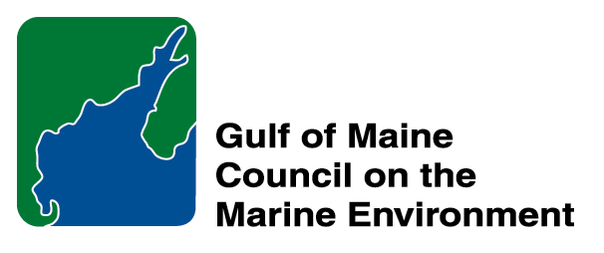 |  | 2014  Susan Snow-Cotter Leadership Award Nomination Form
The Susan Snow-Cotter Leadership Award is bestowed in memory of Susan Snow-Cotter, a long-time friend of the Council and Working Group. The Award is given to an individual from one of the five states and provinces bordering the Gulf of Maine. The Susan Snow-Cotter Leadership Award honors coastal management professionals who exemplify outstanding leadership or exceptional mentoring in the Gulf of Maine watershed. As former Director of the Massachusetts Office of Coastal Zone Management, Susan was recognized as a leader who exhibited unwavering passion, enthusiasm, and insight to develop pragmatic approaches to coastal management challenges. The Council presents this award to a professional who has demonstrated exceptional leadership in coastal and ocean planning and management by:

- Developing pragmatic approaches;
- Building collaborative efforts through mobilizing and unifying others around an issue or initiative; and/or
- Serving as a strong and supportive mentor to emerging coastal management professionals.

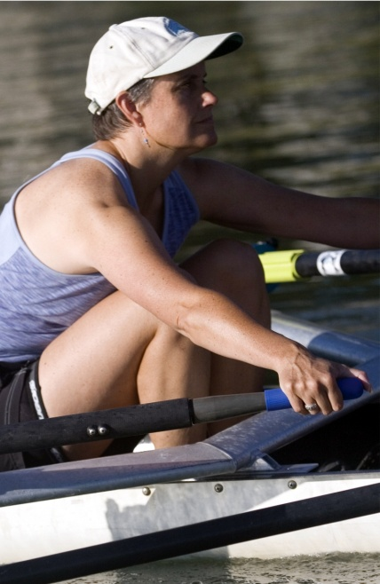  Susan Snow-Cotter | 0BNomination instructions  - Individuals or organizations may submit nominations. Self-nominations are not accepted.  - The nominee must be resident of Maine, Massachusetts, New Brunswick, New Hampshire, or Nova Scotia and his/her work be conducted primarily in the Gulf of Maine region.  - The nominee’s contributions must have occurred in the Gulf of Maine watershed.  - Nominations must be made on this form. Attachments will not be accepted.  - Nominations must be emailed to jleblanc@gulfofmaine.org by the close of business on March 30, 2014. Please rename the nomination form with _LastNameofNominee added to the end of the file name.
Questions? Please contact Council Coordinator Joan LeBlanc at jleblanc@gulfofmaine.org

To view a list of past award winners, please visit: http://www.gulfofmaine.org/2/opportunities/

Nominee information
Name (as it would appear on the award plaque if selected): Dr. Jo Ann Muramoto
Affiliation (if applicable): The Association to Preserve Cape Cod
Mailing address: PO Box 398, Barnstable, MA 02630
Phone: 508-362-4226
Email: jmuramoto@apcc.org

Brief background on why the individual/organization is being nominated: Summary that will be read during the awards ceremony if nominee is selected. This text will also be used in media releases (not to exceed 2,000 characters, including spaces and punctuation):

Name and contact information of person making the nomination:
Name: Donald J. Palladino, PhD
Affiliation: President, Friends of Herring River, Wellfleet/Truro, Inc.
Address: P.O. Box 496, Wellfleet, MA sds02667
Phone: 508 349 2950
Email: don.palladino@comcast.net

Just like Susan Snow-Cotter, Dr. Jo Ann Muramoto is a coastal management professional who exhibits unwavering passion, enthusiasm, and insight and who routinely develops pragmatic approaches to coastal management challenges. As the Association to Preserve Cape Cod’s senior scientist and regional coordinator for the Massachusetts Bays Program, Jo Ann has spearheaded collaborative efforts to conquer a myriad of coastal zone protection and improvement initiatives. She is a leader, a mentor and innovator on Cape Cod and across the entire Gulf of Maine region.

Cape Cod is a region comprised of small towns that lack resources to effectively plan and respond to coastal management challenges. Dr. Muramoto provides scientific and technical assistance to local natural resource, conservation, public works and planning officials, enabling them to effectively compete for grants and carry out innovative management initiatives. In the past year alone she has:

- Assisted 10 towns and 7 nonprofits in preparing grant applications and management action plans.
- Conducted an internal study of the ecological impacts of the Pilgrim Nuclear Plant on Cape Cod Bay.
- Coordinated the Cape Cod herring count program (18 runs utilizing over 100 volunteers and coordinated with DMF and NOAA).
- Helped develop a study to model the impact of sea level rise on Cape Cod’s sole source aquifer.
- Launched an update of the Cape Cod Critical Habitat Atlas.
- Conducted a survey of marine invasive species in Cape Cod Bay.
- Carried out a broad spectrum of educational and mentoring programs, including supervising interns, providing practical science experience for scout groups, conducting/planning workshops on stormwater management, and designing and implementing training for volunteers.
During that same time period, Dr. Muramoto has also remained a tireless advocate for No Discharge Areas, ecologically sound aquaculture programs and decision-making based on sound science.

