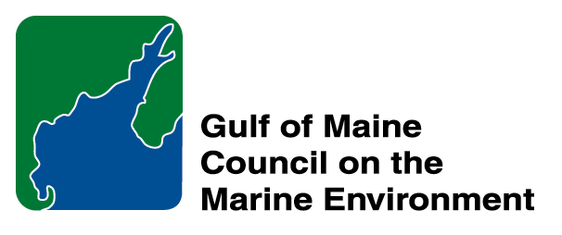 |  | 2014  Sustainable Communities  Nomination Form
The intent of the ‘Sustainable Communities Award’ is to recognize communities, or groups within communities, of their exemplary work in achieving sustainability outcomes related to the environment and economy, in line with the objectives of the GOMC Action Plan. The selection criteria are derived from the Melbourne Principles and the Government of New Brunswick’s Community Recognition Award selection criteria.
- Provides a long-term vision for communities based on pillars of sustainability: social /cultural, environmental and economic, as well as political equity, and the community’s individuality.
- Works towards achieving long-term economic, social, and environmental security.
- Recognizes the intrinsic value of biodiversity and natural ecosystems, and acts to promote the stewardship of biodiversity and natural ecosystems, and protects and/or restores them.
- Strives to enable communities to minimize their ecological footprint.
- Engages the community in the planning and implementation of sustainable solutions.
- Builds on the characteristics of ecosystems in the development and nurturing of healthy and sustainable communities.
- Recognizes and builds on the distinctive characteristics of the community, including their human and cultural values, history, and natural systems.
- Empowers people and fosters participation.
- Expands and enables communication and cooperative networks to work towards sustainability as a common and shared goal.
- Promotes sustainable production and consumption, through appropriate use of environmentally sound technologies and effective demand management.
- Enables continual improvement, based on action planning, accountability, transparency and good governance.

Overarching Program Criteria
Nominations should demonstrate that the community, group, program, or project contributed to the long-term viability of the community, improved the health of its immediate environment, and impacted positively the health of the Gulf of Maine.

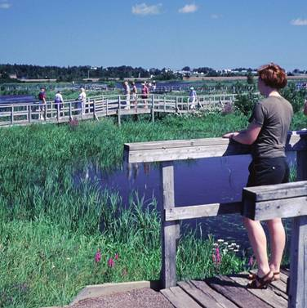 | Nomination instructions  - Individuals or organizations may make nominations. Self-nominations are not accepted.  - The community must be based in part or in whole in Maine, Massachusetts, New Brunswick, New Hampshire, or Nova Scotia. The nominee’s contributions must have occurred in the Gulf of Maine watershed.  - Nominations must be made on this nomination form. This form may be reproduced electronically. Nominations with missing information will not be considered. Please provide all information on this form—attachments will not be accepted.  - Nominations must be emailed to jleblanc@gulfofmaine.org by the close of business on March 30, 2014. Please rename the nomination form with _LastNameofNominee added to the end of the file name.
Questions? Please contact Council Coordinator Joan LeBlanc at jleblanc@gulfofmaine.org.
Nominee Information
Name (as it would appear on the award plaque if selected) Town of Plymouth
Affiliation: (David Gould, obo Town of Plymouth, Dept. of Marine and Environmental Affairs)
Mailing address: 11 Lincoln St., Plymouth MA 02360
Phone: 508-747-1620 x 127
Email: dgould@townhall.plymouth.ma.us

Brief background on why the community or group is being nominated:
Summary will be read during the awards ceremony if nominee is chosen. This text will also be used in media releases (not to exceed 2,000 characters, including spaces and punctuation):

The Town of Plymouth has been exemplary in restoring fish passage and instream and wetland habitat throughout the community. David Gould and his staff in the Department of Marine and Environmental Affairs have removed three out of the six dams along the 1.5 mile Town Brook, the stream that supported the first settlers, with the fourth to be removed within the next few years and the other two having reliable fish passage structures. One of the largest projects to date, the Eel River Headwaters Restoration, restored 1.5 miles of degraded stream channel and 40 acres of cranberry bogs to native wetland habitat, installed two new culverts and completed a full dam removal. The Town is currently working to restore another large cranberry bog complex, Tidmarsh Farms, which will result in restoration of 250 acres of former cranberry bog into functional wetlands. Plymouth has also completed smaller projects on its many ponds and tributaries, including removing weirs for salter brook trout habitat on Wellingsley Brook and reducing stormwater and nutrient pollution throughout the town by implementing green infrastructure. The Gulf of Maine Council has played a strong financial role in helping to support many of these restoration projects, as well. David and his staff are highly motivated on both a professional and personal level to improve the habitats of Plymouth and have been extremely successful in making their goals a reality.

Contact Information for Person Making the Nomination
Name & Affiliation: Sara Grady, Massachusetts Bays Program – South Shore (North and South Rivers Watershed Association)
Address: PO Box 43, Norwell MA
Phone: 781-659-8168
Email: sara@nsrwa.org

