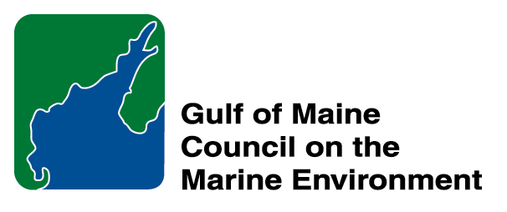 |  | 2014  Sustainable Communities  Nomination Form
The intent of the ‘Sustainable Communities Award’ is to recognize communities, or groups within communities, of their exemplary work in achieving sustainability outcomes related to the environment and economy, in line with the objectives of the GOMC Action Plan. The selection criteria are derived from the Melbourne Principles and the Government of New Brunswick’s Community Recognition Award selection criteria.
- Provides a long-term vision for communities based on pillars of sustainability: social /cultural, environmental and economic, as well as political equity, and the community’s individuality.
- Works towards achieving long-term economic, social, and environmental security.
- Recognizes the intrinsic value of biodiversity and natural ecosystems, and acts to promote the stewardship of biodiversity and natural ecosystems, and protects and/or restores them.
- Strives to enable communities to minimize their ecological footprint.
- Engages the community in the planning and implementation of sustainable solutions.
- Builds on the characteristics of ecosystems in the development and nurturing of healthy and sustainable communities.
- Recognizes and builds on the distinctive characteristics of the community, including their human and cultural values, history, and natural systems.
- Empowers people and fosters participation.
- Expands and enables communication and cooperative networks to work towards sustainability as a common and shared goal.
- Promotes sustainable production and consumption, through appropriate use of environmentally sound technologies and effective demand management.
- Enables continual improvement, based on action planning, accountability, transparency and good governance.

Overarching Program Criteria
Nominations should demonstrate that the community, group, program, or project contributed to the long-term viability of the community, improved the health of its immediate environment, and impacted positively the health of the Gulf of Maine.

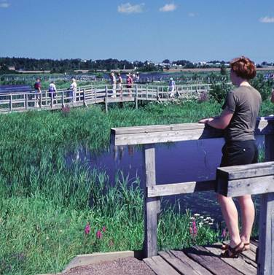 | Nomination instructions  - Individuals or organizations may make nominations. Self-nominations are not accepted.  - The community must be based in part or in whole in Maine, Massachusetts, New Brunswick, New Hampshire, or Nova Scotia. The nominee’s contributions must have occurred in the Gulf of Maine watershed.  - Nominations must be made on this nomination form. This form may be reproduced electronically. Nominations with missing information will not be considered. Please provide all information on this form—attachments will not be accepted.  - Nominations must be emailed to jleblanc@gulfofmaine.org by the close of business on March 30, 2014. Please rename the nomination form with _LastNameofNominee added to the end of the file name.
Questions? Please contact Council Coordinator Joan LeBlanc at jleblanc@gulfofmaine.org.
Nominee Information
Name (as it would appear on the award plaque if selected) Town of Plymouth
Affiliation: (David Gould, obo Town of Plymouth, Dept. of Marine and Environmental Affairs)
Mailing address: 11 Lincoln St., Plymouth MA 02360
Phone: 508-747-1620 x 127
Email: dgould@townhall.plymouth.ma.us

Brief background on why the community or group is being nominated:

Summary that will be read during the awards ceremony if nominee is chosen. This text will also be used in media releases (not to exceed 2,000 characters, including spaces and punctuation):
With arguably the richest history of all towns in Massachusetts, Plymouth could have easily focused its attention on the tourism associated with the Pilgrims' settlement. Instead, the Town has chosen to recognize its rich environmental heritage and to invest in those resources just as heavily. Plymouth is truly a Sustainable Community in its vision for the downtown and tourist center, but also for its efforts to protect the vibrant recreational and commercial fishery in Plymouth Harbor, the unique pineland and kettlehole pond ecosystems, and the ancient herring runs that return to its rivers and streams. Plymouth residents have repeatedly voted to contribute Town resources to match funds from state, federal, and private entities for ecosystem restoration projects. These partnerships have demonstrated the significant regional benefits from ecological restoration in Plymouth. One excellent example of the Town's commitment to a vision for a sustainable future is the Town Brook Restoration Project. This 2.5-mile-long Brook was the Pilgrims' fresh water supply for generations and remains one of the state's strongest herring runs, despite centuries of industrial uses. Since the late 1990's, Plymouth has been steadily implementing a 15-step restoration plan to restore fish passage, improve water quality, and provide passive recreation on the Brook. By leveraging its financial commitment and the in-kind services of its Departments, Plymouth has attracted the support of leaders in restoration from all sectors of the economy. The Town Brook restoration is merely one of the ambitious projects that the Town has undertaken. This commitment to the environment has stood as an example to other coastal communities and an investment in the Town's economy. In 2020, Plymouth will celebrate its quadricentennial and the value that its residents have placed on community sustainability will be showcased on the world stage.

Contact Information for Person Making the Nomination
Name & Affiliation: Nick Wildman, MA Division of Ecological Restoration
Address: 251 Causeway St., Boston MA 02114
Phone: 617-626-1527
Email: nick.wildman@state.ma.us

