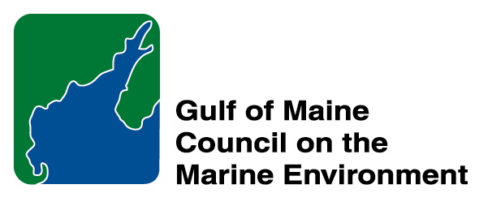 |  | 2014  Sustainable Communities  Nomination Form
The intent of the ‘Sustainable Communities Award’ is to recognize communities, or groups within communities, of their exemplary work in achieving sustainability outcomes related to the environment and economy, in line with the objectives of the GOMC Action Plan. The selection criteria are derived from the Melbourne Principles and the Government of New Brunswick’s Community Recognition Award selection criteria.
- Provides a long-term vision for communities based on pillars of sustainability: social /cultural, environmental and economic, as well as political equity, and the community’s individuality.
- Works towards achieving long-term economic, social, and environmental security.
- Recognizes the intrinsic value of biodiversity and natural ecosystems, and acts to promote the stewardship of biodiversity and natural ecosystems, and protects and/or restores them.
- Strives to enable communities to minimize their ecological footprint.
- Engages the community in the planning and implementation of sustainable solutions.
- Builds on the characteristics of ecosystems in the development and nurturing of healthy and sustainable communities.
- Recognizes and builds on the distinctive characteristics of the community, including their human and cultural values, history, and natural systems.
- Empowers people and fosters participation.
- Expands and enables communication and cooperative networks to work towards sustainability as a common and shared goal.
- Promotes sustainable production and consumption, through appropriate use of environmentally sound technologies and effective demand management.
- Enables continual improvement, based on action planning, accountability, transparency and good governance.

Overarching Program Criteria
Nominations should demonstrate that the community, group, program, or project contributed to the long-term viability of the community, improved the health of its immediate environment, and impacted positively the health of the Gulf of Maine.

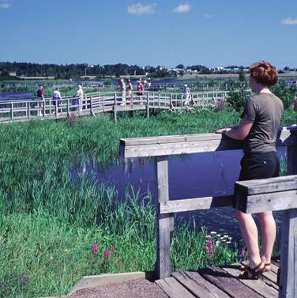 | Nomination instructions  - Individuals or organizations may make nominations. Self-nominations are not accepted.  - The community must be based in part or in whole in Maine, Massachusetts, New Brunswick, New Hampshire, or Nova Scotia. The nominee’s contributions must have occurred in the Gulf of Maine watershed.  - Nominations must be made on this nomination form. This form may be reproduced electronically. Nominations with missing information will not be considered. Please provide all information on this form—attachments will not be accepted.  - Nominations must be emailed to jleblanc@gulfofmaine.org by the close of business on March 30, 2014. Please rename the nomination form with _LastNameofNominee added to the end of the file name.
Questions? Please contact Council Coordinator Joan LeBlanc at jleblanc@gulfofmaine.org.
Nominee Information
Name : Municipality of the County of Colchester
Affiliation: c/o Crawford MacPherson (Director of Community Development)
Mailing address: 1 Church Street Truro, Nova Scotia, B2N 3Z5
Phone: 902/ 897-3170
Email: CMacPherson@colchester.ca

Brief background on why the community or group is being nominated:

Summary that will be read during the awards ceremony if nominee is chosen. This text will also be used in media releases (not to exceed 2,000 characters, including spaces and punctuation):

The Municipality of the County of Colchester is working with regional partners, governments and residents to reduce flood impacts and improve local water quality. The Municipality is working cooperatlively as a pilot study in Provincially funded flood-mitigation framework to help Nova Scotia communities.

Colchester County communities are receiving funding in the first year because it is particularly vulnerable to flooding. Approved projects include installing permanent flow monitoring stations, raising dykes, stabilizing river banks and removing sediment from stream beds.

In addition to mitigating the effects of flooding to the communities and an effort of continuous improvement, the County also wanted to demonstrate how low impact development solutions can help to improve water quality while addressing stomrwater management. The County has installed Rain gardens designed by Dalhousie University staff. Installation will be supervised by Dalhousie and Municipal staff. Main construction will be undertaken by Municipal Public Works staff and there will be opportunity for RBC and students to participate in the planting of the rain garden.

The county has also installed pervious pavement: Municipal Engineering staff oversaw the replacement of hard surface parking lot with pervious pavement, based on design specs from UNH’s Stormwater Center. A collaboration established through the Gulf of Maine program in 2012. Installation of the base and pavement was undertaken by municipal Public Works staff and local paving contractor.

These two stormwater initatives coupled with the work they are doing in collaboration with the province set the County apart for their wholestic view to climate adapation and mitigation. They are not only minimizing their ecological footprint, but they are Engages the larger Nova Scotian community in demonstrating that these sustainable solutions are possible in Nova Scotia. The rain garden and pervious pavement site will be a demonstration site for municipalities, developers and community members to visit, learn from and hopefully implement on their own. Their long-term vision for more sustainable community has begun in part by these initiatives. They will no doubt be contributing to their achievement of long-term economic, social, and environmental security.

Contact Information for Person Making the Nomination
Name : Sophia Foley
Affiliation : Nova Scotia Environment
Mailling Address : 1903 Barrington Street – Suite 2085, PO Box 442, Halifax, NS B3J 2P8
Phone : 902-424-1996
Email : foleysm@gov.ns.ca

