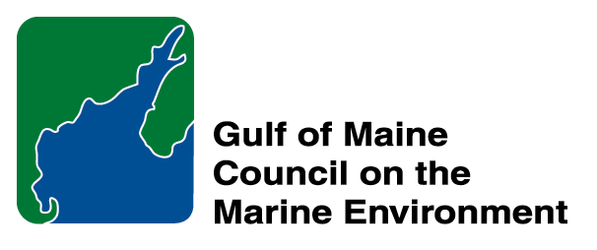 | 2014 Gulf of Maine Council Visionary Award  Nomination Form

The Gulf of Maine Visionary Award is presented annually to an individual or organization within each of the five Gulf of Maine jurisdictions of Massachusetts, New Hampshire, Maine, New Brunswick, and Nova Scotia. The Awards recognize innovation, creativity, and commitment to marine protection by businesses, environmental organizations, or individuals who are making a difference to the health of the Gulf of Maine.
* As the Council celebrates our 25th Anniversary, we seek to recognize the value of young people as well as experienced leaders in working to protect the Gulf of Maine ecosystem. We welcome and encourage nominees of all ages (including students or youth organizations) for our 2014 Gulf of Maine Visionary Awards and Longard Volunteer Award.

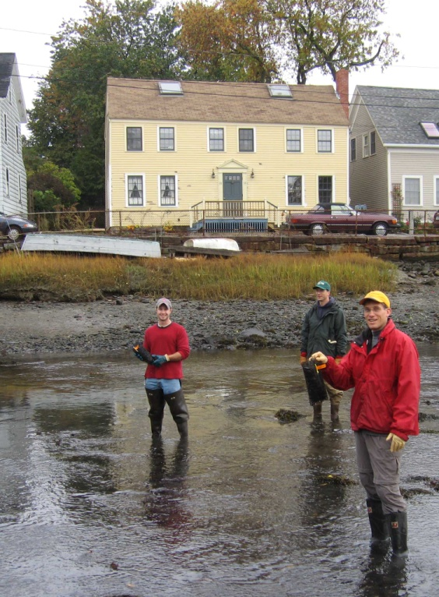 | Nomination instructions:  - Individuals or organizations may make nominations. Self-nominations are not accepted.  - The nominee must reside in Maine, Massachusetts, New Brunswick, New Hampshire, or Nova Scotia. The nominee’s contributions must have occurred in the Gulf of Maine watershed.  - Visionary Award nominees may be paid professionals or volunteers.  - Nominations must be made on this nomination form. Nominations with missing information will not be considered. Attachments will not be accepted.  - Nominations must be emailed to jleblanc@gulfofmaine.org by the close of business on March 30, 2014. Please rename the nomination form with _LastNameofNominee added to the file name.
Questions? Please contact Council Coordinator Joan LeBlanc at jleblanc@gulfofmaine.org
To view a list of past award winners, please visit: http://www.gulfofmaine.org/2/opportunities/

Nominee information
Name (as it will appear on the award plaque if selected): Massachusetts Division of Ecological Restoration
Affiliation: (Hunt Durey, obo MA DER)
Mailing address: 251 Causeway St., 4th Fl., Boston MA 02114
Phone: 617-626-1540
Email: hunt.durey@state.ma.us

Brief background on why the individual/organization is being nominated. This summary will be read during the awards
ceremony if nominee is selected. This text will also be used in media releases (not to exceed 2,000 characters, including spaces and punctuation):

The Massachusetts Division of Ecological Restoration epitomizes the word “visionary”. The Division was formed in 2009 by combining the Massachusetts Wetlands Restoration Program and the Massachusetts Riverways Program to take a more holistic approach to ecological restoration. This synergistic merger has turned the state into a national leader in habitat restoration, with 115 projects completed, restoring 1,500 acres of marsh and opening 97 river miles. Most of this restoration has occurred in the Gulf of Maine.

The Division’s vision goes above and beyond accomplishing habitat restoration to just benefit the environment. The Division recognizes that there is an important human element to habitat restoration projects and has conducted and funded several studies to document the socioeconomic and ecosystem services benefits of habitat restoration projects, such as job creation, flood protection, fisheries production, water quality improvement, increased property values, attraction for tourism, and expansion of recreational opportunities. The results of these studies promote the social and economic values of habitat restoration projects and have been used and referenced by others across the country.

The Division has a demonstrated record of successfully managing and implementing habitat restoration projects. This record of success, and the talent and professionalism of its staff, makes the Division a trusted partner for funding agencies. In 2014 alone, the Division secured over $14 million in competitive federal grant funding to implement river and wetland restoration projects across Massachusetts.

Name and contact information of person making the nomination:
Name & Affiliation: Steve Block, NOAA Restoration Center
Address: 55 Great Republic Drive, Gloucester MA 1930
Phone: 978-281-9127 (office); 978-689-7653 (cell)
Email: steve.block@noaa.org

The mission of the Council is to maintain and enhance environmental quality in the Gulf of Maine and to
allow for sustainable resource use by existing and future generations.

Nova Scotia Environment • 2013-2014 Secretariat
The mission of the Council is to maintain and enhance environmental quality in the Gulf of Maine and to
allow for sustainable resource use by existing and future generations.

Massachusetts Office of Coastal Zone Management • 2002-2003 Secretariat
GOMC • c/o NHDES • PO Box 95 • Concord, NH, US • 03302-0095 • Phone (603) 225-5544

