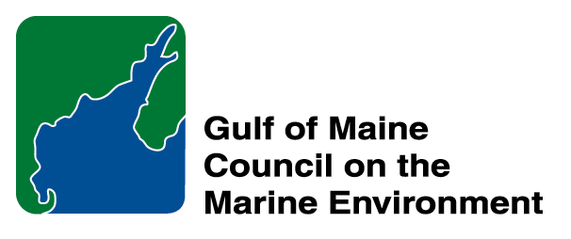 | 2014 Gulf of Maine Council Visionary Award  Nomination Form

The Gulf of Maine Visionary Award is presented annually to an individual or organization within each of the five Gulf of Maine jurisdictions of Massachusetts, New Hampshire, Maine, New Brunswick, and Nova Scotia. The Awards recognize innovation, creativity, and commitment to marine protection by businesses, environmental organizations, or individuals who are making a difference to the health of the Gulf of Maine.
* As the Council celebrates our 25th Anniversary, we seek to recognize the value of young people as well as experienced leaders in working to protect the Gulf of Maine ecosystem. We welcome and encourage nominees of all ages (including students or youth organizations) for our 2014 Gulf of Maine Visionary Awards and Longard Volunteer Award.

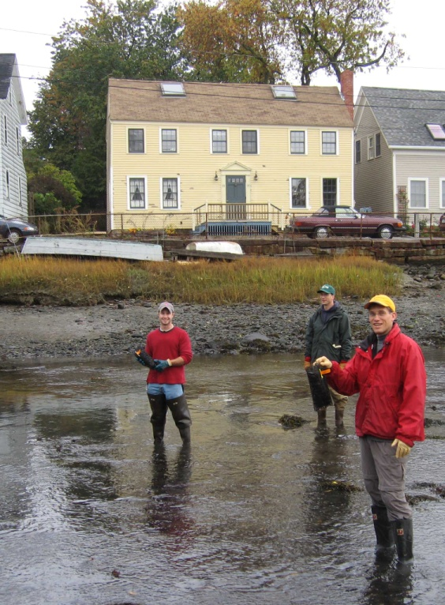 | Nomination instructions:  - Individuals or organizations may make nominations. Self-nominations are not accepted.  - The nominee must reside in Maine, Massachusetts, New Brunswick, New Hampshire, or Nova Scotia. The nominee’s contributions must have occurred in the Gulf of Maine watershed.  - Visionary Award nominees may be paid professionals or volunteers.  - Nominations must be made on this nomination form. Nominations with missing information will not be considered. Attachments will not be accepted.  - Nominations must be emailed to jleblanc@gulfofmaine.org by the close of business on March 30, 2014. Please rename the nomination form with _LastNameofNominee added to the file name.
Questions? Please contact Council Coordinator Joan LeBlanc at jleblanc@gulfofmaine.org
To view a list of past award winners, please visit: http://www.gulfofmaine.org/2/opportunities/

Nominee information
Name (as it will appear on the award plaque if selected): Todd Callaghan
Affiliation: Massachusetts Office of Coastal Zone Management
Mailing address: 251 Causeway St., Suite 800, Boston MA 02114
Phone: 617-626-1233
Email: Todd.Callaghan@state.ma.us

Brief background on why the individual/organization is being nominated:
Summary will be read during the awards ceremony if nominee is selected. This text will also be used in media releases (not to exceed 2,000 characters, including spaces and punctuation):

Since his tenure with the Massachusetts Office of Coastal Zone Management (CZM) began in 1999, Todd Callaghan has diligently worked to develop the strategy for achieving a Massachusetts statewide No Discharge Area (NDA) designation. The implementation of the NDA strategy so far has resulted in the protection of 900,000 acres of state waters from the harmful effects of vessel discharges to water quality and public health caused by bacteria, viruses, nutrients, and chemicals. In 2014, the final pieces of the puzzle—a strip of waters between two and three miles from shore extending from Manchester-by-the-Sea to Marshfield, a corridor in Vineyard Sound, and a corridor in Nantucket Sound—were submitted by the Commonwealth of Massachusetts for designation by the U.S. Environmental Protection Agency, thanks to Todd’s efforts and leadership. He has also secured the funding for, and managed the design of, eight commercial pumpout facilities, totaling over $100,000. These facilities provide a convenient way for boat owners to properly dispose of their sewage. His work has resulted in a program that serves as a national model, providing assistance to programs on both the East and West Coasts. In addition to the protection of Massachusetts waters, impacts of sewage disposal to the greater Gulf of Maine have been significantly reduced due to Todd’s efforts. Todd has also been a significant contributor to the development of protections to marine habitats through his leadership of the Massachusetts Ocean Management Plan Habitat Workgroup. This work has involved the collection and analysis of sophisticated data resulting in the development of highly accurate maps for six Special, Sensitive, or Unique resource areas. For these reasons, I believe that Todd Callaghan is the ideal choice for the 2014 Gulf of Maine Visionary Award.

Name and contact information of person making the nomination:
Name & Affiliation: Robert Boeri, MA Office of Coastal Zone Management
Address: 251 Causeway St., Suite 800, Boston MA 02114
Phone:617-626-1050
Email: robert.boeri@state.ma.us

The mission of the Council is to maintain and enhance environmental quality in the Gulf of Maine and to
allow for sustainable resource use by existing and future generations.

Nova Scotia Environment • 2013-2014 Secretariat

