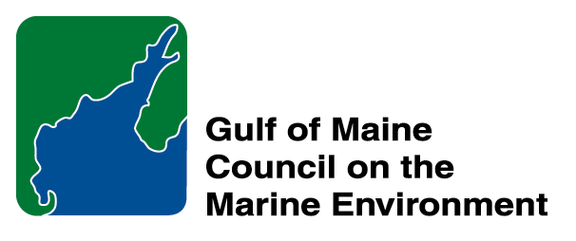 | 2014 Gulf of Maine Council Visionary Award  Nomination Form

The Gulf of Maine Visionary Award is presented annually to an individual or organization within each of the five Gulf of Maine jurisdictions of Massachusetts, New Hampshire, Maine, New Brunswick, and Nova Scotia. The Awards recognize innovation, creativity, and commitment to marine protection by businesses, environmental organizations, or individuals who are making a difference to the health of the Gulf of Maine.
* As the Council celebrates our 25th Anniversary, we seek to recognize the value of young people as well as experienced leaders in working to protect the Gulf of Maine ecosystem. We welcome and encourage nominees of all ages (including students or youth organizations) for our 2014 Gulf of Maine Visionary Awards and Longard Volunteer Award.

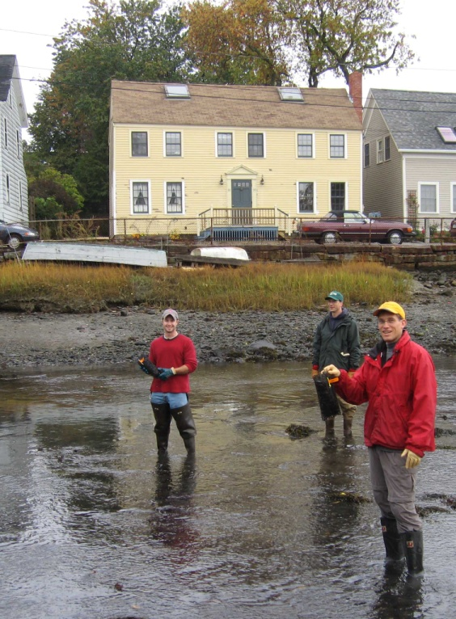 | Nomination instructions:  - Individuals or organizations may make nominations. Self-nominations are not accepted.  - The nominee must reside in Maine, Massachusetts, New Brunswick, New Hampshire, or Nova Scotia. The nominee’s contributions must have occurred in the Gulf of Maine watershed.  - Visionary Award nominees may be paid professionals or volunteers.  - Nominations must be made on this nomination form. Nominations with missing information will not be considered. Attachments will not be accepted.  - Nominations must be emailed to jleblanc@gulfofmaine.org by the close of business on March 30, 2014. Please rename the nomination form with _LastNameofNominee added to the file name.
Questions? Please contact Council Coordinator Joan LeBlanc at jleblanc@gulfofmaine.org
To view a list of past award winners, please visit: http://www.gulfofmaine.org/2/opportunities/

Nominee information
Name (as it will appear on the award plaque if selected): Phil Colarusso
Affiliation: U.S. Environment Protection Agency
Mailing address: 5 Post Office Square, Boston MA 02109
Phone: 617-918-1506
Email: Colarusso.phil@epa.gov

Brief background on why the individual/organization is being nominated:
Summary will be read during the awards ceremony if nominee is selected. This text will also be used in media releases (not to exceed 2,000 characters, including spaces and punctuation):

Phil Colarusso has been the leader in New England on the conservation of eelgrass. One of his major contributions has been as the organizer of the annual eelgrass meeting, which celebrated its 20th year in 2013. At these meetings, scientists and managers congregate to hear the latest research on eelgrass and other seagrasses, to review the status of eelgrass in New England, and to discuss conservation and management issues related to eelgrass. The meeting typically attracts 50+ people from state and federal agencies, academia, and non-profit organizations. Phil always provides great insights, great organization, unique and creative perspectives, and he does it all with a great sense of humor. The respect Phil commands within the field insures that key players in eelgrass conservation and management will always be present at his annual meetings. One of the real positive outcomes of these meetings is to increase the awareness of the need for conservation action on eelgrass in management agencies that might not have been aware of this need. Phil also deserves this award for his tireless efforts to insure that eelgrass beds are conserved and restored in the face of development threats, underwater cable projects, and impacts from marinas. He was a key management player in decisions that promoted eelgrass conservation at Sears Island, Maine when it was being considered for the development of an oil terminal, in Salem Sound when eelgrass was impacted by the Hubline Project, and in many smaller projects throughout New England. He has also been active in promoting and implementing efforts to restore eelgrass. His Ph.D. dissertation provided valuable insights into how eelgrass responds to light stress and provided fill with the scientific skills to complement his management expertise. Although mostly known for his work on eelgrass, in his job at EPA Phil has contributed in important ways to positive conservation outcomes in other major New England coastal issues, such as the decision to require upgrading of the cooling system on Brayton Point Power Plant.

Name and contact information of person making the nomination:
Name & Affiliation: Robert Buchsbaum, Mass Audubon
Address: Mass Audubon, 346 Grapevine Road, Wenham, MA 01984
Phone: 978-927-1122 x2703
Email: rbuchsbaum@massaudubon.org

The mission of the Council is to maintain and enhance environmental quality in the Gulf of Maine and to
allow for sustainable resource use by existing and future generations.

Nova Scotia Environment • 2013-2014 Secretariat

