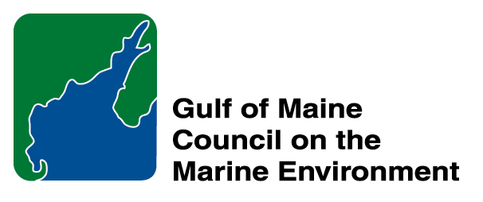 | 2014 Gulf of Maine Council Visionary Award  Nomination Form

The Gulf of Maine Visionary Award is presented annually to an individual or organization within each of the five Gulf of Maine jurisdictions of Massachusetts, New Hampshire, Maine, New Brunswick, and Nova Scotia. The Awards recognize innovation, creativity, and commitment to marine protection by businesses, environmental organizations, or individuals who are making a difference to the health of the Gulf of Maine.
* As the Council celebrates our 25th Anniversary, we seek to recognize the value of young people as well as experienced leaders in working to protect the Gulf of Maine ecosystem. We welcome and encourage nominees of all ages (including students or youth organizations) for our 2014 Gulf of Maine Visionary Awards and Longard Volunteer Award.

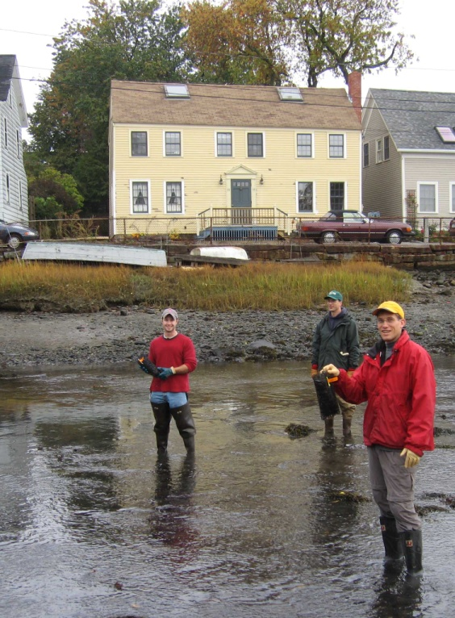 | Nomination instructions:  - Individuals or organizations may make nominations. Self-nominations are not accepted.  - The nominee must reside in Maine, Massachusetts, New Brunswick, New Hampshire, or Nova Scotia. The nominee’s contributions must have occurred in the Gulf of Maine watershed.  - Visionary Award nominees may be paid professionals or volunteers.  - Nominations must be made on this nomination form. Nominations with missing information will not be considered. Attachments will not be accepted.  - Nominations must be emailed to jleblanc@gulfofmaine.org by the close of business on March 30, 2014. Please rename the nomination form with _LastNameofNominee added to the file name.
Questions? Please contact Council Coordinator Joan LeBlanc at jleblanc@gulfofmaine.org
To view a list of past award winners, please visit: http://www.gulfofmaine.org/2/opportunities/

Nominee information
Name (as it will appear on the award plaque if selected): North and South Rivers Watershed Association
Affiliation: (Samantha Woods, obo NSRWA)
Mailing address: P.O. Box 43, Norwell MA 02061
Phone: 781-659-8168
Email: samantha@nsrwa.org

Brief background on why the individual/organization is being nominated. This summary will be read during the awards
ceremony if nominee is selected. This text will also be used in media releases (not to exceed 2,000 characters, including spaces and punctuation):
The North and South Rivers Watershed Association has been a leader in protecting, enhancing, and restoring the ecological values of a watershed that stretches over 12 towns in eastern Massachusetts. For over 40 years, the NSRWA has been a voice for the rivers and has leveraged the support of its members, community leaders, and regional experts to maintain clean water, healthy habitats, and sustainable recreation. The NSRWA uses strong science to bolster their message supporting the values that watershed residents place on healthy streams and a vibrant estuary. That message is carried out through their numerous education programs, comments on regulatory actions within the watershed, and outreach to local media. As a leader in habitat restoration, the NSRWA staff has partnered with state and federal agencies, as well as national non-profit organizations to build a strong technical and scientific foundation for projects like dam removal and saltmarsh restoration in their watershed. With these partnerships, the NSRWA has been able to capitalize on the extensive ecological monitoring they have done to design and implement proactive measures to forestall environmental degradation and to protect the environmental resources that the watershed communities cherish. One current focus of the NSRWA is the restoration of Third Herring Brook, a major tributary to the North River. Through their role on this project and many others, the NSRWA is laying the foundation to make their next 40 years even more effective than the first.

Name and contact information of person making the nomination:
Name & Affiliation: Nick Wildman, MA Division of Ecological Restoration
Address: 251 Causeway St., Boston MA 02114
Phone: 617-626-1527
Email: nick.wildman@state.ma.us

The mission of the Council is to maintain and enhance environmental quality in the Gulf of Maine and to
allow for sustainable resource use by existing and future generations.

Nova Scotia Environment • 2013-2014 Secretariat
The mission of the Council is to maintain and enhance environmental quality in the Gulf of Maine and to
allow for sustainable resource use by existing and future generations.

Massachusetts Office of Coastal Zone Management • 2002-2003 Secretariat
GOMC • c/o NHDES • PO Box 95 • Concord, NH, US • 03302-0095 • Phone (603) 225-5544

