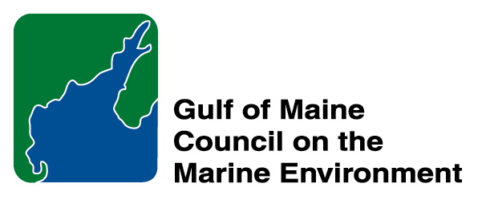 | 2014 Gulf of Maine Council Visionary Award  Nomination Form

The Gulf of Maine Visionary Award is presented annually to an individual or organization within each of the five Gulf of Maine jurisdictions of Massachusetts, New Hampshire, Maine, New Brunswick, and Nova Scotia. The Awards recognize innovation, creativity, and commitment to marine protection by businesses, environmental organizations, or individuals who are making a difference to the health of the Gulf of Maine.
* As the Council celebrates our 25th Anniversary, we seek to recognize the value of young people as well as experienced leaders in working to protect the Gulf of Maine ecosystem. We welcome and encourage nominees of all ages (including students or youth organizations) for our 2014 Gulf of Maine Visionary Awards and Longard Volunteer Award.

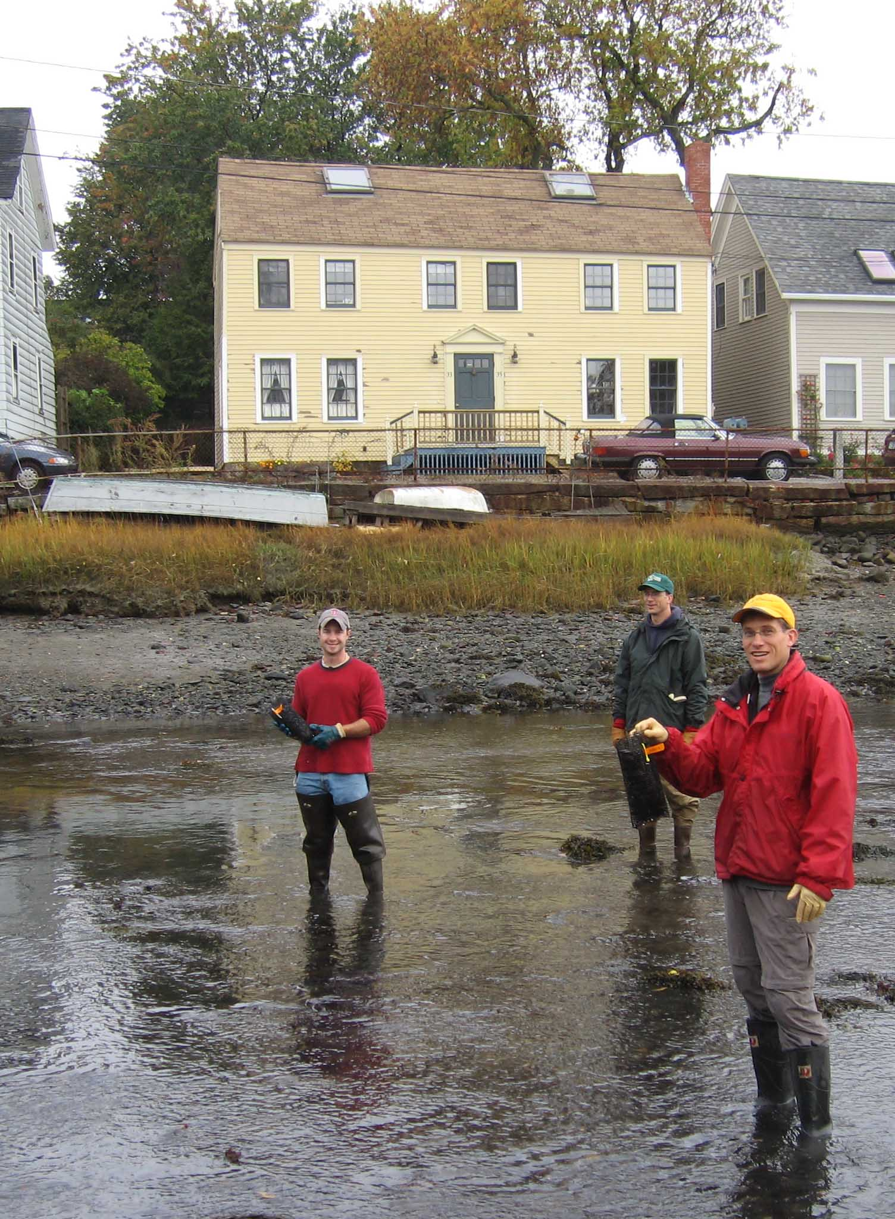 | Nomination instructions:  - Individuals or organizations may make nominations. Self-nominations are not accepted.  - The nominee must reside in Maine, Massachusetts, New Brunswick, New Hampshire, or Nova Scotia. The nominee’s contributions must have occurred in the Gulf of Maine watershed.  - Visionary Award nominees may be paid professionals or volunteers.  - Nominations must be made on this nomination form. Nominations with missing information will not be considered. Attachments will not be accepted.  - Nominations must be emailed to jleblanc@gulfofmaine.org by the close of business on March 30, 2014. Please rename the nomination form with _LastNameofNominee added to the file name.
Questions? Please contact Council Coordinator Joan LeBlanc at jleblanc@gulfofmaine.org
To view a list of past award winners, please visit: http://www.gulfofmaine.org/2/opportunities/

Nominee information
Name (as it will appear on the award plaque if selected): Mary M. Cerullo
Affiliation: Friends of Casco Bay
Mailing address: 43 Slocum Drive, South Portland, ME 04106
Phone: (207) 799-8574
Email: mcerullo@cascobay.org

Brief background on why the individual/organization is being nominated:
Mary Cerullo is a rare find in this world! She is an accomplished author of more than 20 non-fiction children’s books on the ocean. She is a talented word smith, educator, lecturer, and played a central role in the formation of the National Marine Educators Association and Gulf of Maine Marine Educators Association. She is a down-to-earth person dedicated to environmental education.

Summary that will be read during the awards ceremony if nominee is selected. This text will also be used in media releases (not to exceed 2,000 characters, including spaces and punctuation):

Over the past 40 years, Mary Cerullo has worked to inspire a love of science and marine stewardship. She has been instrumental in the creation of several marine education organizations and is the award-winning author of more than 20 children’s books on the ocean, most of which feature Gulf of Maine issues and critters.
In 1973 Mary Cerullo and a group of dedicated teachers organized the Massachusetts Marine Educators.
In 1976, Mary helped create the National Marine Educators Association.
In 1990 she developed Gulf of Maine Aquarium’s (GMA) poster describing Maine’s aquatic ecosystem— Mt. Katahdin to the Sea. 65,000 copies were used in classrooms throughout Maine. Mary also developed classroom activities based on data made available by NASA.
Mary teamed up with Bill Curtsinger, an outstanding National Geographic underwater photographer to produce a book series Sea Soup: Phytoplankton, (1999) and Sea Soup: Zooplankton (2001). She has written books on lobsters, squid, and shipwrecks, which are used in classrooms all over New England. She will soon publish a 4-volume set on sharks.
In 1998 Mary joined Friends of Casco Bay. She developed BayScaping, teaching residents to grow lawns that keep Casco Bay blue. BayScaping is the model for YardScaping, a statewide program on ecological lawn care. Mary also wrote the Casco Bay Curriculum, 40 activities for 4th-6th grades.
When the acting president of the Gulf of Maine Marine Educators Association (GOMMEA) had to step down for family medical issues, Mary stepped up to fill the gap. Her expertise and leadership made for a flawless transition.
“Mary likes to make learning fun”--Jeff Sandler/ Marine Educator/Mr. Fish
“She is a rare find in this world. Her skills, knowledge, grace, dignity and compassion have blessed us all.” --Jeanne Meggison/ NMEA
“Mary lights up a room and makes others smile. Her can-do attitude and nonchalant demeanor make her a powerhouse of a woman who gets the job done.”--Carol Steingart/GOMMEA
Name and contact information of person making the nomination:
Name & Affiliation: Peter Milholland – Friends of Casco Bay
Address: 43 Slocum Dr. South Portland, ME 04106
Phone: (207) 799-8574
Email: pmilholland@cascobay.org

The mission of the Council is to maintain and enhance environmental quality in the Gulf of Maine and to
allow for sustainable resource use by existing and future generations.

Massachusetts Office of Coastal Zone Management • 2002-2003 Secretariat
GOMC • c/o NHDES • PO Box 95 • Concord, NH, US • 03302-0095 • Phone (603) 225-5544

The mission of the Council is to maintain and enhance environmental quality in the Gulf of Maine and to
allow for sustainable resource use by existing and future generations.

Nova Scotia Environment • 2013-2014 Secretariat

