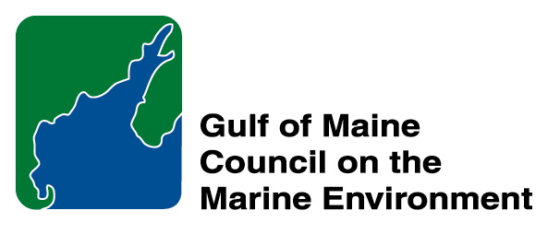 | 2014 Gulf of Maine Council Visionary Award  Nomination Form

The Gulf of Maine Visionary Award is presented annually to an individual or organization within each of the five Gulf of Maine jurisdictions of Massachusetts, New Hampshire, Maine, New Brunswick, and Nova Scotia. The Awards recognize innovation, creativity, and commitment to marine protection by businesses, environmental organizations, or individuals who are making a difference to the health of the Gulf of Maine.
* As the Council celebrates our 25th Anniversary, we seek to recognize the value of young people as well as experienced leaders in working to protect the Gulf of Maine ecosystem. We welcome and encourage nominees of all ages (including students or youth organizations) for our 2014 Gulf of Maine Visionary Awards and Longard Volunteer Award.

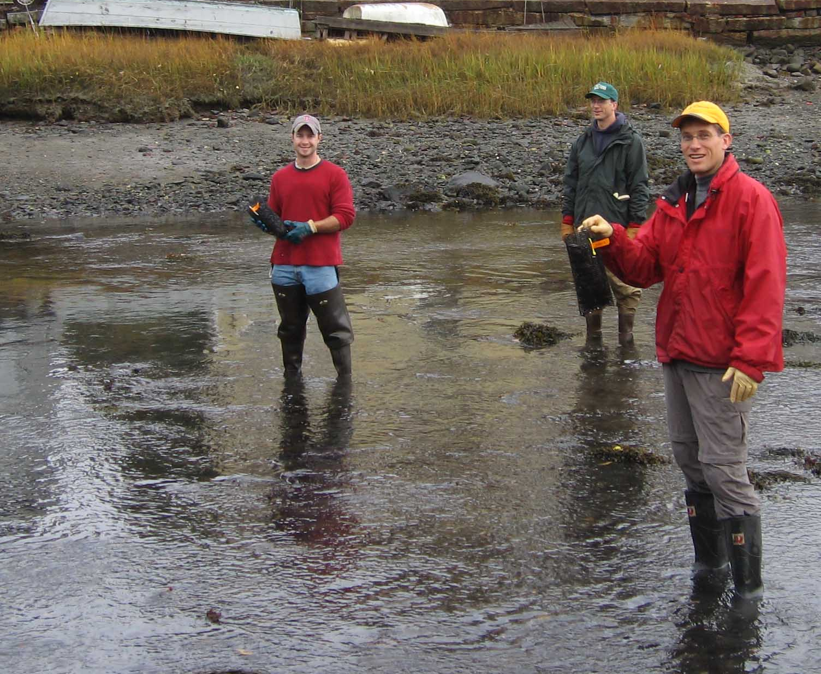 | Nomination instructions:  - Individuals or organizations may make nominations. Self-nominations are not accepted.  - The nominee must reside in Maine, Massachusetts, New Brunswick, New Hampshire, or Nova Scotia. The nominee’s contributions must have occurred in the Gulf of Maine watershed.  - Visionary Award nominees may be paid professionals or volunteers.  - Nominations must be made on this nomination form. Nominations with missing information will not be considered. Attachments will not be accepted.  - Nominations must be emailed to jleblanc@gulfofmaine.org by the close of business on March 30, 2014. Please rename the nomination form with _LastNameofNominee added to the file name.
Questions? Please contact Council Coordinator Joan LeBlanc at jleblanc@gulfofmaine.org
To view a list of past award winners, please visit: http://www.gulfofmaine.org/2/opportunities/

Nominee information
Name (as it will appear on the award plaque if selected): Stewart Fefer
Affiliation: U.S. Fish and Wildlife Service
Mailing address: 4R Fundy Rd., Falmouth, ME 04105
Phone: 207-781-8364
Email: stewart_fefer@fws.gov

Brief background on why the individual/organization is being nominated:
By building strong partnerships, retaining a talented and dedicated staff and developing a flexible, voluntary approach to conservation, Stewart Fefer has translated an ambitious vision for coastal Maine into thousands of acres of restored and protected habitat for waterbirds, migratory fish and endangered species. Since 1991, the Gulf of Maine Coastal Program, led by Stewart, has played an active role in partnerships to:

• permanently protect 58 coastal nesting islands,
• complete 112 projects that protect coastal wetlands, upland buffers and riparian habitat,
• restore nesting seabird habitat on 12 islands,
• restore 196 coastal wetlands,
• remove numerous dams that once blocked migratory fish including directing millions of funding to the Penobscot River Restoration Project,
• implement 3 landscape-scale Northern Forest projects
• bring $50.7 in grant funding to conservation projects in Maine.

Stewart has constantly advocated for on-the-ground conservation actions and kept focus on protecting the highest value habitats in Maine. He has provided a unique and powerful set of skills that have helped him lead and succeed. He has combined his considerable knowledge of conservation biology with a lifetime of experience in coastal Maine, a practical knowledge of funding sources, a commitment to work in partnerships, an understanding of the importance of targeted outreach, and a passion to protect and restore our coastal environment, for fish, for wildlife -- and for all of us.

Stewart has worked tirelessly on behalf of nationally important fish and wildlife resources in coastal Maine. He has developed innovative partnerships with National Wildlife Refuges, state agencies, statewide conservation groups, land trusts and angling clubs to restore and permanently protect coastal nesting islands, coastal wetlands, and rivers harboring Atlantic salmon and other migratory fish. He has been extremely effective in accessing federal grants and identifying matching non-federal funds. He was the driving force behind four large partnership grants funded through the National Fish and Wildlife Foundation – the Atlantic Salmon Collaborative, the Maine Habitat Restoration Partnership, the Maine Wildlife Habitat Initiative, and the Gulf of Maine Seabird Island Restoration Project. In addition, he has coordinated partnerships to successfully implement three large grants and one small grant through the North American Waterfowl Management Plan, seven National Wetland Conservation Grants, and a variety of other grants funded directly through the U.S. Fish and Wildlife Service, the Casco Bay National Estuary Program and the National Fish and Wildlife Foundation. In total, Stewart has secured $50.7 million in outside funding for habitat protection and restoration projects in coastal Gulf of Maine. This work has leveraged an additional $125 million in funding.

Stewart has always believed in large-landscape scale conservation approaches and in the importance of increasing access to biological information and analysis. Stewart has advocated for GIS tools to help the conservation community prioritize, select, and implement projects that will yield the greatest benefit to our trust resources. His pioneering work in conservation planning has helped highlight the need for tools currently being developed by the North Atlantic Landscape Conservation Cooperative to address major environmental and human-related factors that limit fish and wildlife populations at the broadest of scales, including developing adaptation strategies in response to climate change.

Stewart has received a variety of local, regional and national recognition for his conservation work. In 1995, he was awarded the John Gottschalk Partnership Award by the Northeast Region of the Fish and Wildlife Service. In 1999, he was honored with the prestigious Chuck Yeager Award for Natural Resource Conservation from the National Fish and Wildlife Foundation for his outstanding record in obtaining funding and building coalitions for coastal conservation projects. Bard College also recognized him for his accomplishments in wildlife management and biological conservation in 2002 with the John and Samuel Bard Award in Medicine and Science. He was also recognized with an award for his conservation accomplishments by the University of Maine in 2009 and in 2011 with the John Gottschalk Partnership Award.

After 38 years of a career focused on conservation, Stewart will be retiring in March 2014. We feel that this award will recognize Stewart’s visionary approach to tackling some of the Gulf of Maine’s most significant habitat issues.

Summary that will be read during the awards ceremony if nominee is selected. This text will also be used in media releases (not to exceed 2,000 characters, including spaces and punctuation):
By building strong partnerships, retaining a talented and dedicated staff and developing a flexible, voluntary approach to conservation, Stewart Fefer has translated an ambitious vision for coastal Maine into thousands of acres of restored and protected habitat for waterbirds, migratory fish and endangered species. Stewart has worked tirelessly on behalf of nationally important fish and wildlife resources in coastal Maine. He has developed innovative partnerships with National Wildlife Refuges, state agencies, statewide conservation groups, land trusts and angling clubs to restore and permanently protect coastal nesting islands, coastal wetlands, and rivers harboring Atlantic salmon and other migratory fish. In total, Stewart has secured $50.7 million in outside funding for habitat protection and restoration projects in coastal Gulf of Maine. This work has leveraged an additional $125 million in funding.

Name and contact information of person making the nomination:
Name & Affiliation: Jed Wright, USFWS
Address: 4R Fundy Rd., Falmouth, ME 04105
Phone: 207-781-8364
Email: jed_wright@fws.gov

The mission of the Council is to maintain and enhance environmental quality in the Gulf of Maine and to
allow for sustainable resource use by existing and future generations.

Massachusetts Office of Coastal Zone Management • 2002-2003 Secretariat
GOMC • c/o NHDES • PO Box 95 • Concord, NH, US • 03302-0095 • Phone (603) 225-5544

The mission of the Council is to maintain and enhance environmental quality in the Gulf of Maine and to
allow for sustainable resource use by existing and future generations.

Nova Scotia Environment • 2013-2014 Secretariat

