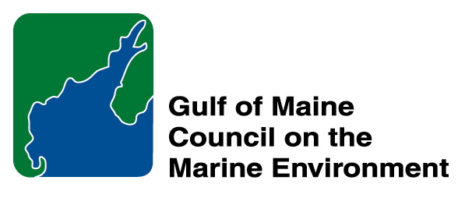 | 2014 Gulf of Maine Council Visionary Award  Nomination Form

The Gulf of Maine Visionary Award is presented annually to an individual or organization within each of the five Gulf of Maine jurisdictions of Massachusetts, New Hampshire, Maine, New Brunswick, and Nova Scotia. The Awards recognize innovation, creativity, and commitment to marine protection by businesses, environmental organizations, or individuals who are making a difference to the health of the Gulf of Maine.
* As the Council celebrates our 25th Anniversary, we seek to recognize the value of young people as well as experienced leaders in working to protect the Gulf of Maine ecosystem. We welcome and encourage nominees of all ages (including students or youth organizations) for our 2014 Gulf of Maine Visionary Awards and Longard Volunteer Award.

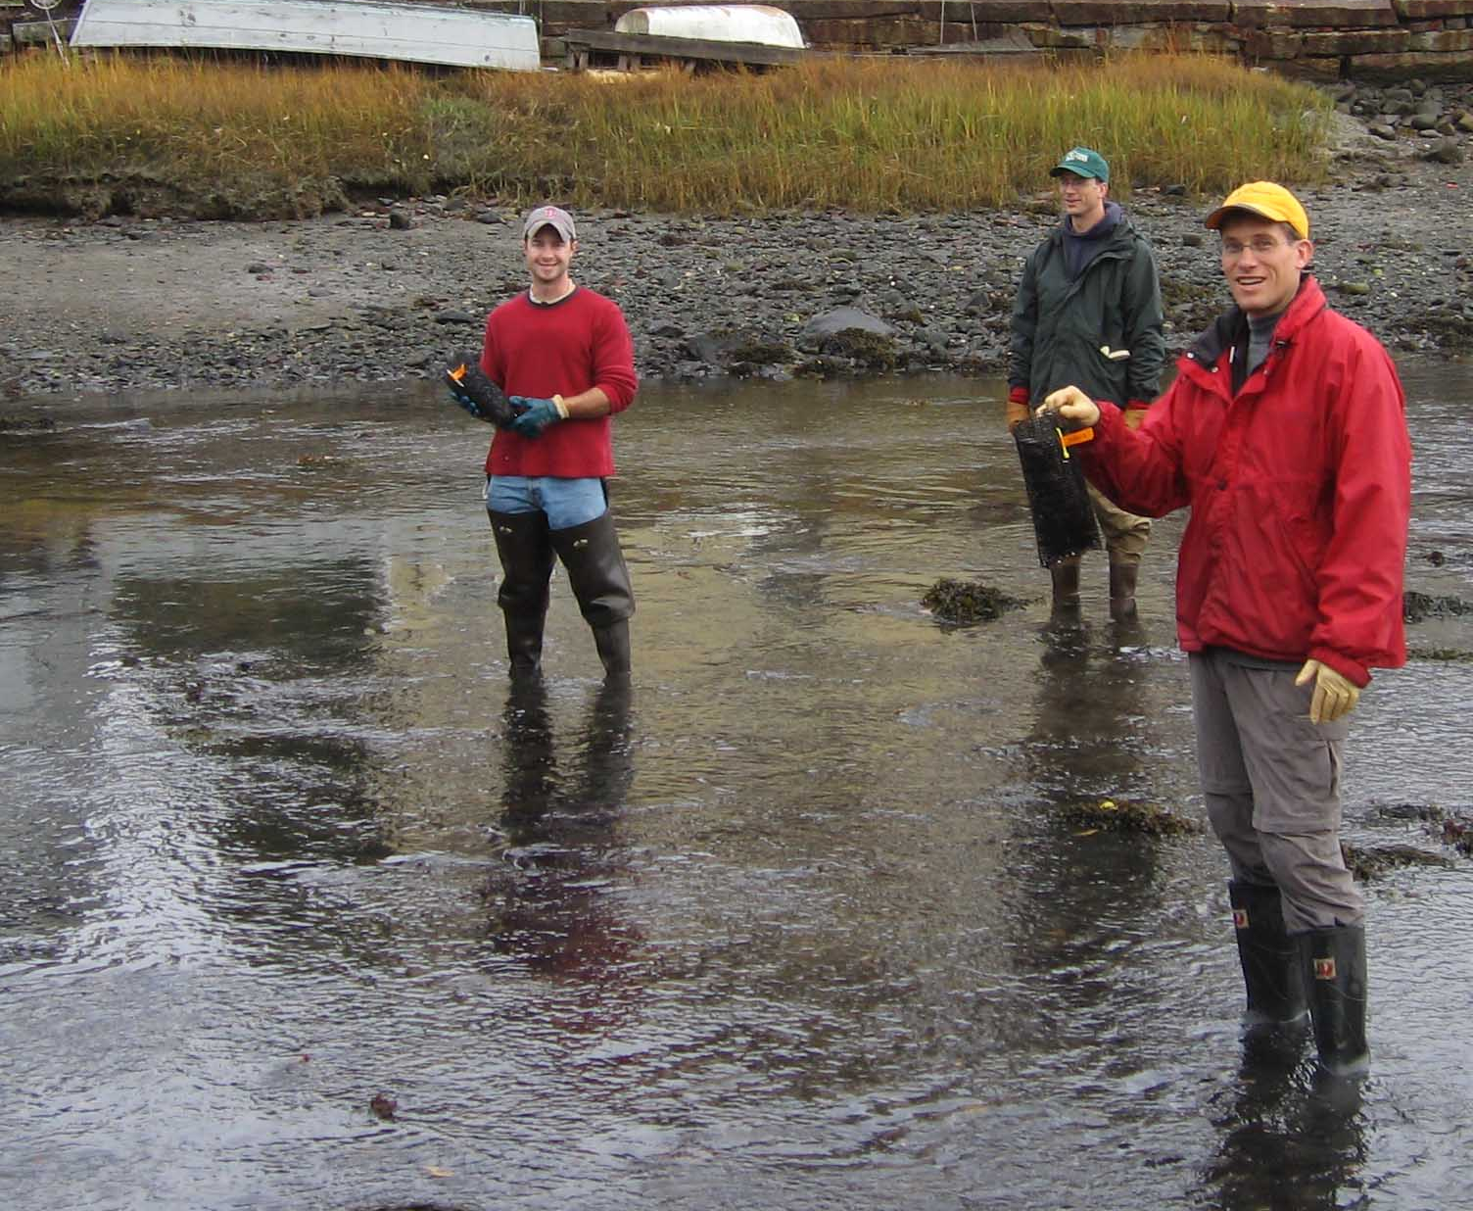 | Nomination instructions:  - Individuals or organizations may make nominations. Self-nominations are not accepted.  - The nominee must reside in Maine, Massachusetts, New Brunswick, New Hampshire, or Nova Scotia. The nominee’s contributions must have occurred in the Gulf of Maine watershed.  - Visionary Award nominees may be paid professionals or volunteers.  - Nominations must be made on this nomination form. Nominations with missing information will not be considered. Attachments will not be accepted.  - Nominations must be emailed to jleblanc@gulfofmaine.org by the close of business on March 30, 2014. Please rename the nomination form with _LastNameofNominee added to the file name.
Questions? Please contact Council Coordinator Joan LeBlanc at jleblanc@gulfofmaine.org
To view a list of past award winners, please visit: http://www.gulfofmaine.org/2/opportunities/

Nominee information
Name (as it will appear on the award plaque if selected): Isabella Hillman
Affiliation: resident of the community of Rye, New Hampshire; student at Rye Junior High School
Mailing address: 399 Central Rd, Rye, NH 03870
Phone: 603-964-1337
Email: steveandkate@comcast.net (parents)

Brief background on why the individual/organization is being nominated:
At 12 years old, Isabella Hillman is a young person making waves in her coastal community of Rye, New Hampshire. This seventh grade student had the initiative and commitment to see her idea for smoke-free beaches through to a non-binding resolution passed at Town Meeting last March that makes all town beaches in Rye smoke-free zones. Her grassroots community and civic involvement resulted in helping to solve a local environmental problem. Instead of only noticing and complaining about the cigarette butt litter in the sand and the second hand smoke wafting towards her and her friends on the beach, Isabella took matters into her own capable hands and worked to change the problems she observed. She met with a local civic league that helped her learn about the steps required to influence change in town policy. She successfully tackled the daunting task of submitting her resolution as a petitioned warrant article to be put up for a vote at Town Meeting, which involved many steps along the way and careful navigation of town government processes and deadlines. First Isabella did research and modeled her resolution after one that had been passed in the community of York, Maine. She then collected petition signatures for her resolution by knocking on doors and standing at a beachfront store. In December of 2013, Isabella went before the Rye Board of Selectmen with the signatures for her petition to get the resolution as a town warrant article up for town vote (25 is required to have it considered for placement on Town Warrant). Then she had the courage to address the town’s deliberative session in February, pointing out that cigarette butts are the most common litter found on beaches and that rather than breaking down, they leave behind a legacy of toxic chemicals that get in the water. She also said that second hand smoke is a known threat to human health, citing the sources of her thorough research. Smoke-free beaches would help our environment and our health, she said. Isabella’s letter to the editor on the warrant article made an equally compelling case and appeared in Seacoast Online the day of the town vote. On the voting day, Isabella was out by the polls with a sign about her cause. Her hard work and persistence on this challenging issue resulted in a town vote of 1,193 to 471 in favor of making Rye town beaches smoke-free. As a non-binding resolution, it means that fines or penalties cannot be given to people that choose to smoke on the beach despite the smoke-free zone, but it is strongly discouraged to smoke. Notably, the community of York, Maine has seen a significant reduction in smoking on their beaches since their non-binding resolution was passed. Isabella is now working on signs that will be placed on the beaches this summer to inform people about the smoke-free town beaches. Lifeguards will also help spread the word. Isabella signed her letter to the editor “Resolution Initiator,” and she is a true initiator and young leader making positive changes in both the environment and human health of her community.

Summary that will be read during the awards ceremony if nominee is selected. This text will also be used in media releases (not to exceed 2,000 characters, including spaces and punctuation):

At 12 years old, Isabella Hillman is a young person making waves in her coastal community of Rye, New Hampshire. This seventh grade student had the initiative and commitment to see her idea for smoke-free beaches through to a non-binding resolution passed at Town Meeting last March that makes all town beaches in Rye smoke-free zones. Her grassroots community and civic involvement resulted in helping to solve a local environmental problem. Instead of only noticing and complaining about the cigarette butt litter in the sand and the second hand smoke wafting towards her and her friends at the beach, Isabella took matters into her own capable hands and worked to change the problems that she observed. She successfully tackled the daunting task of getting a petitioned warrant article passed in her community, which had many steps along the way and the careful navigation of town government processes and deadlines. As a non-binding resolution, it means that fines or penalties cannot be given to people that choose to smoke on the beach despite the smoke-free zone, but it is strongly encouraged not to smoke. Notably, the community of York, Maine has seen a significant reduction in smoking on their beaches since their non-binding resolution was passed. Isabella is now working on signs that will be placed on the beaches this summer to inform people about the smoke-free town beaches. Isabella signed her letter to the editor that appeared in Seacoast Online, “Resolution Initiator,” and she is a true initiator and young leader making positive changes in both the environment and the human health of her community.

Name and contact information of person making the nomination:
Name & Affiliation: Jamie MaCallum, NH Surfrider Foundation
Address: P.O. Box 686 Portsmouth, NH 03801
Phone:
Email: aj.jamie@gmail.com

The mission of the Council is to maintain and enhance environmental quality in the Gulf of Maine and to
allow for sustainable resource use by existing and future generations.

Massachusetts Office of Coastal Zone Management • 2002-2003 Secretariat
GOMC • c/o NHDES • PO Box 95 • Concord, NH, US • 03302-0095 • Phone (603) 225-5544

The mission of the Council is to maintain and enhance environmental quality in the Gulf of Maine and to
allow for sustainable resource use by existing and future generations.

Nova Scotia Environment • 2013-2014 Secretariat

