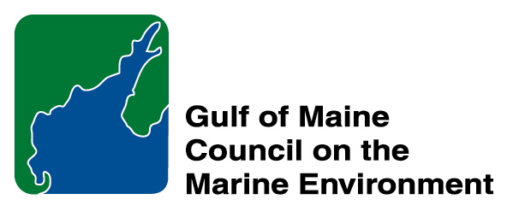 | 2014 Gulf of Maine Council Visionary Award  Nomination Form

The Gulf of Maine Visionary Award is presented annually to an individual or organization within each of the five Gulf of Maine jurisdictions of Massachusetts, New Hampshire, Maine, New Brunswick, and Nova Scotia. The Awards recognize innovation, creativity, and commitment to marine protection by businesses, environmental organizations, or individuals who are making a difference to the health of the Gulf of Maine.
* As the Council celebrates our 25th Anniversary, we seek to recognize the value of young people as well as experienced leaders in working to protect the Gulf of Maine ecosystem. We welcome and encourage nominees of all ages (including students or youth organizations) for our 2014 Gulf of Maine Visionary Awards and Longard Volunteer Award.

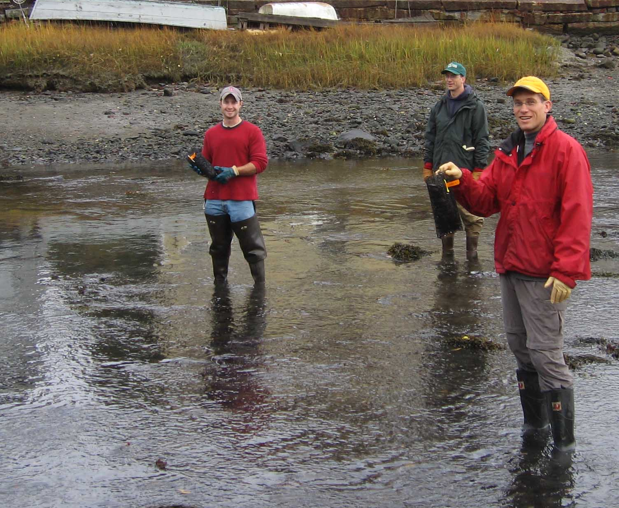 | Nomination instructions:  - Individuals or organizations may make nominations. Self-nominations are not accepted.  - The nominee must reside in Maine, Massachusetts, New Brunswick, New Hampshire, or Nova Scotia. The nominee’s contributions must have occurred in the Gulf of Maine watershed.  - Visionary Award nominees may be paid professionals or volunteers.  - Nominations must be made on this nomination form. Nominations with missing information will not be considered. Attachments will not be accepted.  - Nominations must be emailed to jleblanc@gulfofmaine.org by the close of business on March 30, 2014. Please rename the nomination form with _LastNameofNominee added to the file name.
Questions? Please contact Council Coordinator Joan LeBlanc at jleblanc@gulfofmaine.org
To view a list of past award winners, please visit: http://www.gulfofmaine.org/2/opportunities/

Nominee information
Name (as it will appear on the award plaque if selected): The Gundalow Company
Affiliation:
Mailing address: 60 Marcy Street, Portsmouth, NH 03801
Phone: 603-433-9505
Email: mbolster@gundalow.org

Brief background on why the individual/organization is being nominated:
The historic seaport city of Portsmouth, New Hampshire is very proud to nominate Portsmouth’s Gundalow Company for the Gulf of Maine Council Visionary Award. The nonprofit Gundalow Company is leading the effort to protect our region’s maritime heritage and environment through education and action. For centuries, gundalows connected up-river seacoast communities with Portsmouth, the region’s seaport and primary market town. By harnessing the wind and riding the tide, gundalows moved bricks, hay, firewood, and goods crucial to the economy and everyday life. Gundalows have been the iconic work boat for the Piscataqua region since the 1600s. The Gundalow Company takes its inspiration from the vital role of those historic wooded vessels. Its outreach educational programming is as important for the future of our city’s maritime heritage and estuarine protection, as its predecessors were for the past.

From 2002 to 2011, the Gundalow Company provided dockside programs to more than 100,000 students and visitors on the Captain Edward H. Adams, a 30-year old replica, modeled after the last gundalow to carry cargo on our waterways. But, by 2011, the Adams proved to be too authentic to comply with modern U.S. Coast Guard safety requirements. Recognizing the need to have students of all ages afloat to genuinely connect with their waterways, the Gundalow Company built a new gundalow, the Piscataqua. Looking and feeling authentic, it has all the safety features and structural integrity required by the U.S. Coast Guard for passenger-carrying vessels. The Piscataqua was built on the grounds of Portsmouth’s famed Strawbery Banke Museum by local shipwrights and volunteers using traditional methods and tools, all in view of the public.

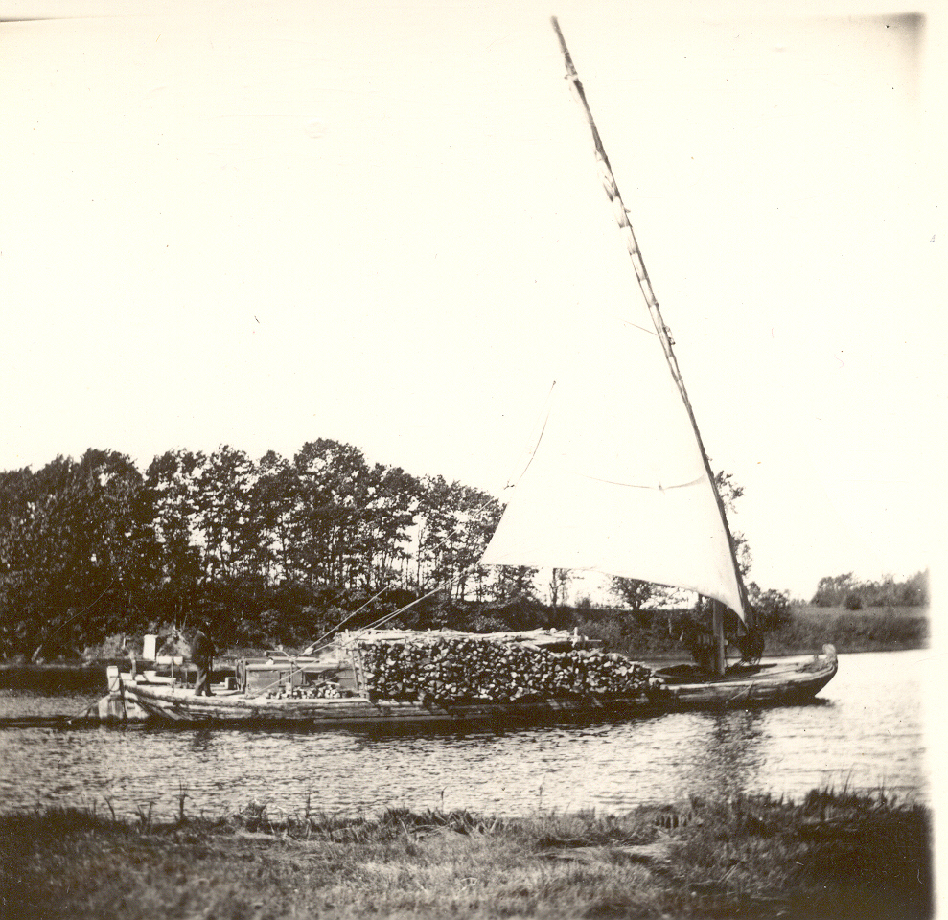
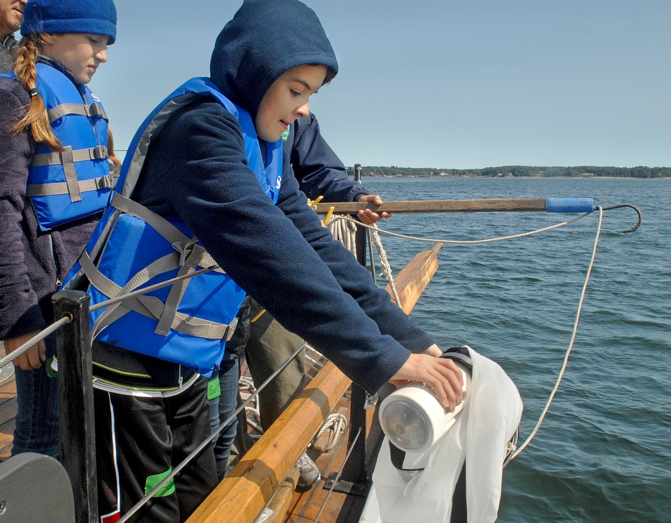
Today the Gundalow Company’s mission, to protect the Piscataqua Region’s maritime heritage and environment through education and action, is more urgent than ever. Held throughout the tidal towns of the Piscataqua Region, its programs connect our maritime history with contemporary coastal issues such as stakeholder awareness, water quality, habitat restoration, conservation, and stewardship. In its first two seasons of operating the Piscataqua, the Gundalow Company has served over 3,000 elementary school students and over 8,000 public passengers. The programs weave together science, social studies, maritime skills and stewardship while introducing an appreciation for a sense of place. Their programs increase awareness of the shared responsibility of becoming informed stewards of our rivers and bays. The Gundalow does this all with a small staff and over 100 volunteers!

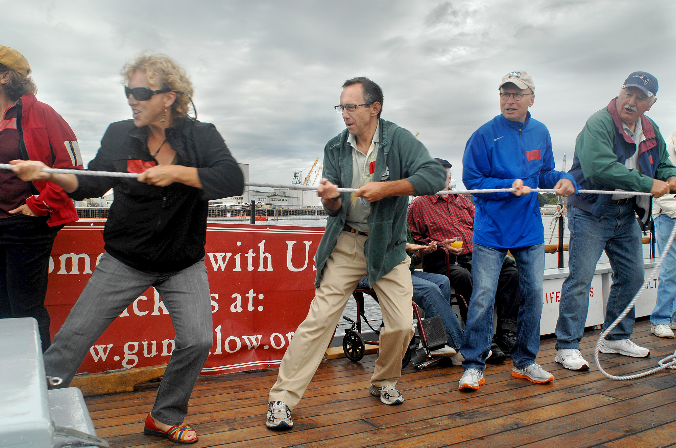
In 2012, The Gundalow Company began offering new programs on the Piscataqua for teachers and their 4th-5th grade students. In 2013 they were fully booked with 84 student programs in the spring and fall. In addition to the student programs, the Gundalow offers public sails which focus on connecting people to the history of place, to get them to think about its future. As executive Director Molly Bolster has said, the approach we take is connecting people with a place so they will care about it. If they don’t see it and smell it and experience it, it is very challenging. The Gundalow Company conducted the following programs during the 2013 season, with additional programming planned for 2014.

2013 Education Programs
Education Sails 93 approximately 1900 students
2 adult groups, 8 high school classes,
9 middle school classes,
58 upper-elementary classes; 6 camps
Classroom Presentations 13 approximately 270 students
Shore-based Education Programs 16 approximately 400 students
2013 Outreach Events
Annual Meeting 75 guests
Gundalow Gatherings (Speaker series) 176 guests
SAIL Portsmouth Week-end 350 guests
UNH Ocean Discovery Day 160 guests
NH Fish & Lobster Festival 180 guests
2013 Volunteer Programs
5 Continuing Education Events 140 volunteers
4 Training/Orientations 60 volunteers
Rig-Up and Down Rigging 54 volunteers
Volunteer contribution 3675 hours
2013 Public Sails
285 trips 4800 passengers

The Gundalow Company hosted 15 Contemporary Coastal Issues events in 2013, 3 indoors and 12 under sail on the Piscataqua. Topics included oysters, fisheries, threats to the estuary, marine debris, lobsters, stormwater run-off, the working waterfront, shipyard history, human impact and lighthouse history. Complimentary tickets were provided to municipal decision-makers and local teachers interested in school sails. Event speakers included the following:

Contemporary Coastal Issues Under Sail Attendance
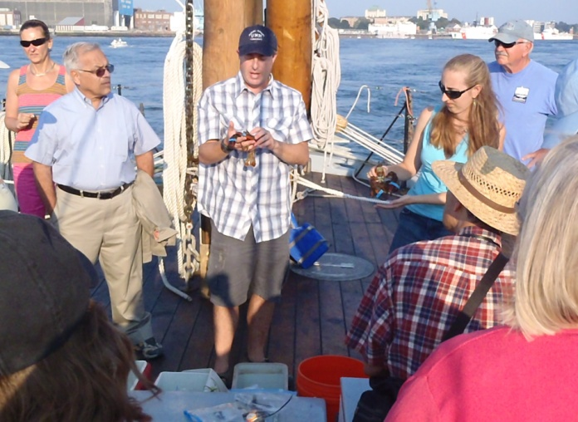
Peter Wellenberger, Great Bay-Piscataqua Waterkeeper 27
Rachael Miller, Rozalia Project 43
James Houle, UNH Stormwater Center 36
Ray Grizzle & Ray Konisky, Oyster Bed Restoration 26
Rachel Rouillard, Piscataqua Region Estuaries Partnership 19
Geno Marconi, Director of the NH Port Authority 28
Lou Ferland, Portsmouth Police Chief (retired) 23
Jeremy D’Entremont, Portsmouth Harbor Historian 20
Jason Goldstein, UNH Research Scientist 21
Jeff Bolster, Professional Seafarer & UNH Historian 13
Eric Chapman, NH Sea Grant/UNH Cooperative Extension 15
Gary Hildreth, Portsmouth Naval Shipyard Historian 28
Contemporary Coastal Issues – Free Winter Series
Peter Wellenberger, Great Bay-Piscataqua Waterkeeper 19
Rachel Rouillard, Piscataqua Region Estuaries Partnership 21
Jeff Bolster, Professional Seafarer & UNH Historian 36

In 2013, the Gundalow Company sponsored 12 maritime concerts under sail on the Piscataqua and 3 maritime music events indoors. All concerts were performed by local musicians including
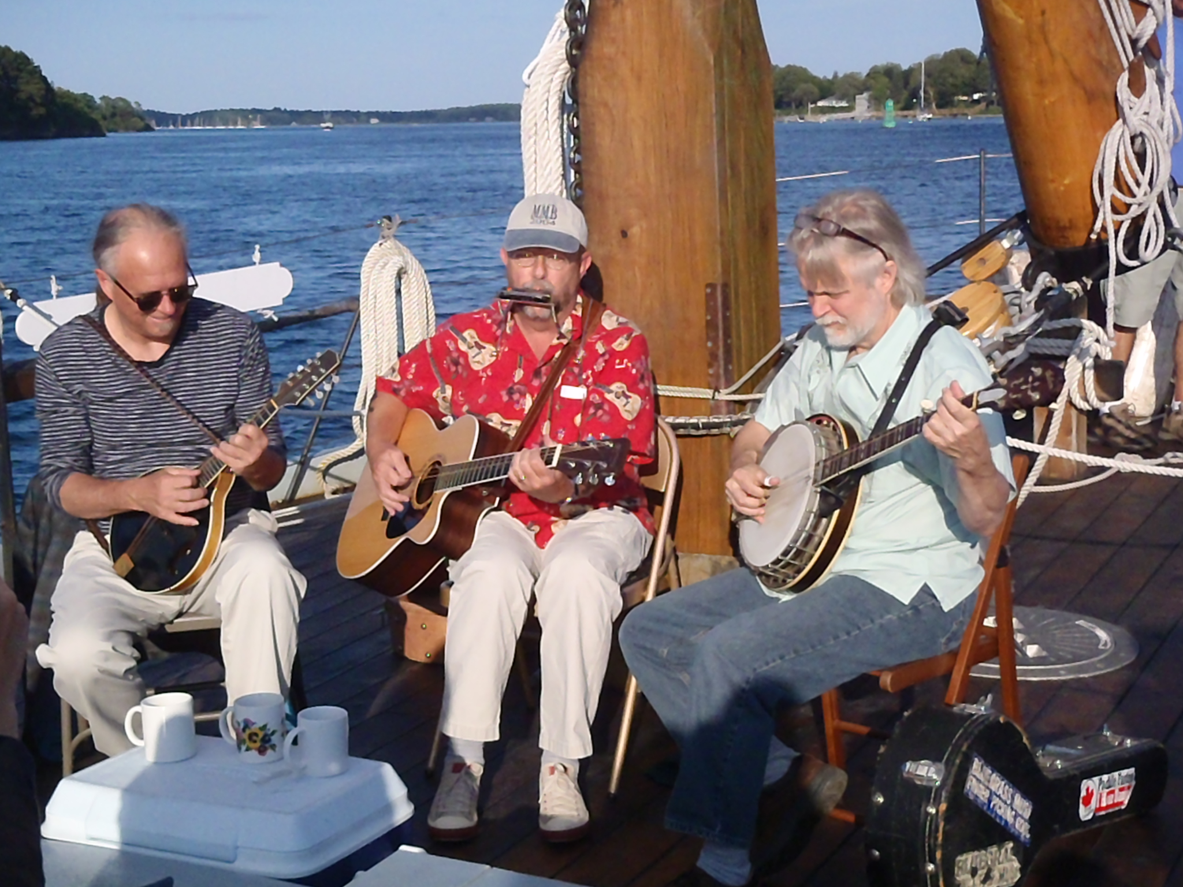
- Joyce Andersen and Kent Allyn - traditional, folk, swing
- Doug Bennett and Bruce Derr - jazz, folk, blues, instrumentals
- Great Bay Sailor - maritime music celebration
- Antique Brass - blues, ragtime, seafaring tunes
- Jeff Warner and Barbara Benn - toe-tapping, back-porch music
- London Julie - Greek/Middle Eastern style maritime
- David Graf and Kent Allyn - blues, jazz and swing
- Lex and Joe contemporary rhythm and blues
- The Short Brothers - bluegrass with 3-part harmony
- High Range - roots, folk and bluegrass
- Sparrow’s Joy - northern roots music
- Drowned Valley - banjo tunes, bluegrass, country ballads
- Sylvan Roots - contemporary and traditional folk
- Jim Prendergast and Emery Hutchins ballads, foot-stomping tunes, traditional Irish
- Susie Burke & David Surette – folk and acoustic roots music
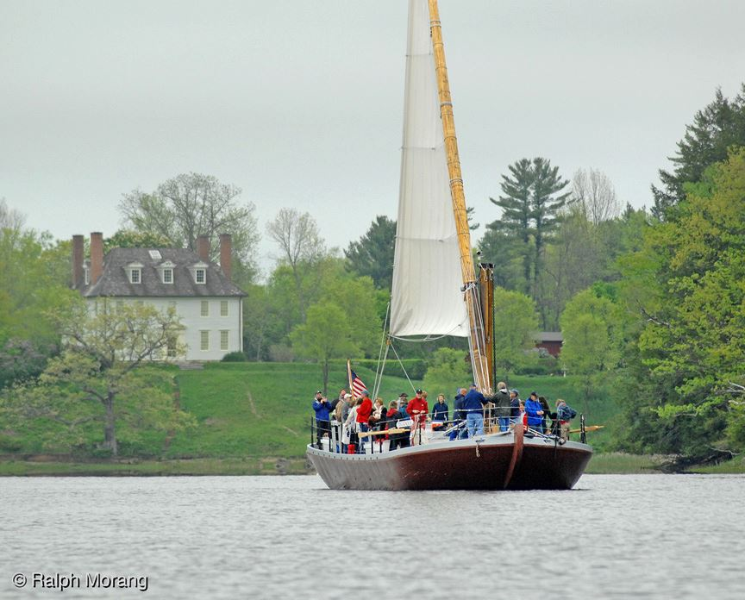
The city of Portsmouth firmly believes that the activities of Gundalow Company directly contribute to a greater understanding of human impact and connections to our rivers in the past, present and future. Its programs increase awareness of the shared responsibility of becoming informed stewards of our rivers, harbors and bays. Because of this, the City of Portsmouth clearly believes that the nonprofit Gundalow Company deserves the 2014 Gulf of Maine Visionary Award. Thank you for this opportunity to nominate the Gundalow Company.

Summary that will be read during the awards ceremony if nominee is selected. This text will also be used in media releases (not to exceed 2,000 characters, including spaces and punctuation):

The nonprofit Gundalow Company is leading the effort to protect its region’s maritime heritage and environment through education and action. For centuries, gundalows connected up-river seacoast communities with Portsmouth, the region’s seaport and primary market town. Gundalows moved bricks, hay, firewood and goods, crucial to the economy and everyday life. The Gundalow Company takes its inspiration from the vital role of those historic wooded vessels. From 2002 to 2011, the Gundalow Company provided dockside programs to more than 100,000 students and visitors on the Captain Edward Adams, a 30-year old gundalow replica. But by 2011, the Adams proved to be too authentic to comply with U.S. Coast Guard safety requirements. Recognizing the need to have students of all ages afloat to genuinely connect with their waterways, the Gundalow Company built a new gundalow, the Piscataqua. Looking and feeling authentic, it meets all U.S. Coast Guard requirements for passenger-carrying vessels. The Piscataqua was built on the grounds of Portsmouth’s famed Strawbery Banke Museum by local shipwrights and volunteers using traditional methods and tools, all in view of the public.

Today the Gundalow Company’s mission is more urgent than ever. The Gundalow’s programs connect its maritime history with contemporary coastal issues such as community awareness, water quality, habitat restoration, conservation, and stewardship. In its first two seasons of operating the Piscataqua, the Gundalow Company served over 3,000 school students and over 8,000 public passengers. The programs weave together science, social studies, maritime skills and stewardship while introducing an appreciation for a sense of place. The programs increase awareness of the shared responsibility of becoming informed stewards of our rivers and bays. The Gundalow does this all with a small staff and over 100 volunteers!

Name and contact information of person making the nomination:
Name & Affiliation: John Bohenko, City Manager
Address:
Portsmouth City Hall
1 Junkins Avenue
Portsmouth, NH 03801
Phone: 603-610-7202
Email: jpb@cityofportsmouth.com

The mission of the Council is to maintain and enhance environmental quality in the Gulf of Maine and to
allow for sustainable resource use by existing and future generations.

Massachusetts Office of Coastal Zone Management • 2002-2003 Secretariat
GOMC • c/o NHDES • PO Box 95 • Concord, NH, US • 03302-0095 • Phone (603) 225-5544

The mission of the Council is to maintain and enhance environmental quality in the Gulf of Maine and to
allow for sustainable resource use by existing and future generations.

Nova Scotia Environment • 2013-2014 Secretariat

