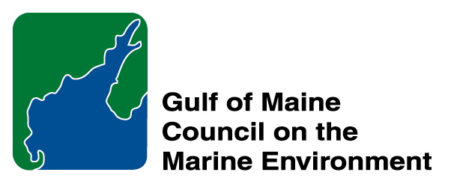 |  | 2014 Gulf of Maine  Longard Award  Nomination Form

The Longard Gulf Volunteer Award is bestowed each year in memory of Art Longard, a founding member of the Gulf of Maine Council on the Marine Environment and long-time Working Group member. The Award is given to an individual from one of the five states and provinces bordering the Gulf of Maine. The Longard Award recognizes individual commitment to volunteer programs dedicated to environmental protection and sustainability of natural resources within the marine, near shore, and watershed environments of the Gulf of Maine.
* As the Council celebrates our 25th Anniversary, we seek to recognize the value of young people as well as experienced leaders in working to protect the Gulf of Maine ecosystem. We welcome and encourage nominees of all ages (including students or youth organizations) for our 2014 Gulf of Maine Visionary Awards and Longard Volunteer Award.

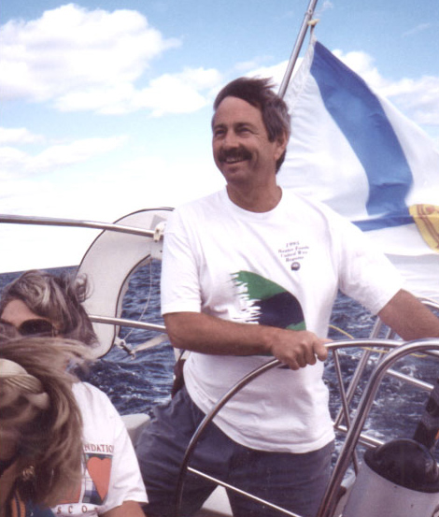  Art Longard | Nomination instructions  - Individuals or organizations may submit nominations. Self-nominations are not accepted.  - The nominee must be resident of Maine, Massachusetts, New Brunswick, New Hampshire, or Nova Scotia. The nominee’s contributions must have been to the Gulf of Maine watershed.  - Longard Award nominees must have contributed to the Gulf of Maine in their capacity as a volunteer, NOT as a paid professional.  - Nominations must be made on this form. Attachments will not be accepted.  - Nominations must be emailed to jleblanc@gulfofmaine.org by the close of business on March 30, 2014. Please rename the nomination form with _LastNameofNominee added to the end of the file name.
Questions? Please contact Council Coordinator Joan LeBlanc at jleblanc@gulfofmaine.org.

To view a list of past award winners, please visit: http://www.gulfofmaine.org/2/opportunities/

Nominee information
Name (as it would appear on the award plaque if selected): Jillian Olsen
Mailing address: 840 Clementsport Rd, Clementsvale, NS, B0S 1G0
Phone: 902-308-0472
Email: jillian.olsen4494@gmail.com

Brief background on why the individual/organization is being nominated:

Jillian Olsen has made a tremendous contribution to the conservation of species at risk in the Annapolis River Watershed through her volunteerism with the Clean Annapolis River Project. Jillian has been active in assisting with CARP’s two species at risks projects: Wood Turtle (Glyptemys insculpta) Research and Outreach, and Striped Bass (Morone saxatilis) Research & Outreach.

The Wood Turtle Research and Outreach Project involves collecting critical field data, required to improve the understanding of the ecological needs and population dynamics of the wood turtle. Volunteers are crucial in the data collection process, and the project would not be able to achieve its objectives without their contributions. Over the 2013 field season Jillian logged 125 volunteer hours, which included land and water based visual surveys, radio-telemetry, turtle nest checks, nest emergence surveys, and over wintering surveys. This data is being used to improve conservation efforts for the local wood turtle population.

The Striped Bass Research project examines the Bay of Fundy Population of striped bass, which has been listed as endangered by the Committee on the Status of Wildlife in Canada (COSEWIC). The Annapolis is one of the few systems that still supports this species in the region. CARP is gathering data to determine the structure and composition of the Bay of Fundy striped bass population, a critical step in developing appropriate and effective conservation efforts. Jillian logged 10.5 field hours volunteering with the Striped Bass Research project, helping to set and check fyke nets and assist with beach seining and subsequent fish ID. In order to perform these duties Jillian has put in a tremendous amount of time and effort in to learning field methodologies and techniques, to ensure the consistent collection of high quality data.

Jillian is CARP’s youngest volunteer as well as being one of the most dedicated, placing her in an important role as a leader and mentor for other youth in the communities found throughout the watershed. We believe she is an excellent role model for her peers, as she has taken her passion for wildlife, and used it as a catalyst to become an active member of the conservation community in the Annapolis River Watershed.

Summary that will be read during the awards ceremony if nominee is selected. This text will also be used in media releases (not to exceed 2,000 characters, including spaces and punctuation):

The Clean Annapolis River Project (CARP) would like to recognize the volunteer contributions of Ms. Jillian Olsen, who has been an active and dedicated in her role on projects related to species at risk in the Annapolis River Watershed. Jillian played a major role in conducting field based activities as part of CARP’s Wood Turtle Research & Outreach, and Striped Bass Research Projects.

The Wood Turtle Research and Outreach Project involves collecting critical field data, required to improve the understanding of the ecological needs and population dynamics of the wood turtle. Volunteers are crucial in the data collection process, and the project would not be able to achieve its objectives without their contributions. Jillian participated in land and water based visual surveys, radio-telemetry of tagged turtles, turtle nest checks, nest emergence surveys, and overwintering surveys. This data is being shared with partner institutions, and being incorporated into conservation efforts for the local wood turtle population.

The Striped Bass Research project examines the Bay of Fundy Population of striped bass, which has been listed as endangered by the Committee on the Status of Wildlife in Canada. The Annapolis is one of the few systems that still supports this species in the region. CARP is gathering data to determine the structure and composition of the Bay of Fundy striped bass population, a critical step in developing appropriate and effective conservation efforts. Jillian assisted the Project Leader with field sampling, including the setting and checking of fyke nets, beach seining, and fish identification.

In order to perform all of her field duties Jillian has put in a tremendous amount of time and effort toward learning field methodologies and techniques, to ensure the consistent collection of high quality data.

Jillian is CARP’s youngest volunteer as well as being one of the most dedicated, placing her in an important role as a leader and mentor for other youth in the communities found throughout the watershed. We believe she is an excellent role model for her peers, as she has taken her passion for wildlife, and used it as a catalyst to become an active member of the conservation community in the Annapolis River Watershed.

Name and contact information of person making the nomination:
Name: Katie McLean
Affiliation: Outreach Coordinator, Clean Annapolis River Project
Address: 314 St. George St., PO Box 395, Annapolis Royal, Nova Scotia, B0S 1A0
Phone: (902)-532-7533 ext. 6
Email: katiemclean@annapolisriver.ca

