Mini - Directional Committee Call April 30, 2015
Participants:
Jawed Hameedi (NOAA)
Jim Latimer (EPA)
David Page (Bowdoin)
Christine Tilburg (GOMC)

Purpose of the Call
The purpose of this call was to brainstorm the possible way forward with ESIP 2.0 and the current ESIP structure. Participants were composed of members of the Directional Committee who had an interest in ESIP’s structure.

Possible Structure
At the start of the call Christine Tilburg stated that ESIP 1.0’s structure worked very well for the initial indicators and analysis. She wondered if a similar structure might be possible for ESIP 2.0 but wasn’t sure what the theme areas/focus would be. It might be difficult to explain to participants (example: inviting people to participate in the “Regulating Committee”.) Jawed Hameedi stated that he has concerns too as it is difficult to figure out where some indicators fit into the ecosystem services box (figure copied below).

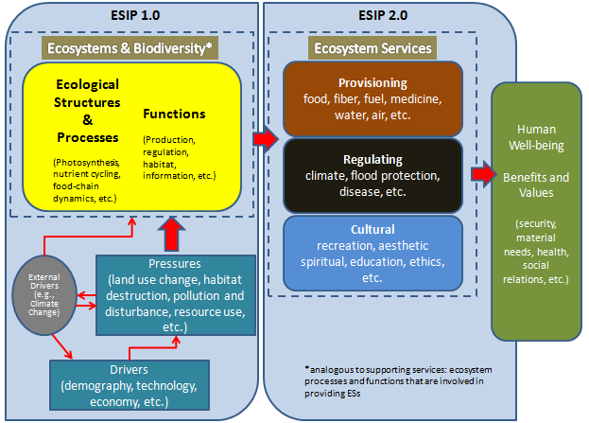

As an example which box would include primary production? He wondered if it would be a good idea to brainstorm categories that would fit with the ecosystem services. The subcommittees could then be set up for the specific categories. This would give ESIP a good opportunity to frame the discussion. Christine stated that she likes that idea but it is important that specific indicators are not assigned to the catogories. In the past the ESIP community has NOT liked being told what the indicators are. The groups like to brainstorm those together.

An example of the process might be to think about what is important in a Gulf of Maine context. Jim Latimer liked the idea to get categories that are useful to the Gulf of Maine. He also commented that the categories could include biodiversity. Jawed stated that biodiversity is confusing with respect to fit under ecosystem services. Supporting services (like some in ESIP 1.0) have long term scales where as many of the ecosystem services are shorter term. Christine wondered if it would be good to think in terms of the three ecosystem service types: Cultural, Regulating, and Provisioning but also include an Emerging Issues category. The group felt this was a good way to approach the problem. Christine mentioned that Peter Wells put together an emerging issues paper for the State of the Gulf Report (http://www.gulfofmaine.org/2/sogom-homepage/emerging-issues/). Jawed pointed out that regardless of how this process is undertaken the group will still be limited to what information is available. Reliable sources for information will be necessary. (The Emerging issues identified in the 2010 State of the Gulf Report can be seen at: http://www.gulfofmaine.org/2/wp-content/uploads/2014/03/emerging-issues.pdf).

Annual ESIP Steering Committee Meeting
Christine wondered if it would be helpful to take time during the ESIP Steering Committee Annual Meeting to brainstorm this structural idea. She would like to include individuals that have participated in ESIP 1.0 and the Directional Committee effort. (Action to be taken: Include on Annual Steering Committee meeting agenda. - June 16, 2015.) This brainstorming could focus on a higher level and would then be used to organize the ESIP subcommittees. (Action to be taken: Christine needs to find out if NHDES (location of ESIP meeting) has the capability to have people calling in for around 1 hour for this discussion.)

Potential Products
Jim wondered if the group should have in mind specific products (similar to how ESIP 1.0 was geared towards producing fact sheets). Christine stated that she feels fact sheets and enhanced webtools would be appropriate.

