Directional Committee Call December 11, 2014
Participants:
Robin Anderson (DFO)
John Brazner (NS DNR)
Jeff Hyland (NOAA)
Jim Latimer (EPA)
Hilary Neckles (USGS)
Jerry Neff (Consultant)
David Page (Bowdoin)
Shannon Sterling (Dalhousie)
Christine Tilburg (GOMC)
Paul Stacey (NH Fish and Wildlife)

Introduction and Reminder
After introductions Christine Tilburg reminded the subcommittee that she had asked everyone to send her integrative or ecosystem service-type indicators that ESIP might consider for ESIP 2.0. Christine stated that it isn’t important to get too hung up on indicators that might be missing from the slides but instead use the indicators to help describe the framework. She mentioned that Jim Latimer had helped her place the integrative indicators into the ecosystem service framework prior to the call.

Ecosystem Services
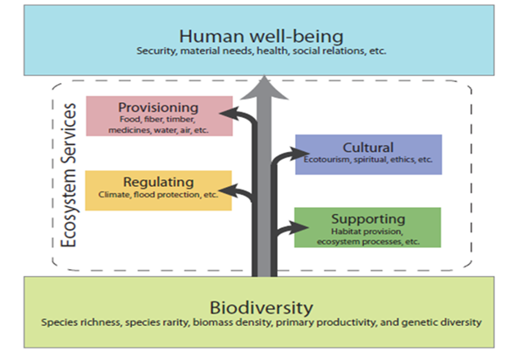
The group discussed the slide that showed ecosystem services building upon a foundation of biodiversity. Original figure sent by Paul Stacey and comes from the Global Footprint Network website. Jim Latimer wondered if biodiversity can be considered cross-cutting and therefore does not fit into the subgroups. Jim also mentioned that he has seen people place biodiversity in with the Supporting subgroup. Jeff Hyland stated that biodiversity is often placed in the Supporting subgroup. However, he believes that biodiversity runs through each subgroup. John Brazner stated that if biodiversity is set aside it is important to still emphasize it.
Individuals on the call then discussed the various subgroups. David Page stated that one thing to keep in mind is that many of these indicators have existing criteria. For example land use criteria co-vary with indicators that are specific such as impervious surface. It is important to keep in mind information that will be readily available. Shannon Sterling agreed and pointed out that many of these criteria can be utilized with available GIS. John stated that while he likes the idea of a forest extant/human disturbance indicator the landscape needs to be kept in mind (example: there is not much forest cover in Nova Scotia). (Jim email: Keep in mind existing indicators that provide insight into the services).
Robin Anderson then stated that while she likes the ecosystem service subgroups she has difficulty understanding where specific indicators might go. As an example, how would runoff and coastal sewage be represented in the ecosystem services framework. The group agreed that nutrient cycling and number of shellfish advisories might cover the issue but likely more. Another example might be aquaculture. Aquaculture could be a provisional service but there is an environmental footprint that needs to be covered too. Christine stated that for her the difficulty is that ESIP 1.0 focused mainly on condition indicators that have fairly clear cause and effect relationships. The ecosystem services have metrics that can appear in several subgroups based on interpretation. (Jim email: Ecosystem services can be broader than just direct). Robin used the aquaculture example in that it would be covered in Provisional but the actual metric for waste would be covered in Supporting. John made the comment that fisheries and broader aquaculture need to be covered in Provisional or Culture (currently missing). (Action to be taken: Add to slides for future reference). John also stated that with respect to metrics that cover adverse or negative impacts he is not sure they belong in the subgroup categories.
The group discussed the appropriate incorporation of negative impacts more completely. Jim stated that it might be a good idea to have a separate grouping for negative effects. Paul cautioned that he has seen people get bogged down with this type of framework. David stated that in a broader picture it might make sense to think of ecosystem services in terms of a positive and negative budget. (Jim email: Profit – loss: tradeoffs with positive and negative aspects of the indicators (black or red; positive vs negative – net). John stated that a shortcoming of the ecosystem services frame work is that it is only concerned with the “human” part of the equation. Christine stated that she would be concerned about that but there is a strong base with the twenty-two priority indicators used in ESIP 1.0. Hilary Neckles asked if ESIP will continue using and updating the ESIP 1.0 indicators. Christine replied that ESIP 1.0 indicators will continue to be used and updated (Climate Change indicators have already been updated in the webtools since the first printing of the fact sheets). David stated that it is also important that the indicators in question have datasets available.
Jeff wondered if ESIP will be able to put a monitoring system in place. Christine replied that ESIP does not have funding for monitoring but uses datasets already available. However, ESIP has worked with several groups to fill in gaps (ex: chlorophyll a and secchi sampling in New Brunswick and impervious surface analysis for Nova Scotia).
Ecosystem Services Framework – Revision
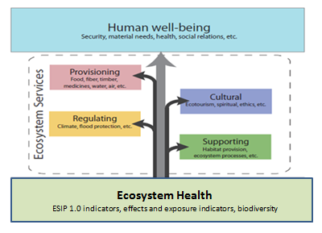
The group then discussed Slide 7: Exposure and Effects indicators and wondered how they would fit in. The group agreed that it is important to measure the effects and/or trade-offs from the ecosystem services. Robin wondered what would happen if the group revisited the framework at the beginning of the slides and changed the green box to represent ecosystem health. The health of the ecosystem is the foundation of the ecosystem services. To assess the green box then a series of indicators of condition are needed (ESIP 1.0 indicators). Hilary liked this idea and in particular the importance of capturing indicators that assist in determining the health of the system. David liked this suggestion also. He also stated that biodiversity is a key part of the “green box”. Jeff agreed and stated that a framework of integrative indicators relies on ecosystem health and services built up it. Jim wondered about how integrity fits in with this framework. Robin stated that ecosystem integrity combines services and status indicators. If there isn’t ecosystem integrity there are diminished ecosystem services. David stated that the nice thing about using this framework is that it works on a macro and micro level.
John stated that he didn’t want to throw a wrench in the process but he wondered where Shannon’s effects and exposure indicators might fit in. Shannon stated that she sees them fitting into the green Ecosystem Health box. John wondered if most of the DPSIR-type indicators would fit in there. Hilary stated that the Ecosystem Health ( or Ecosystem Condition) box will be complex and could include both “Exposure” and “Effects” indicators.
Next Steps
Christine suggested that she bring together the notes and map out the framework a little more thoroughly with example indicators for a call in January. She thinks she could have a document completed in February and the Directional Committee can disband. She stated that she would love to have individuals in the committee join other ESIP committees for ESIP 2.0 if time and interest is there.

