**Steering Committee Conference Call: February 24, 2015**

**Participants**

Adria Elskus (USGS, UMaine), Jawed Hameedi (NOAA), Jim Latimer (EPA), Kathryn Parlee (EC), Marilyn ten Brink (EPA), and Christine Tilburg (GOMC)

**1. Great Coast Marsh**

ESIP’s journals continue to be popular with around 200 visitors per month The January 2015 entry focused on a Smart Tour of the Great Marsh (author: Prassede Valle). Another ESIP member (Randy Milton from ESIP’s Aquatic Habitat Subcommittee) read the entry and asked the journal author if they would like to write a chapter for an upcoming Springer Wetland Encyclopedia. Adria Elskus pointed out that the past journal links don’t appear to be updated. Christine Tilburg noted this problem and will discuss it with Jim Cradock (IT) during their monthly call on February 24. ***(Action to be taken: Christine needs to follow up with Jim Cradock.)***

**2. EC Funding: Gulf of Maine Initiative**

ESIP was notified in January that a proposal with Eastern Charlotte Waterways (ECW) was funded for the Bay of Fundy. This exciting project is a collaboration with ECW and Clean Annapolis River Project to collect samples for both sediments and water quality to add to the ESIP regional database. Both the Eutrophication Subcommittee and Contaminants Subcommittee identified these data gaps with their indicator analysis and fact sheets. The sediment sampling will be conducted prior to March 31 as 30% of the funds need to be used by that date. Jim Latimer mentioned that he has the water quality sampling plan generated. Christine suggested he send that forward to Donald Killorn (ECW). Jawed Hameedi asked about the location and number for the sediment samples. Christine stated that 20 samples will be collected from 16 Gulfwatch sites (the extra samples are for duplicates). Christine stated that according to the Gulfwatch team most of the samples were selected randomly to obtain geographic coverage.

*Email from Peter Wells February 23, 2015: “As I recall, the sites were chosen based on geographic coverage in the GOM/BofF, availability of blue mussels in quantity at the site, accessibility of the site, and in a few cases, proximity to known or suspected pollution sources. Some sites on the US side also were the same as in the NOAA Mussel Watch Program.”*

The group also discussed how the samples will be composited prior to separation of field duplicates.

**3. NEERS**

NEERS’ upcoming Spring meeting will be April 16 – 18 in Rhode Island. Christine and Jim Latimer plan to submit an abstract for ESIP focusing on the work of the Directional Committee and ESIP 2.0. Jim mentioned that he will be in Italy for that time period so Christine will need to present. The Steering Committee discussed the best way of presenting ESIP materials: Ignite, 20 minute oral presentation, or poster. Jim confirmed that ESIP would need to submit two separate abstracts to present both in the Ignite session and Poster session. The Steering Committee then agreed that the 20 minute presentation would be best.

Marilyn ten Brink suggested that the presentation be made available on the “News and Accomplishments” webpage. She mentioned that there is a program (Camtasia) that allows for voice recordings with the power point slides. Christine agreed to look into doing this for the NEERS meeting after the presentation. ***(Action to be taken: Christine needs to look into this program).***

**4. Location of Annual Meeting**

The ESIP Annual Meeting will be held on June 16 in Portsmouth, New Hampshire. Christine spoke with Joan LeBlanc and Steve Couture about the location of the June Working Group and Council Meetings. Those two GOMC meetings will be at the New Hampshire DES building. Steve has stated that ESIP can use a smaller conference room at no charge. The Steering Committee discussed the location and how travel arrangements might be made. Everyone agreed utilizing one of the NH DES conference rooms would be best. ***(Action to be taken: Christine needs to follow up with Joan and Steve.)***

**5. Directional Committee**

The Directional Committee held their final conference call this month. They finalized the framework for ESIP 2.0. Christine is providing a 2 page write up for their review. Several individuals that participated in the work expressed their pleasure in the discussions and will likely participate in ESIP in the future. The framework (as developed by Jim Latimer) is below. Christine mentioned that the Steering Committee will need to discuss how the ESIP subcommittee structure will be determined for ESIP 2.0.

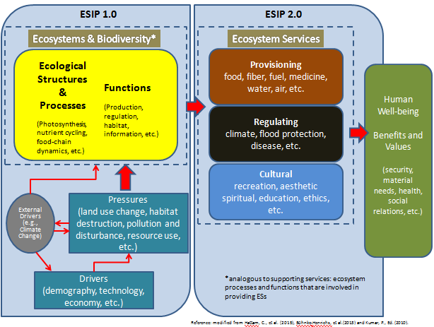

**6. ICUC Effort**

The ICUC team has also been very busy with a conference call in December and January. A third call is scheduled for this Thursday (February 25) to discuss an app called WetPro and the proposal that was submitted from St. Mary’s University to obtain assistance to develop that specific app. The team hopes to put out a request for proposals in March.