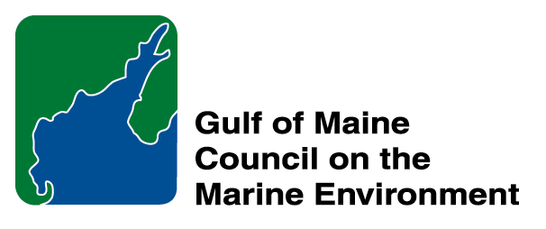 | 2015 Gulf of Maine  Industry Award  Nomination Form

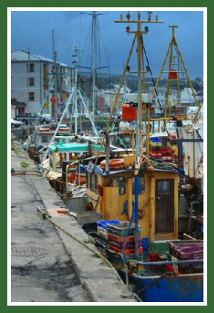 | The Gulf of Maine Industry Award is made annually to an individual, company, or organization within the Gulf of Maine region: Massachusetts, New Hampshire, Maine, New Brunswick, and Nova Scotia. The Award recognizes demonstrated innovation and leadership in efforts to improve the well-being of the Gulf of Maine ecosystem and the communities that call it home. Nominations are sought for nominees from the following sectors: tourism; fisheries (commercial and recreational); aquaculture (finfish and shellfish); renewable energy generation (tidal, wave and wind) and transportation (shipping, ferries, etc.).  Nomination instructions:  - Individuals or organizations may submit nominations. Self-nominations are not accepted.  - The nominee must be resident of Maine, Massachusetts, New Brunswick, New Hampshire, or Nova Scotia. The nominee’s contributions must have been to the Gulf of Maine watershed.  - Industry Award nominees may be paid professionals or volunteers.  - Nominations must be made on this form. Attachments will not be accepted.  - Nominations must be emailed directly to theresa.torrent@maine.gov  by March 30, 2015. Please rename the nomination form with  _LastNameofNominee added to the end of the file name.
Questions? Please contact Theresa Torrent at theresa.torrent@maine.gov or 207.287.2351.
To view a list of past award winners, please visit: http://www.gulfofmaine.org/2/opportunities/

Nominee information
Name (as it would appear on the award plaque if selected): Neptune’s Harvest
Mailing address: Neptune's Harvest P.O. Box 1183 Gloucester MA 01931 (Attn: Ann Molloy, Sales Director)
Phone: 1 (800) 259-4769
Email: ann@neptunesharvest.com

Brief background on why the individual/organization is being nominated:
Since 1986, this innovative organic fertilizer company has been targeting sustainable industry and protection of Gulf of Maine resources in everything they do. Their drive to take advantage of diversification opportunities while maintaining their commitment to improvement of ecosystem health has made them a leader in the industry and a model to follow.

Summary that will be read during the awards ceremony if nominee is selected. This text will also be used in media releases (not to exceed 2,000 characters, including spaces and punctuation):
Few companies embody the spirit of “Yankee ingenuity” quite as fully as Neptune’s Harvest, of Gloucester, MA. Neptune's Harvest is a spin-off of its parent company, a wholesale fish and seafood company called Ocean Crest Seafoods, Inc., which has been operating on Gloucester’s waterfront since 1965. Because 60-70% of processed fish remains as waste, or gurry, the company wanted to find an innovative way to avoid the costly and environmentally unsound approaches typically available for managing this byproduct. To do so, Ocean Crest got together with researchers from the University of Massachusetts marine science research center and developed the process of turning the gurry into fertilizer, allowing the company to beneficially use 100% of the fish they process.
Neptune’s Harvest products are beneficial to the Gulf of Maine environment because the company is able to use every part of each fish, so the waste that was once dumped back into the ocean or sent to landfills is instead used to help grow stronger, healthier plants by improving the soil. The use of these organic products eliminates, or greatly reduces, the need to use pesticides or any other chemicals that could runoff to coastal resources, and increases the organic matter in the soil. Higher organic content and lower chemical load means the soil holds more water, reducing runoff and helping to maintain healthy watersheds.
Neptune’s Harvest is a family run business that sells its organic products to everyone from small home gardeners to large farms, locally and around the world, in volumes ranging from one quart containers to 4,500 gallon tanker trucks. Their success stems from their goal of producing organic fertilizers that simply work better than chemical products, so that more people will choose and use organics and better protect our Gulf of Maine ecosystem. They are a model of sustainable, innovative industry in the Gulf of Maine, strengthening the working waterfront in Gloucester MA.

Contact information for person making the nomination:
Name & Affiliation: Kathryn Glenn, North Shore Regional Coordinator, MA CZM
Address: 2 State Fish Pier, Gloucester MA 01930
Phone: 978-281-3972
Email: kathryn.glenn@state.ma.us

